A CONCEPTUAL FRAMEWORK OF eNODEB PEAK PATTERNS PREDICTION BASED DYNAMIC PRICING SCHEME FOR ENHANCED QUALITY OF LTE NETWORK SERVICES

^{*1}Temitope Oluseun EFUWAPE
seunwape@gmail.com
efuwapebt@bellsuniversity.edu.ng
+234 805 5600544

¹Olusegun Adedeji OJESANMI (Professor)
dejioje@yahoo.com
ojesanmioa@funaab.edu.ng
08056052007, 09072127007

¹Department of Computer Science
College of Physical Sciences
Federal University of Agriculture, Abeokuta
Ogun State, Nigeria.

*Corresponding author

A CONCEPTUAL FRAMEWORK OF eNODEB PEAK PATTERNS PREDICTION BASED DYNAMIC PRICING SCHEME FOR ENHANCED QUALITY OF LTE NETWORK SERVICES

Abstract: The telecommunications industry in sub-Saharan Africa is experiencing a notable seismic change. With exponential technological growth, evolving teledensity, and growing customer base, telecommunications is at a crossroads. However, the consequence of this growth has been a continuous degradation in the quality of service (QoS) provided by Long Term Evolution (LTE) service providers, which has resulted in unsatisfactory experiences for subscribers and customers. In light of the extant literature and research on pricing and artificial intelligence in the context of network management, this study proposes the application of the Long Short-Term Memory (LSTM) model of deep learning to predict the eNodeB peak patterns and develop a dynamic pricing scheme in LTE networks. Each of the interconnected components that make up our proposed architectural framework is essential to the dynamic pricing and design process. This ensures seamless integration of predictive modelling, decision-making algorithms, and communication with users. In addition to the comprehensive analysis, the model is applied to a real world 4G LTE traffic dataset to evaluate and examine the proposed framework. Finally, the result of this study will demonstrate the utility of the scheme to enhance the quality of LTE network services in sub-Saharan Africa.

Keywords: Long Short-Term Memory (LSTM), eNodeB, Long Term Evolution (LTE), Dynamic Pricing

1. INTRODUCTION
Cellular network is a significant mobile communication that has transformed modern society by providing reliable, high-bandwidth, and low-latency communication through diverse technologies, from Wireless Fidelity (WiFi) networks to 4G and beyond (Wu et al., 2023). The ongoing progress and recognition of these technologies have resulted in a substantial surge of mobile users, high-data-demanding applications across sectors such as education, media, banking, transportation, manufacturing and their usage. According to Ericsson (2022) and Huawei (2020), the total global mobile data traffic shall reach 90EB/month by 2022 and increase to approximately 115EB/month by the end of 2028. This represents a significant challenge for telecommunications operators in managing the large network flow while maintaining and enhancing service quality. Moreover, the number of mobile data users is expected to rise significantly, with 7.3 billion wireless data devices in 2022, and an anticipated increase to over 9.2 billion devices by 2028. Long term evolution (LTE ) technology advancements, increasing data service demands and infrastructure deficiencies brought on by the rapid population growth using the mobile internet have all contributed to a significant strain on network resources and a decline in the quality of service (QoS) offered to end users (Shakir et al., 2023). In order to solve the difficulties in improving the quality of LTE network service and reducing congestion, the flag is raised. Quality of Service (QoS) is a crucial aspect of cellular communication, particularly in LTE. QoS refers to the collective effect of service performance that determines the level of service and user satisfaction (ITU-T E.800). In order to maintain that end-users receive high-quality service, especially in data-intensive applications like online gaming and video streaming, LTE must guarantee a respectable degree of quality of service. One of the simplest ways to enhance the quality of LTE network service is to install additional eNodeBs to increase the capacity of cellular networks and accomplish load balancing, but this comes at a high cost to telecommunications operators. Therefore, incentivizing users to reduce their data resources during peak periods will go a long way to reduce congestion and service quality degradation, improving the whole user experience.
Despite being relatively new, dynamic pricing in the telecommunications industry has great potential to maximize network utilization and boost profits. Dynamic pricing involves adjusting prices of communication services in real-time based on a number of variables including demand, supply, service quality level and customer behaviour (Anees et al., 2021) thus presenting to the end-users the prices they are willing to pay. In order to improve QoS, the scheme can incentivize end-users to reduce their demand for network resources during periods of high congestion. Additionally, the dynamic pricing scheme takes user behavior and peak patterns into account to ensure equitable resource allocation and pricing. This highlights how crucial this scheme is to preserving fair access to network resources and improving user experiences. Many authors have proposed different pricing schemes for cellular networks but their chapped and static time-based characteristics makes it difficult to maintain adequate quality of service during periods of peak demand (Masli et al., 2022). The work in (Kokkinen et al., 2020) was enhanced in Ding et al., (2020) through the introduction of a framework that dynamically combines temporal and spatial traffic patterns to devise a pricing scheme. The results showed a reduction in the traffic peak-average ratio and enhanced network performance. Researchers are using ML algorithms to account for the dynamics aspect of traffic variations (Susanto et al., 2023). These algorithms have the ability to analyze large volumes of cellular traffic data and extract valuable information about the eNodeB patterns, allowing telecom service providers to make informed decisions and insightful predictions of traffic levels and pricing. Alsaade and Al-Adhaileh (2021) used statistical time series models, such as autoregressive integrated moving average (ARIMA) and single exponential smoothing (SES), to model and forecast the traffic volume of LTE networks. They were able to anticipate network traffic with improved accuracy. Numerous studies have shown the efficacy of statistical, machine learning, and deep learning-based models in various aspects of LTE network management. Alsaade and Al-Adhaileh (2021) applied statistical time series models like single exponential smoothing (SES) with autoregressive integrated moving average (ARIMA), to model and predict the traffic volume of LTE networks. They were able to anticipate network traffic with improved accuracy. Gijon et al. (2021) presented a study comparing different supervised learning models and statistical time series analysis approaches to predict monthly peak-hour data traffic on a cell basis in a Long Term Evolution (LTE) network, the models considered include random forest (RF), artificial neural networks, support vector regression (SVR), seasonal-ARIMA and Additive Holt–Winters. The results demonstrated that supervised learning-based models performed better than the time series approaches in predicting peak hour traffic, while simultaneously reducing data storage and capacity requirements. Jiang (2022) and Alekseeva et al. (2021) conducted an extensive analysis of existing studies in the field of LTE network management with artificial intelligence mechanisms. The result of the studies demonstrate the potential of ML cellular traffic prediction in enhancing quality of service in LTE, this motivates our choice of this approach. Under the aforementioned context, the study aims to develop a dynamic pricing scheme based on predicted eNodeB peak patterns using deep learning-based models. To achieve this objective, the study seeks to answer the following research questions: What methodology is employed to identify and predict eNodeB peak patterns in LTE networks? What methodology is employed to develop a dynamic pricing scheme based on predicted eNodeB peak patterns? The paper is organized as follows: Section 2 outlined the related review in the area and introduced the knowledge gaps of state-of-the art. Section 3 displayed conceptual framework and Section 4 summarized methodological study design. Under Section 5, recommendation is stated. Finally, conclusion and references provided in section 6 and 7 respectively.
2. REVIEW OF RELATED LITERATURE
2.1 Long Term Evolution (LTE)
The Third Generation Partnership Project (3GPP) developed the Long Term Evolution (LTE) and the technology standard aligned with the underlying cellular network architecture. This involves the division of a large geographical area into smaller cells, with each separate cell served by a base station called the evolved NodeB (eNodeB) respectively. These eNodeBs facilitate communication with each other and with the core network thereby providing data transfer and voice communication services to the end-users (Nisar & Baseer, 2021; Salih et al., 2020). An LTE network consists of three main components that work together to deliver enhanced performance and quality of service. The core network (CN), the access network and the end user equipment (Jaffry, 2020). The user equipment (UE) is an essential component of LTE networks. They are equipped with LTE-compatible modems and antennas to establish wireless communication with the evolved NodeB over the access network. The core network, known as evolved packet core (EPC) is the central component of an LTE network. It consists of logical multiple elements, including the mobility management entity (MME), serving gateway (SGW), and packet data network gateway (PGW). The deployment of LTE offers a number of advantages to end-users, including higher data transfer rates, lower latency, and improved spectral efficiency. These benefits assist the streaming of high-definition videos, playing of online games, and the utilization of other data-intensive applications with minimal difficulty. As a result, LTE has become a popular choice for mobile network operators, with LTE networks deployed globally. Over the years, the LTE network has undergone several upgrades, with the introduction of LTE-Advanced and LTE-Advanced Pro introduced to enhance the performance and capabilities of LTE networks.
2.2 Dynamic pricing and cellular networks
Dynamic pricing schemes have been widely studied and applied in various industries, including transportation, hospitality, and e-commerce (Guo et al., 2022). In a recent study, Balakumar et al. (2024) used a dynamic pricing technique based on machine learning to control variations in electricity in a smart grid network. The authors calculated the dynamic pricing based on the feeder anticipated power usage by using Internet of Things (IoTs) devices to get a real-time dataset from the Distribution Smart Substation (DSS) and several individual feeder lines. Avoiding individual feeders’ overload, because of dynamic pricing, the grid’s robustness and dependability increased. Additionally, the method reduces the likelihood of breakdowns and disruptions while making better use of the current infrastructure. Using their pricing strategies of mobile data bundles, Inegbedion et al. (2023) used the Nash Equilibrium (NE), to stimulate and test the competitive behaviors of GSM operators in Nigeria. According to the study’s findings, game theory is an appropriate and proven technique for stimulating and forecasting subscribers’ behaviors in a competitive setting in order to improve revenues. Bajracharya el al. (2022) explored incentivizing users to offload their traffic to unlicensed frequency bands in cellular networks. It proposed an economical approach, utilizing unlicensed bands to enhance capacity. The article models the operator-user interaction as a stackelberg game, considering fairness with legacy WiFi users. Multi-armed bandit algorithms adapt to user behaviors. Simulation results validate the approach, but limitations include scalability and dynamic network conditions. Overall, the study presents a cost-effective approach to encourage traffic offloading, utilizing game theory and adaptive algorithms, with room for further research.
Puspita et al. (2022) analyzed the sensitivity of an internet pricing scheme model using a modified C-RAN model. The research explores different pricing schemes, incorporates fair network traffic management, and utilizes the CES utility function. Based on analysis using secondary data, the study suggests the potential profitability of the improved model for Internet Service Providers (ISPs). The sensitivity analysis reveals that the model's behaviors vary based on specific variable values. Overall, the study provides insights into the sensitivity of the pricing scheme model and its potential implications for ISPs. In the context of priority pricing for usage –based mobile internet access charging, the author (Cho-S, 2021) introduced a heuristic algorithm priority dynamic pricing with multiple service levels for optimal price selection. The pricing scheme hereby produces a pricing plan that can efficiently and effectively control radio resource usage and manage user needs on networks. Chounos et al. (2020) in their study introduced a novel framework for dynamic policy and charging rules in 5G multi-tenancy environments The study concentrates on adaptive pricing schemes to allocate network resources when existing resources are inadequate. The framework stimulates the negotiation between mobile network operators and infrastructure providers (InPs) as service level agreements (SLAs) and provides an analytical structure, collaboration methods, and testbed trials to validate the framework's ability to handle further traffic demands. Overall, it offers a way out to price and allocate resources in a more effective way in dynamic network environments.
Zhou et al. (2020) examined the application of time-dependent pricing for resource allocation in software-defined cellular networks (SDN) given both mobile users’ complete and incomplete information and price disparity. The authors design the joint pricing and bandwidth demand as a two-stage Stackelberg leader-follower game to increase the surpluses of network service providers (NSPs) and minimize the peak-to-average traffic ratio (PATR). On the other hand, NSPs might incentive users to shift their demand for a higher revenue and lower PATR. Qian et al. (2020) discussed the challenges of dynamically sharing the multi-mode spectrum in 5G-VANET to optimize network throughput. It proposes a dynamic stackelberg pricing game approach, including an access price strategy and distributed mode selection for vehicle users (VUEs). The algorithm evaluates using traffic scenarios, demonstrating a significant improvement in VANET's transmission rate. Overall, the paper presents a solution for optimizing network performance in 5G-VANET through spectrum sharing.
3. CONCEPTUAL FRAMEWORK
This section presents the overarching architectural framework (Figure 1) that underlies our dynamic pricing scheme for postpaid users. The architecture serves as a conceptual framework that orchestrates the dynamic adjustment of pricing tiers in response to the predicted user behaviour and eNodeB peak patterns. Each of the many interrelated parts that make up the architectural framework is essential to the dynamic pricing process. The architecture is designed to ensure seamless integration of predictive modelling, decision-making algorithms, and user communication. This study applied research focusing on a scheme to address a problem of enhancing the quality of LTE network services. It is theoretical-descriptive research, analyzing and investigating specific aspects of reality and establishing a description and specific context. Both quantitative and qualitative data collection methods are employed for the study.

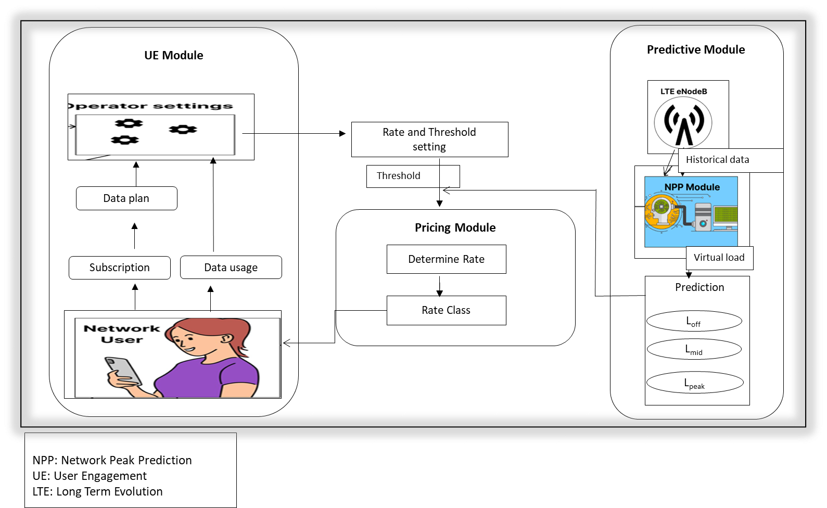

Figure 1. The proposed architectural framework for dynamic pricing scheme

4. DYNAMIC PRICING SCHEME
At its core (Figure 1), the architectural framework comprises three main modules: predictive models, pricing engine, and user interface. These modules collaborate harmoniously to achieve the dynamic pricing goals, ensuring equitable resource distribution and enhanced QoS provisioning.
4.1 Predictive Module
The module is capable of generating accurate predictions of peak patterns for eNodeB. The predictive module employs deep learning-based models and historical dataset to forecast traffic volumes and congestion trends in the network. The eNodeB peak pattern is designed as a time series-forecasting tool that employs deep learning models to predict fluctuations in LTE network traffic. The model incorporates historical dataset, including user traffic, signal quality, and timestamps to forecast future states of network congestion. The analysis of trends and patterns in data usage over time enables the effective learning of these sequence dependencies, which are crucial for accurate prediction. The model output is useful in identifying specific times that are likely to experience peak or off-peak traffic, thereby enabling telecommunication operators to prepare or adjust resources accordingly. This predictive capability is fundamental to ensuring efficient network management and optimal allocation of bandwidth and other resources, with the help of these features. The prediction problem reformulated (Ferreira et al. (2023) below:
Given an eNodeB $b$ network traffic load at previous time step $t$
$${ X}_{t}^{b}=[x_{1}, ………, x_{t}]$$
$$where:$$
$b= 1, ⋯,n_{a}$
$then$
$y= f\left(X_{t}^{n}; θ\right)+ { ε}_{n}$ (1)
$where: y$, the predicted eNodeB peak traffic at the next time step $t_{a+1}$ , $X_{t}^{n}$ is the function that maps input features to the target variable y parameterized by$\left( θ\right)$, ${ ε}_{n}$ is the prediction errors (residual) that could influence the prediction quality and $n$ is the total number of observations.

4.1.1 Machine learning models
The Long Short-Term Memory (LSTM) model is a variant of the recurrent neural networks (RNNs) that are adept at handling data sequences and capturing temporal dependencies. RNN incorporates a memory element that enables them to store and utilize information from previous inputs to generate subsequent outputs in the sequence (Orievto et al., 2023). However, RNNs are not able to handle long-term dependencies in the data. They suffer from the vanishing gradient and exploding gradient problems. Figure 2 depicts the basic RNNs single cell architecture. It consists of an input at a time step$x_{t}$, a hidden state (memory) at a time step $h_{t-1}$ and an output at a time step $O_{t}$ . At a specific time step 𝑡, these parameters, are connected and expressed as
$x_{t } ∈ R^{n_{x}}$; $h_{t }= tanh(W_{x} .x_{t}+ W_{h} .h_{t-1} + b_{h})$ (2)
$O_{t} = (W_{o} . h_{t } + b_{o})$ (3)
where: $W_{x}, W_{h}, W_{o }$ are the weight parameters,$tanh$ is non-linear activation function and $b_{h}$ $, b_{o}$ are the bias parameters .

LSTM was introduced by Hochreiter and Schmidhuber in 1997 (Siami‐Naminiet al., 2018) to improve on the deficiencies of RNNs and this capability makes them highly suitable for time series data, such as network traffic usage and its associated statistics, which are inherently sequential, and where the order of data points are of critical importance. They are capable of retaining significant information over extended periods, which is essential for accurate prediction where past usage patterns influence future behaviour. LSTM ability to learn from the long-term dependencies in data usage patterns endows them with the ability to forecast future network traffic effectively, thereby making them an optimal choice for predictive tasks.
As in Figure 3, LSTM processes sequences of data, with each unit in the layer having the capability to remember information for an extended period. The LSTM modifies its cell state by a combination of three gates: input, forget, and output as shown in equations (4-8) to control the information flow, the cell state $C_{t-1}$ acts as a memory that carries information across the entire cell. The forget gate $f_{t }$decides what information to be discarded or retained where $x_{t}$ is the input feature at the current time step $t+1$, $h_{t-1}$is the previous hidden state of the LSTM cell. , $σ$ is the sigmoid function, $W_{f} ,$weight parameters and$b_{f}$ is the bias parameter. Based on the forget gate, the input gate $i_{t}$determines what new information to be stored or updated in the cell state .The new cell state $C_{t}$ is updated with new information. An activation function $tanh$ creates a vector of new information${C_{t}}^{^}$, and, add it to the state. Depending on the new cell state, the output gate $O_{t}$ decides what the next hidden cell state should be with respective W weight parameters to be learned during training and Hadamard product (∙). For this study, the internal state of the network is process by iterating the following equations below (Santos Escriche et al., 2023):
Forget Gate: Decides what information to discard from the cell state
$f_{t }= σ(W_{f} . [h_{t-1}, x_{t}] + b_{f})$ (4)

Input Gate: Decides what new information to store in the cell state
$i_{t} = σ(W_{i} . [h_{t-1}, x_{t}] + b_{i})$ (5)
${C_{t}}^{^} = tanh(W_{c} . [h_{t-1}, x_{t}] + b_{c})$ (6)

Output Gate: Decides what to output based on cell state
$O_{t} = σ(W_{o} . [h_{t-1}, x_{t}] + b_{o})$ (7)
$h_{t } = O_{t} . tanh(C_{t})$ (8)

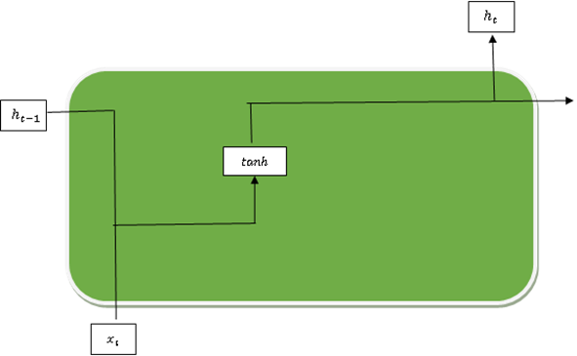

Figure 2. A basic RNN architecture

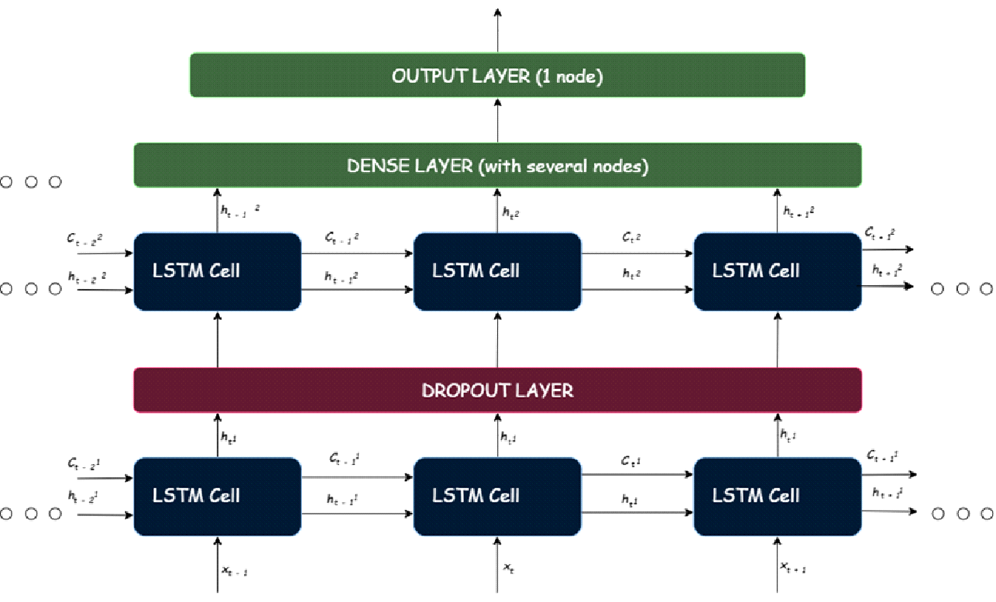
Figure 3. Two-layered architecture of the LSTM

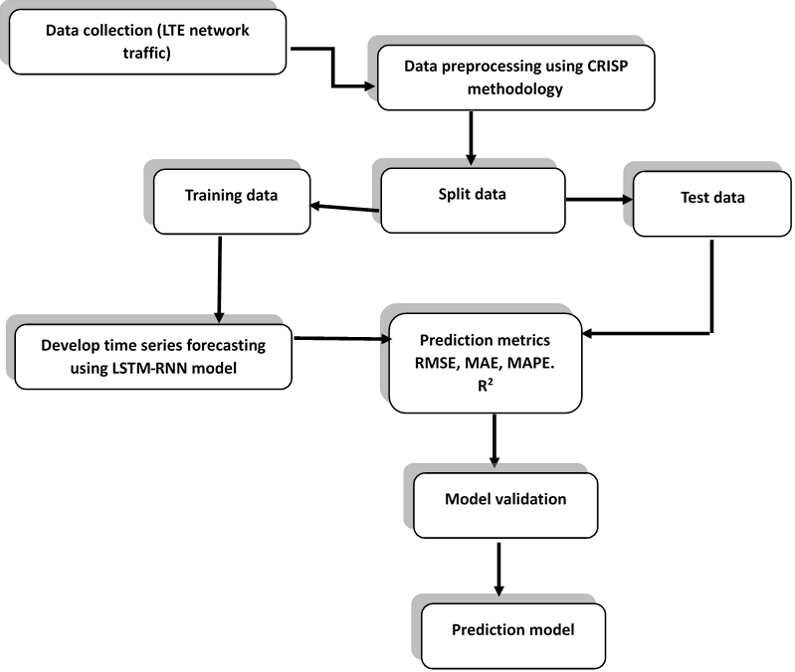

Figure 4: The machine learning workflow

4.1.2 Machine learning workflow

This paper employs the CRISP-DM methodology for the machine learning process to achieve the desired goal (Schröer et al., 2021). The methodology consists of the steps shown in Figure 3. The CRISP-DM technique has been the most widely used standard for data mining and machine learning projects. This continues to serve as the established norm, and an industry-independent process model for the execution of machine learning projects.
4.1.3 Assessment metrics
Four forecast assessment metrics were manipulated to evaluate the accuracy of the predictions. The assessment metrics used are the root mean square error (RMSE), which measures the mean deviations of the predictions from the true values. It is the square root of the mean square error. A lower RMSE value indicates a better performance of the model, and smaller deviations from the predicted to the true values (Terven et al., 2023). It therefore penalizes large errors. RMSE is calculated as follows:
$RMSE=\sqrt{\frac{1}{n}{\sum_{t=1}^{n}{}(x_{t}-ŷ_{t})}^{2}}$ (9)

The mean absolute error (MAE) measures the mean of the absolute difference between the predicted values and the true values. The smaller the value, the closer the forecasts are to actual values and the better the model. MAE is calculated as follows:

$MAE=\frac{1}{n}\sum_{t=1}^{n}{}|x_{t}-ŷ_{t}|$ (10)

The mean absolute percentage error (MAPE) is a measure of the mean percentage error of the model’s predictions associated with the true values. MAPE is easy to interpret, as it is expressed in percentage terms. It is also scale-independent, a property that facilitates the comparison of models across diverse scales of the target variable. It is calculated as follows:

$MAPE=\frac{1}{n}\sum_{t=1}^{n}{}|\frac{{|x}_{t}-ŷ_{t}|}{x_{t}} X 100$ (11)
The coefficient of determination $\left(R^{2}\right)$ does measure how well the model can explain the deviation in the predicted variable. It measures the percentage of the variance in the predicted variable that the deep learning-based algorithms explain on a scale of between zero and one. The higher the value of $R^{2}$, the better the model would be in predicting the traffic peak hours of the cellular network accurately. It is calculated as follows:

$R^{2}=1- \frac{{\sum_{t=1}^{n}{}(x_{t}-ŷ_{t})}^{2}}{{\sum_{t=1}^{n}{}(x_{t}-ẍ_{t})}^{2}}$ (12)

$$where:$$
$x_{t}$ be the true value, $ŷ_{t}$ be the predicted value, $ẍ_{t}$ be the mean of the true values and n be the total number of the testing dataset.

4.1.4 Proposed Implementation
The study will implement the proposed dynamic pricing scheme in a simulated network using Objective Modular Network Testbed (OMNeT++ 5.0), a component-based simulator with an extensive library of predefined components for modelling common typical network elements. The validation will be carried out using real world 4G LTE traffic dataset from a sub-Saharan African LTE service provider. The results will assess in terms of network throughput, latency, price paid per user and operator revenue. Python programming language and its related libraries used for all experimental procedures and numerical calculations.
Throughput: It measures the rate at which data is successfully transferred through the LTE network.
Latency: The actual period for a data packet to move from its source to destination. It assesses the delay in data delivery.
5. RECOMMENDATIONS
The following recommendations are made:
- Additional research and analysis on the other modules to ascertain their functionality in relation to the proposed scheme.
- Explore multiple machine learning algorithms for eNodeB peak patterns prediction in order to ascertain and achieve greater accuracy.
6. CONCLUSION
The authors look at the potential of utilizing prediction of data traffic patterns and dynamic pricing scheme to optimize the quality of LTE network services. A conceptual framework for a dynamic pricing scheme based on predicted eNodeB peak pattern is introduced to achieve this, which utilizes deep learning-based techniques for traffic modeling and prediction. The long short-term memory (LSTM) is a variant of recurrent neural networks (RNNs) that is particularly adept at processing sequences of data and capturing long-term temporal dependencies. The LSTM–RNNs is capable of retaining significant information over extended periods, which is vital for precise forecasting in situations where historical usage patterns shape future behaviour. Their capacity to discern long-term dependencies in data usage patterns endows them with the ability to forecast future network loads with remarkable efficacy, rendering them an optimal choice for this predictive task.
7. REFERENCES
Alekseeva, D., Stepanov, N., Veprev, A., Sharapova, A., Lohan, E.S., & Ometov, A. (2021). Comparison of Machine Learning Techniques Applied to Traffic Prediction of Real Wireless Network. IEEE Access, 9, 159495–159514.
Alsaade, F.W., & Al-Adhaileh, M.H. (2021). Cellular Traffic Prediction Based on an Intelligent Model. Mob. Inf. Syst., 6050627:1-6050627:15.
Anees, A., Dillon, T., Wallis, S., & Chen, Y.-P. P. (2021). Optimization of day-ahead and real-time prices for smart home community. International Journal of Electrical Power & Energy Systems, 124, 106403
Bajracharya, R., Shrestha, R., Hassan, S. A., Konstantin, K., & Jung, H. (2022). Dynamic Pricing for Intelligent Transportation System in the 6G Unlicensed Band. IEEE Transactions on Intelligent Transportation Systems, 23(7), 9853–9868. https://doi.org/10.1109/TITS.2021.3120015

Balakumar, P., Ramu, S.K., & Vinopraba, T. (2024). Dynamic Pricing for Load Shifting: Reducing Electric Vehicle Charging Impacts on the Grid through Machine Learning-based Demand Response. Sustainable Cities and Society, 103, https://doi.org/105256. 10.1016/j.scs.2024.105256.

Chounos, K., Apostolaras, A., & Korakis, T. (2020). A Dynamic Pricing and Leasing Module for 5G Networks. IEEE 3rd 5G World Forum (5GWF), 343–348. https://doi.org/10.1109/5GWF49715.2020.9221096

Ericsson Mobility Report. (2022) Mobile data traffic outlook. https//www.ericsson.com/reports-and-papers/mobility-report/data forecasts/mobile-traffic-forecast. Retrieved June 30, 2023

Gijón, C., Toril, M., Luna-Ramírez, S., Marí-Altozano, M.L., & Ruiz-Aviles, J.M. (2021). Long-Term Data Traffic Forecasting for Network Dimensioning in LTE with Short Time Series. Electronics, 10(10), 1151.

Inegbedion, H.E., Asaleye, A.J., & Obadiaru, E. (2023). Competitive behaviour of major GSM firms’ internet data pricing in Nigeria: A game theoretic model approach. Heliyon, 9.

Jaffry, S. (2020). Cellular Traffic Prediction with Recurrent Neural Network. ArXiv, abs/2003.02807.

Jiang, W. (2022). Cellular traffic prediction with machine learning: A survey. Expert Systems with Applications 117163.

Masli, A. A., Ahmed, F. Y. H., & Mansoor, A. M. (2022). QoS-Aware Scheduling Algorithm Enabling Video Services in LTE Networks. Computers, 11(5), 77. https://doi.org/10.3390/computers11050077

Nisar, F., & Baseer, S. (2021). A Comprehensive Survey on Mobile Communication Generation. 4th International Conference on Innovative Computing, (ICIC) 2, 16. https://doi.org/10.1109/ICIC53490.2021.9692972

Puspita, F. M., Arda, S., Sitepu, R., Yunita, Y., Yuliza, E., Oktarina, S., & Yahdin, S. (2022). Validation of Improved Dynamic Spectrum and Traffic Management Models of Internet Pricing of Fair DSL-LTE Multiple QoS Network. Science and Technology Indonesia, 7(1), 49–57. https://doi.org/10.26554/sti.2022.7.1.49-57

Qian, B., Zhou, H., Ma, T., Xu, Y., Yu, K., Shen, X., & Hou, F. (2020). Leveraging Dynamic Stackelberg Pricing Game for Multi-Mode Spectrum Sharing in 5G-VANET. IEEE Transactions on Vehicular Technology, 69(6), 6374–6387. https://doi.org/10.1109/TVT.2020.2987014

Orvieto, A., Smith, S.L., Gu, A., Fernando, A., Gulcehre, C., Pascanu, R., & De, S. (2023). Resurrecting Recurrent Neural Networks for Long Sequences. ArXiv, abs/2303.06349.

Santos Escriche, E., Vassaki, S., & Peters, G. (2023). A comparative study of cellular traffic prediction mechanisms. Wireless Networks, 29, 2371-2389.

Schröer, C., Kruse, F., & Gómez, J.M. (2021). A Systematic Literature Review on Applying CRISP-DM Process Model. Procedia Computer Science, 181, 526-534, ISSN 1877-0509, https://doi.org/10.1016/j.procs.2021.01.199.

Siami‐Namini, S., Tavakoli, N., & Namin, A.S. (2018). A Comparison of ARIMA and LSTM in Forecasting Time Series. 17th IEEE International Conference on Machine Learning and Applications (ICMLA), 1394-1401.

Susanto, P., Hoque, M.E., Shah, N.U., Al Mamun, A., Hashim, N.M., Mesta, H.A., & Abdullah, N.L. (2023). Antecedents and consequences of a retailer’ price image: The moderating role of pricing strategy. Cogent Business & Management, 10(3).

Terven, J.R., Esparza, D.M., Ramírez-Pedraza, A., & Chavez-Urbiola, E.A. (2023). Loss Functions and Metrics in Deep Learning. A Review. ArXiv, abs/2307.02694.

Wang, Y., & Chien, K. (2018). EPS: Energy-Efficient Pricing and Resource Scheduling in LTE-A Heterogeneous Networks. IEEE Transactions on Vehicular Technology, 67, 8832-8845.
Wu, D., Li, J., Ferini, A., Xu, Y., Jenkin, M., Jang, S., Liu, X., & Dudek, G. (2023). Reinforcement learning for communication load balancing: approaches and challenges. Frontiers of Computer Science, 5, https://doi.org/10.3389/fcomp.2023.1156064

