Knowledge Management Processes and Innovative Practices as Correlates of Librarians' Productivity: A Factor Analysis Approach

Dr. Usman Muhammed Song,
Department of Library and Information Sciences
Federal University, Dutse, Jigawa – Nigeria
u.muhammad@fud.edu.ng
ORCID: 0000-0002-7543-5231

Medina Mohammed,
University Library
Federal University, Dutse, Jigawa – Nigeria
medina.m@fud.edu.ng

Hussaini Muhammad Mairiga,
Department of Library and Information Sciences
Federal University, Dutse, Jigawa – Nigeria
hmairiga@fud.edu.ng

&
Zainab Mukhtar Yusuf,
Department of Library and Information Sciences
Federal University, Dutse, Jigawa – Nigeria
zainabmameemukhtar@gmail.com

Abstract
This study explores the influence of knowledge management processes and innovative practices as they correlate librarians’ productivity aiming to establish factors for enhancing library services in the face of rapid technological advancement. Using factor analysis approach, the study explores the underlying multidimensional relationships among KM and innovative practice variables and condensed them into smaller set of components for model and instrument development. The study found out that that KM process (creation, dissemination and sharing) (β=0.348, t=5.899, p < .01, N = 207) and innovative practices (β=0.620, t=10.496, p < .01, N = 207) enhances librarians’ productivity. The results of the factor analysis revealed 0.960 KMO showing an adequate sample size. The study identified and retained 4 factors with sufficient eigenvalue in Factor 1 (15.549) Factor 2 (7.791), Factor 3 (4.134), Factor 4 (2.261) significantly greater than the randomly generated eigenvalue of parallel analysis confirming the importance of the factors to the study. The CFA revealed CMIN/DF=1.389, RMSEA=0.043, TLI=0.990, and CFI=0.991, which provides an acceptable hypothetical model. The study recommends the application of a strategic approach to increase productivity and human resources. It highlights the importance of factor analysis approach as a mechanism for enhancing librarians' productivity and improving library services.
Keywords: Knowledge Management Process, KM Innovative Practices, Factor Analysis Approach, Librarians Productivity, KM Process Instrument, KM Framework

1. Introduction
The rapid transformation of information technology has changed the roles of libraries and librarians, particularly in this digital age. Since libraries are knowledge-driven organizations, they must manage enormous volumes of information while also encouraging innovation to adapt to the changing requirements of their patrons (Diab, 2021). In this instance, increasing the productivity and efficacy of librarians depends heavily on knowledge management (KM) processes, which include knowledge generation, sharing, and utilization. Innovative methods can also result in better services, happier customers, and increased output in library environments. The quest for a good leadership structure, involving the management of resources, information technology, and culture is the most critical factor in the implementation of Knowledge Management (Ghosh, Milton and Mohanta, 2024). The overall objective of knowledge management is to create new value and use this knowledge to enhance and refine individual competencies in various domains and knowledge bases to meet comprehensive organizational goals.
Innovative library practices go beyond implementing modern technology. These include introducing novel services like coming up with inventive ways to solve problems and using social media to reach a wider audience. To be relevant in an information ecosystem that is evolving quickly, librarians—as essential knowledge workers—must embrace innovation. By doing this, companies will be able to better manage the digital transformation, better serve the demands of various user groups, and eventually perform better themselves. Munir (2022) submitted that KM practice helps organizations improve their performance and productivity through better decision-making, problem-solving, and innovation. Ugwu & Ejikeme (2023) supported that KM and organizational culture have positive and significant contributions to job performance.
Knowledge management (KM) consequently, suggests a correlation between knowledge as an organizational asset and organizational goals, objectives, and strategies (Dei, 2021; Tang, 2017). Although the Knowledge Management process itself will be followed by appropriate employees and advanced technology solutions, the success of KM perspectives largely depends on how libraries and librarians contribute and consume the knowledge. Right knowledge management strategy, analysis, technology adoption, and participation from the stakeholders will ensure the success of knowledge management initiatives (Mittal & Kumar, 2019).
Instead of dumping knowledge across long articles, knowledge managers are now presenting knowledge in a more user-friendly manner, and with short actionable guidelines. These required the adoption of a consistent, standardized format for all documentation to make it easier for employees to spot the answers they need urgently. Developing the necessary processes that conveniently allow users not only to create and access knowledge but to adopt it in their routine tasks. Knowledge sharing is now becoming convenient for librarians through innovative tools such as social media channels, wikis, video conferencing, and mobile apps. These trends have shifted the traditional sharing process activities through the overwhelming Reference Service Desk to an improved IT problem-solving technique.
The relationship between KM processes and innovation practice in terms of information service delivery cannot be overemphasized. While Innovation Practice is seen as a knowledge-based process aimed at creating new ideas, markets, and services towards competitive advantages for the organization, KM processes are practices of creating, sharing, storing, and using serve as enablers for innovation performance. Inków (2020) submitted that the notion of innovation capability is a complex, multifactorial, and multifaceted concept that is closely related to the dynamism of the environment in which the organization operates.
Productivity is a ratio to measure how well companies and organization converts efforts of their employees in relation to materials and machines, into goods and services. Librarians' productivity refers to the extent of producing services through the input of skills that contribute to the advancement of the library in meeting the information needs of the users through effective service delivery. The process of knowledge creation/acquiring, sharing, or knowledge use in an organization will equip employees with skills and pave the way for innovation (Rezaei, Khalilzadeh & Soleimani, 2021). The productivity of librarians is crucial to the delivery of services in the library as academic and research successes hinge on them. The quality of the environment in a workplace and the flow of information determines the level of employee motivation, subsequent performance, and productivity.
The literature revealed less agreement on desirable Knowledge Management Systems for libraries to pursue competitive advantage for the value chain. Ghosh, Milton and Mohanta (2024); Tahleho and Ngulube (2022) submitted that the constructs of supportive organizational culture are often cited as one of the most significant factors affecting KM success. The value chain is a powerful tool to identify strategic actions to ensure competitive advantages for librarians. The area of KM has been described as multifaceted and characterized by several studies focusing on a variety of perspectives which have resulted in development of various models (Elezi and Bamber, 2018). There is paucity of studies showing how KM models fit proper implementation of KM process in libraries and information centers.
It is against this backdrop, that building on knowledge management and innovative capability models, this research aims to reveal the mechanisms of practicing KM by librarians and the mediating role of collaborative innovative practices in information service delivery. The study will investigate the complex relationships among critical factors influencing librarians’ innovative performance in information service delivery through adopting the multivariate exploratory and confirmatory factor analysis (EFA & CFA) methods.

2. Problem Statement and Significance of the Study
In today’s technology-driven society, libraries face increasing competition in service delivery from other information and documentation centers, in become imperative for academic libraries to adopt to innovative KM practices to improve products, services, and customer relationships to stay competitive. This requires them to manage the flow of information across the organization. Though the value of knowledge management (KM) in improving organizational performance is becoming more widely acknowledged, many libraries in developing nations—like Nigeria—find it difficult to fully integrate these practices because of issues like poor technology access, a lack of training opportunities, and inadequate support from the management.
Although librarians are essential to the smooth functioning of academic libraries, their ability to innovate in their duties and apply knowledge management strategies is a key factor in determining their productivity. According to recent studies, KM adoption is strongly influenced by major predictors such teamwork, leadership vision, access to digital tools, and ongoing professional development (Ghosh, Milton and Mohanta, 2024; Tahleho and Ngulube, 2022; Olayemi and Olayemi, 2021). In academic libraries, KM goes beyond investments in technology - requires facilitating the culture and processes that enable the effective combination of intellectual proficiencies and social competencies.
Understanding how KM processes, creative behaviors, and predictors synergistically correlate with academic librarian productivity remains a major knowledge gap despite a plethora of KM studies. Creating a complete model that incorporates these elements is the central idea behind the research problem to increase librarians' ability to innovate, manage knowledge, and provide better services. There is also a lack of standardized instruments designed specifically to measure the efficiency of KM practices in libraries, particularly in the Nigerian context, which makes it difficult to assess the impact of KM on librarians' productivity.
Several factor analyses studies have been conducted on the KM process; Rezaei, Khalilzadeh & Soleimani (2021) examines the mediating role of human capital between KM process and employee performance; Cruthaka (2019) and Saied et al. (2021) explored the role of learning as a mediating variable between different elements of KM process and service quality and Li et al. (2020) identified the influence of KM practices on organizational performance with the mediating role of innovative practices as well the moderating role of opportunity recognition in KM process. These previous researches addressed the positive effects of factors of KM but pay little attention to developing models for studies on measuring librarians’ productivity in relation to KM practice.
The competitive information dissemination environment calls for a robust model for IT-related information application, dissemination, and retrieval and processing mechanism which leads to the successful dissemination of knowledge. Factor analysis was used to develop and verify the proposed innovative KM process model provided a framework for using the KM process to improve productivity, increase innovation, reduce risk, and enhance competitiveness among librarians. By adopting KM perspectives, libraries can reduce the time spent searching for information and make better decisions.

3. Objectives of the Study
Therefore, the central idea behind the research problem for this study is to investigate the relationship between KM processes and the role of innovative practices in relation to librarians' productivity, taking into account the lack of a standardized KM research framework and instruments within the library’s context. To answer this research problem, the study specifically aimed to achieve the following objectives:
- To identify the factors of innovative KM practices that influence librarians' productivity;
- To explore the relationship between KM processes and librarians' productivity, and how it can be used to develop a standardized KM research instrument;
- To develop a conceptual framework tailored to the context of KM practices in libraries;

4. Research Hypothesis
The objective of adopting the factor analysis is to explore the KM dimension and innovative practice is to consider how the original variables is going to be reduced to a smaller set of factors with a minimum loss of major information. However, the factor analysis has been applied to the following hypotheses:
H_{a}1: There is a significant relationship between the productivity of librarians and knowledge management practice in Libraries in Nigeria.
H_{a}2: There is a significant relationship between the productivity of librarians and innovative practices

5. Conceptual Framework of the Study and the Proposed Model
The study was structured on the variables of the KM process and innovative practices influencing the productivity of librarians. The conceptual framework is related to Roger's (2003) Innovation Diffusion Theory (IDT) which was originally Roger's (1962) Diffusion of Innovation (DOI) Theory. The conceptual model will show the diffusion of innovative KM practices of librarians through adopting new ideas and behavior that will enhance their productivity.
Four KM processes were used to be guided by four constructs of Roger's (2003) Innovation Diffusion Theory (IDT). These include the variables of knowledge creation characterized as developing new competencies (knowledge, abilities, and skills) and expertise of librarians, to be guided by the "Relative Advantage Construct” which refers to the degree to which a new practice is perceived to be better than the already existing ones. Knowledge codification/storage (capturing tacit knowledge, analysis, and structuring) is to be guided by "Complexity Construct’ which refers to the degree to which a practice is perceived to be challenging to comprehend and practice. Knowledge dissemination (the right information to the right people), is to be guided by the "Observability Construct” which stands for the degree to which the outcomes of KM and innovative practices are visible to others. The last KM process is the knowledge evaluation as a factor that influences productivity which will be guided by the "Trialability Construct” which refers to the degree to which an innovation can be experimented with before adoption.
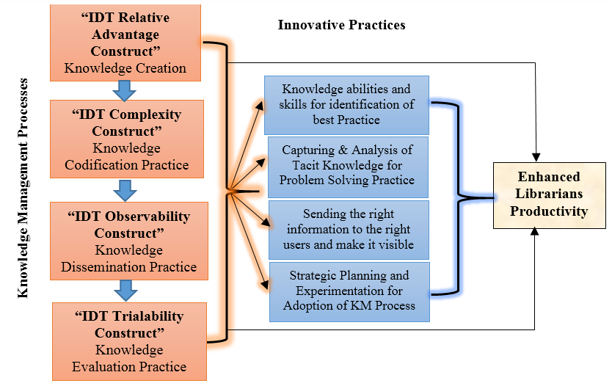
Figure 1: Conceptual Framework of the Study
The study assumed that the productivity of librarians will be enhanced through the adopting KM process which improves librarians' innovation, uniqueness, and competencies that lead to achieving a sound knowledge strategy for an overall organizational productivity. However, for yawning socialization to occur among librarians, there must be a culture of willingness and readiness to share, which may not be automatic. This model assumes that unless the owner of the knowledge has the culture of knowledge sharing, the idea of deep socialization and externalization of knowledge may not be attained which ultimately translates into an effective Knowledge Management Process that creates a value chain.

6. Knowledge Management Process and Factor Analysis Studies
Chicana-Huancaet al. (2022); Cruthaka's (2019) studies established that identifying KM factors is the first step necessary for KM instrument development. Exploratory and confirmatory factor analysis was carried out to validate the structural model. The results revealed that the most influential factors in the application of knowledge is the TAM’s perceived ease of use on knowledge sharing and perceived utility. This finding is in line with Gnawali’s (2020) investigation that knowledge management practices influence organizational performance in various ways including, knowledgeable employees and improved service offering to clients that leads to developing a culture of knowledge sharing and improved organizational competitiveness.
Rezaei, Khalilzadeh & Soleimani (2021); Saied et al. (2021); Li et al. (2020); supported that KM practices are positively related to performance. Abdul-Rauf, Jabar & Mansor (2020) extracted eight constructs including work coordination, communication, information system, knowledge sharing culture, MIS functionality, networking facilities, IT integration, and network capability using Exploratory Factor Analysis (EFA). These constructs were established as valid and reliable variables to be adopted on research instruments for measuring knowledge management process components. Alijanzadeh, Razavi & Limuni (2020) opined that components of knowledge management have direct influence on job performance with a predicted strength of over 37.6% for a competitive advantage in organizations.
The implication of the reviewed studies on the current investigation is that use and application of KM processes should be considered to measure technology experience in knowledge creation, collection, and access to knowledge sharing and transmission and dissemination of knowledge. From the knowledge gaps identified in the literature, the study will use the variables of KM practices for the knowledge value chain which include; Knowledge Generation/Creation, Knowledge Codification/Storage (capturing tacit knowledge, analysis, and structuring), Knowledge Sharing/Dissemination (right information to the right people), and Knowledge Evaluation as factors that influence productivity. Based on these variables identified in the literature, the study is proposing a framework model supporting KM practice for enhancing librarians’ productivity

7.0 Materials and Methods
This research was conducted through correlation research to show how strongly these variables relate to one another. The self-administered survey questionnaire was used for data collection. The questionnaire was adapted from studies of Abdul-Rauf, Jabar & Mansor’s (2020) which was modified to fit with the variable scope of the current research. The Cronbach’s Alpha analysis revealed an acceptable internal consistency of the items (α = 0.879); KM practice α = 0.870, Innovative practice α = 0.746, and KM productivity α = 0.875 while the Analysis of Variance (ANOVA) revealed P-value is ˂ α (f = 101.161, df = 206, p < 0.001); Data were analyzed quantitatively using descriptive statistics of measure of dispersion to summarize data and multiple regression analysis was used to analyze the research hypotheses. IBM SPSS Amos was used for the complex multivariate structural analysis to draw conclusions employing the exploratory factor analysis (EFA) technique to identify latent constructs for theory building and a confirmatory factor analysis (CFA) to assess the goodness-of-fit for the measurement model.
To calculate the sample size of the population whose degree of variability was not known, Cochran's (1977) formula for unknown proportions was taken n₀=z²p×q/e². The maximum variability taken was equal to 50% (p =0.5) at a 95% confidence level with ±5% precision (n₀= 1.96² × (0.5×0.5) / 0.05²) which gives a population of 384 respondents. Therefore, the sample size of the study stood at three hundred and eighty-four (384) librarians who attended the 60th national conference of the Nigerian Library Association (NLA) held in Abuja from 3rd – 8th July 2022. The survey questionnaires were distributed to Librarians who attended the 60th national conference of the Nigerian Library Association (NLA) held in Abuja from 3rd – 8th July 2022 at Bolton Events Center Wuse-Abuja, on the Theme: "Library and Information Services in the Development of Nigeria: 1962-2022".

7.1 Statistical Measures
To clarify the methodological concepts, basic guidelines for presenting and interpreting the results of these techniques were provided. Factor analysis examined the underlying complex, multidimensional relationships among knowledge management variables and condensed the information in to smaller set of components for model and instrument development.
To ensure the realistic and effective content of the research model, the questionnaire contained exogenous variables that were operationalized from the existing literature on knowledge management processes, innovative practice, and KM-sharing tools. To measure the 40 constructs items, containing 16 items related to the application of knowledge management processes, 20 items related to the innovation practices of librarians, and 4 items related to the influence of KM processes on the productivity of librarians. The study used a 7-point Likert scale ranging from 1 strongly disagree to 7 strongly agree to quantify the results. Content validity was done by content experts for feedback and comments and also to check the consistency as a pre-test for the instrument. After effecting the changes, the instrument was distributed to the 384 respondents with a returned rate of 207 copies. The number was enough for running factor analysis to examine underlying factors and their unidimensional attributes (Abdul-Rauf, Jabar & Mansor, 2020; Cruthaka, 2019; Awang, Lim and Zainudin, 2018).

7.2 Description Statistics and Regression Analysis
Descriptive analysis of research variables includes a basic explanation of the mean and standard deviation of the constructs of the 3 variables (Knowledge Management Processes, Innovative Practices, and Librarians' Productivity).
Table 1: Descriptive and Regression Analysis
Coefficientsª |  |  | Unstandardized Coefficients |  | Standardized Coefficients | T | Sig.
Model | Mean | Std. Deviation | B | Std. Error | Beta | T | Sig.
(Constant) |  |  | .783 | .099 |  | 7.897 | .000
KM Process | 4.3982 | 1.47085 | .346 | .059 | .348 | 5.899 | .001
Innovative Practices | 4.3239 | 1.67134 | .542 | .052 | .620 | 10.496 | .001
N | 207
a. Dependent Variable: Librarians’ Productivity
Out of the 207 valid analyzed instruments, the independent variables of KM process (KM creation, codification, dissemination, and evaluation) have mean=4.39, SD=1.47, and innovative practices have mean=4.32, SD=1.67 while the dependent variable of KM and innovative practices for librarians' productivity has mean=4.64, SD=1.46 on a 7-point Likert scale questionnaire. This shows that there is a high level of KM practice by librarians which enhances their productivity. The regression analysis to test the hypothesis of the study revealed that the knowledge management process (KM creation, codification, dissemination, and evaluation) (β=0.348, t=5.899, r²=0.909, p < .01, N = 207), as well as the innovative practices (β=0.620, t=10.496, r²=0.909, p < .01, N = 207), were found to be strongly correlated with librarians’ productivity. The correlation coefficient measures and revealed a strong and positive linear relationship between the KM and innovative practices variables on the dependent variable of enhancing librarians’ productivity. Ugwu & Ejikeme (2023) supported this finding that knowledge management have direct influence on organizational culture and significantly contributes to job performance.
The Beta coefficient of the KM process is 0.348 which shows that a 34.8 % change in librarians' productivity is caused by KM practices and the rest by external factors. The Beta coefficient for innovative practices is 0.620 which applies that 62.0% of changes in librarians' productivity are caused by innovative practices and the rest by external factors. This study concludes that librarians' productivity has a significant relationship with the knowledge management process (KM creation, codification, dissemination, and evaluation) and innovative practices. This finding is in line with Alijanzadeh, Razavi & Limuni (2020), and Gnawali (2020) who revealed that KM practices influence job and organizational performance.

7.2 Analysis and Results
All analyses were performed using SPSS and AMOS statistical software packages. The Kaiser-Meyer-Olkin Measure of Sampling Adequacy with an absolute value of factor loading greater than 0.5 and Bartlett's Test of Sphericity was used to assess the suitability of the data with Promax rotation and enforcing the 40 items grouped under 4-factor of KM practice, innovative practices, predictors of KM practices, influencing KM and innovative practices on improved productivity of librarians to reach a simpler factor structure to test the theoretical structure and instrument development. CFA was then performed to investigate the model's goodness of fit.

7.3 Exploratory Factor Analysis (EFA) Results
The analysis and findings from the EFA suggested that the first four factors have cumulative variance of 92.9% of The Kaiser-Meyer-Olkin Measure of Sampling Adequacy was 0.959, indicating that the sample was adequate. The study conducted parallel analysis to compare the eigenvalues from the data with those from randomly generated data to determine the number of factors to retain. The analysis used a web-based parallel analysis engine presented by Patil et al. (2017) that calculates eigenvalues from randomly generated correlation matrices.
Table 2: Parallel Analysis
Component or Factor | Randomly Generated Eigenvalues (Patil et al., 2017) | The Study’s  Eigenvalues
Factor 1 | 1.825028 | 15.549
Factor 2 | 1.710500 | 7.791
Factor 3 | 1.621765 | 4.134
Factor 4 | 1.547273 | 2.261
Factor 5 | 1.483161 | .960
Factor 6 | 1.424142 | .165
Factor 7 | 1.366463 | .161
Factor 8 | 1.313147 | .121
Factor 9 | 1.263967 | .095
Factor 10 | 1.217437 | .086
The study's eigenvalue in Factor 1 (15.549) Factor 2 (7.791), Factor 3 (4.134), Factor 4 (2.261), are significantly greater than the randomly generated eigenvalue of the corresponding factors confirming the importance of the factors to the study. The study's eigenvalue of Factor 5 (0.960) is less than the randomly generated eigenvalue for the corresponding factors (1.483161), indicating that the remaining factors does not contribute significantly to reducing number of underlying latent factors (or constructs) as hypothesized by the study and therefore, should not be retained. The four factors were retained for the analysis.
Table 3: Kaiser-Meyer-Olkin Measure of Sampling Adequacy
KMO and Bartlett's Test
Kaiser-Meyer-Olkin Measure of Sampling Adequacy. |  | .960
Bartlett's Test of Sphericity | Approx. Chi-Square | 17045.343
Bartlett's Test of Sphericity | Df | 465
Bartlett's Test of Sphericity | Sig. | .000
The results of Kaiser-Meyer-Olkin measure the sampling adequacy of the analysis revealed .960 KMO above the threshold value of 0.6 (Collier, 2020; Ullman, 2001), indicating that the sample size adopted by the study (207 respondents) was adequate and suitable for factor analysis.
Table 4: Factor Loading among the Four Variables and their Correlation
Item Codes | Items on the Instrument | Factor 1 | Factor 2 | Factor 3 | Factor 4
Predictor47 | Access to Technology and Digital Tools | .993
Predictor45 | Availability of Financial and Infrastructural Resources | .992
Predictor38 | Change Management Support | .990
Predictor49 | Leadership Support and Vision | .988
Predictor48 | Training and Professional Development | .986
Predictor44 | Collaboration and Teamwork. | .986
Predictor39 | Effective Communication Channels | .985
Predictor43 | User-Centered Approach | .981
Predictor40 | Institutional KM Strategy and Policies | .979
Predictor46 | Motivation and Incentives for Innovation | .974
Predictor37 | Cross-Disciplinary Knowledge Integration | .974
Predictor41 | Organizational Culture of Learning and Innovation | .968 | Factor 1: Predictors of KM Practice (12 Items)
KM11 | Capturing Tacit Knowledge through Mentorship and Collaboration |  | .986
KM4 | Knowledge Mapping and Expertise Location Systems |  | .977
KM17 | Content Curation and Personalized Resource Recommendations |  | .975
KM18 | Implementation of Document and Content Management Systems |  | .965
KM6 | Knowledge Audits and Gap Analysis |  | .960
KM9 | Fostering Knowledge Sharing Communities of Practice |  | .959
KM12 | Knowledge Taxonomy Development and Metadata Standardization |  | .957
KM3 | Embedded Librarianship in Research Teams |  | .956
KM7 | Use of Collaborative Wikis and Knowledge Portals |  | .944
KM10 | Knowledge Sharing through Peer Review and Feedback Loops |  | .930 | Factor 2: KM Processes (10 Items)
Innovate24 | Adopting Artificial Intelligence for Personalized Services |  |  | .973
Innovate23 | Facilitating Knowledge Transfer through Collaborative Platforms |  |  | .972
Innovate25 | Developing and Managing Digital Literacy Programs |  |  | .972
Innovate27 | Web Portal Services, Blogging Skills, and Gamification of Literacy Programs |  |  | .966
Innovate22 | Knowledge Sharing through Creation of Subject-Based Library Guides | Factor 3: Innovative Practices (5 Items) |  | .964
Product28 | Availability of advanced digital tools facilitates effective KM and innovation, improving librarians' ability to manage and share information |  |  |  | .991
Product33 | Continuous learning and openness to change encourages librarians to adopt KM practices and innovative solutions |  |  |  | .989
Product31 | Sharing ideas and expertise through teamwork foster innovation and improve the collective performance of library staff |  |  |  | .982
Product32 | KM strategies and policies that align with organizational goals encourages the use of KM processes and innovation | Factor 4: Productivity of Librarians as a Result of Practicing KM (4 Items) |  |  | .980
Extraction Method: Principal Axis Factoring.
Rotation Method: Promax with Kaiser Normalization.
a. Rotation converged in 6 iterations.
The relationship between KM processes, creative practices, and librarian productivity is revealed by the pattern mix of the EFA as shown in Table 4. The factor loading matrix reveals underlying patterns that account for the variance in the data by displaying how various items (predictors) cluster under various factors.
Factors including collaboration, leadership support, training, and technological access are among the predictors of knowledge management practices. Factor 1, which represents the primary predictors of knowledge management techniques, is strongly correlated with these items, as indicated by their high factor loadings (above.960). The effectiveness with which KM processes are applied in the library setting is largely determined by these predictors.
Specialized knowledge management practices like content curation, knowledge mapping, and community building are correlated with Factor 2 which represent the major KM processes. The high factor loadings suggests that these processes work together to provide a coherent system for efficiently managing knowledge in a library environment.
Innovative practice factors—adopting artificial intelligence (AI), overseeing digital literacy initiatives, and utilizing subject-based library guides—emphasize the importance of innovation. The loadings in this component imply that these cutting-edge methods are essential for improving the exchange and management of knowledge within the library.
The direct effect of KM and innovative approaches on librarians' productivity is shown in Factor 4 which represent the productivity of librarians. Items such as continuous learning, availability of digital tools, and sharing ideas through teamwork with strong factor loadings suggests that librarians who are innovative perform efficiently with quality of service.
This reflects the real-world interdependence between innovative KM processes and librarians’ productivity. Access to technology (Factor 1) can influence innovative practices (Factor 3), and the successful application of these factors results in higher productivity (Factor 4). A strong knowledge management system reinforced by creativity greatly improves performance of librarian.

7.4 Confirmatory Factor Analysis (CFA) Results
The ratio between χ2 and degrees of freedom, the comparative fit index (CFI), the goodness-of-fit index (GFI), the root mean square residual (RMR) fit, and the mean square error of approximation (RMSEA) was considered, following the criteria for the goodness of fit proposed by Hair et al. (1998); Barbara & Byrne (2001); Bentler (1995; West et al., 2012).
Table 5: Goodness-of-Fit Indices for Factor Models
Name of Index | Index Full Name | Accepted Fit | Model Indices Value
χ2/df | Normed chi-square (CMIN/DF) | ≤ 3 it indicates an acceptable fit  ≤ 5 it indicates a reasonable fit | 1.389
CFI | Comparative Fit Index | ≥ 0,90 indicates an acceptable fit  ≥ 0,95 is considered an excellent fit | 0.991
TLI | Tucker Lewis Index | ≥ 0,9 indicates a reasonable fit  ≥ 0,95 is considered an excellent fit | 0.990
PCFI | Comparative Fixed Parsimony Index | PCFI value of 0.6 or higher indicate acceptable model fit | 0.901
RMSEA | Root Mean Square Error of Approximation | ≤ 0,05 are considered excellent  ≤ 0,08 are considered acceptable | 0.043
PGFI | Parsimony Goodness of Fit Index / | ≥ 0.5 indicates a reasonable fit  = 1 is considered a perfect fit | 0.832
The χ²/df ratio of 1.389 is below the threshold of 3, indicating a good fit indices between the observed data and the proposed model. This suggests that the model explains the variance in innovative KM practices effectively without being overly complex. The TLI (Tucker Lewis Index) value of 0.990 also indicates an excellent fit, suggesting that the model is well-specified and reflects the structure of innovative KM practices effectively.
RMSEA (Root Mean Square Error of Approximation) value of 0.043 indicates an excellent fit. This means that the model has minimal error in approximation and confirms the appropriateness of the proposed model. All indices in these analysis point to a well-fitting model, suggesting that the proposed model for innovative KM practices in academic libraries effectively captures the key variables and their interrelationships. The confirmatory factor analysis results confirm that the proposed model on innovative KM practices is robust and well-aligned with the observed data.
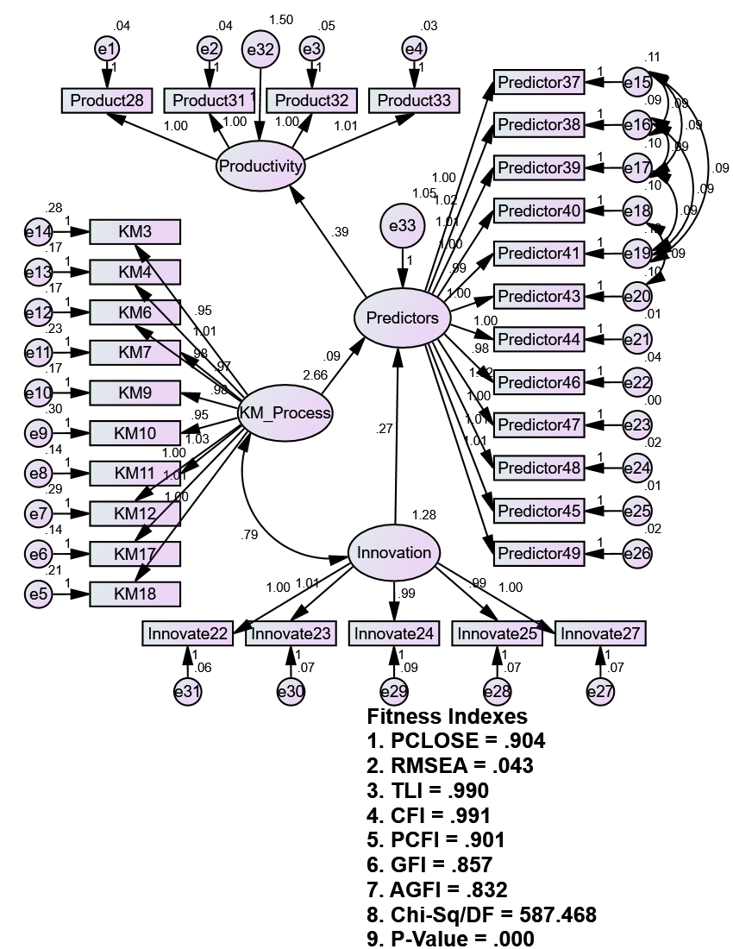
Fig 2: Path Analysis
7.5 Innovative Knowledge Management Practices
In line with the findings of the current investigation and the factor analysis, the major innovative KM practices include the following:
- Knowledge Sharing through Social-Media and Blogs: By sharing resources, trends, and advancements in a variety of subjects through blogs, webinars, and social media platforms, librarians promote the diffusion of knowledge outside of the library.
- Implementing Cloud-Based and Creation of Subject-Based Library Systems: The process of converting conventional Integrated Library Systems (ILS) to cloud-based platforms allows patrons and library employees to access library materials and services remotely, improving accessibility. Additionally, it gives users rapid access to important information and resources for study and research needs.
- Facilitating Knowledge Transfer through Collaborative Platforms: Utilizing institutional intranets, Microsoft Teams, Slack, and other collaborative tools to encourage in-the-moment knowledge exchange and cooperation between library personnel and users.
- Developing and Managing Digital Literacy Programs: To give people the skills they need to navigate the ever-expanding digital information ecosystem, librarians offer training in digital literacy and information literacy.
- Adopting Artificial Intelligence for Personalized Services: providing library patrons with individualized search help, research support, and resource discovery through the use of AI-driven chatbots or other recommended systems.
- Data Curation and Research Data Management Services: providing data curation services that improve the usability and lifespan of academic data for future research, such as organizing, conserving, and making research data available.
- Gamification of Information Literacy Programs: employing gamification strategies to engage users and enhance their information-seeking and knowledge-management abilities, such as interactive modules, quizzes, and prizes.

8. The Proposed Framework
This framework showed the proposed four factors can enhance librarians’ productivity. The findings of the study revealed that knowledge is a fluid mix of regular experiences, values, and conceptual information that provides a framework for evaluation and decision-making. To enhance the provision of the knowledge inventory using strategic objectives, a distinction was made between organizational and shared knowledge. The needed knowledge is then compared with the available knowledge to make clear the ‘knowledge gap’. The knowledge gap will be used to identify what knowledge development is needed in the libraries to be shared to create knowledge value. Librarians should familiarize themselves with the available information, experiences, and skills. At the end of each process, evaluation is required which will enable knowledge development and possible adjustments.
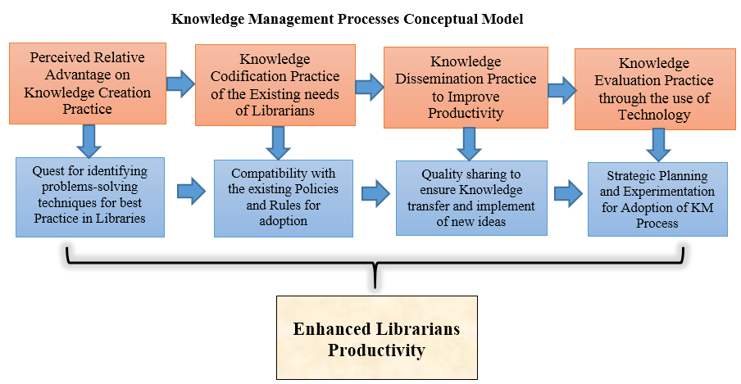
Fig. 3: Innovative KM Process Conceptual Framework (Source: The Researchers)
The perceived relative advantage of knowledge creation for solving a practical problem can influence the adoption of the KM process characterized by the development of new knowledge, abilities, and skills of librarians. The codification of the existing values, needs, and experiences of librarians to ensure their compatibility with the existing policies or rules in the library influences the processes and practices of KM in libraries. The dissemination process as the outcomes of these innovations improves productivity and librarians’ performance while knowledge evaluation is a factor that influences productivity which can be experimented with the use of technological advancements. This framework provides an all-inclusive understanding of the adoption of KM and innovative practices in Nigerian libraries.

9. Practical Implications
Factor analysis is used to answer research questions involving direct or indirect observation of one or more independent variables to validate the cause-and-effect relationship. Therefore, the findings improve the understanding of innovative and KM practices and align them to improvement in the productivity of librarians, thus, contributing to the existing literature. The study confirmed that organizational structure must be sufficiently flexible and dynamic, so that communication is not limited to a team or departmental boundaries, but rather penetrate the outside environment. These relationships will inform library administration, innovators, and project managers about the appropriate investment in KM practices in their daily transactions.
The study explores constructs for the development of KM research instruments from the library's perspective. This presents a practical implication for KM researchers in the library domain to pretest the instrument for validation. Innovative capabilities and knowledge management practice capabilities when coherently aligned will allow librarians and other information practitioners to have cohesive strategies, optimize information resource utilization, avoid redundancy of effort, and improve access to highly scarce and skilled IT. The identified variables have the latent to serve as the basis for establishing perceptions of assessment strategies and informing KM practices and policies which maximize these capacities in extension services.

10. Theoretical Implications
The findings conceptualize dimensions of knowledge management via social interaction. While various studies have been conducted to analyze the KM capacity networks, the current study introduces exploratory results for KM instruments and model development to discretely quantify perceptions of KM and innovative practice capacity in libraries in Nigeria.

11. Limitations for Further Studies
Although the sample size adopted by the study was acceptable, the potential bias existed of not including all categories of librarians, which was a possibility to the limitation of the study. This research was conducted at a specific time frame during a conference, which may yield different results at other times since other settings might have different cultures and structures, thus, its generalizability is limited to other similar contexts.

12. Conclusions and Recommendations
This study aimed to explore the influence of the knowledge management process and innovative practice on the productivity of librarians. Knowledge Management is seen as a multifaceted area that functions as a tool for identifying appropriate solutions to organizational problems from an available pool of knowledge items. Especially for libraries that must create and manage vast knowledge resources, different categories of users, and a competitive IT environment. The findings from this study developed a KM research instrument within the library context which will address the shortcomings of the lack of a comprehensive instrument for conducting the KM process and innovative practice research within the library context.
The conclusions of this paper illustrate that the developed framework can enhance the performance of librarians significantly through well planned innovative KM researches in generating and implementing new empirical ideas. KM practice is an important mechanism for increasing the productivity of librarians and increasing the effectiveness of libraries in the era of rapid technological development. Libraries with vibrant knowledge management strategies can achieve better administrative capacity and the adaptation of technical skills to increase productivity and organize human resources to strengthen connections with innovation. The following are recommendations arising from the study:
The most important strategies needed to improve capability of KM practice are the involvements of top management, organizational culture, necessary staff skills, transformation, and change management. The study recommended that when implementing innovative KM practices in libraries, KM practice should be aligned with the appropriate innovative practice, using their order of importance to prioritize implementation.

Conflicts of Interest
No potential conflict of interest relevant to this article was reported. The development of the article was fully funded by the authors.
Data Availability
The data used in this study for both the factor analysis and descriptive statistics are available.
Funding
This research did not receive any external funding. It was fully supported and financed by the researchers.

Reference
Abubakar, A. M., Elrehail, H., Alatailat, M. A., and Elçi, A. (2019) Knowledge management, decision-making style, and organizational performance; Journal of Innovative Knowledge 4, 104–114. doi: 10.1016/j.jik.2017.07.003
Alijanzadeh, E., Razavi, A.S. & Limuni, S.T. (2020) Predicting Job Performance Based on Knowledge Management. Journal of Management and Accounting Studies 8(4) 34–38, DOI: https://doi.org/10.24200/jmas.vol8iss04pp34-38
Ayodele, S. K., & Ajayi, J.L. (2021). Emotional Intelligence, Knowledge Sharing and Productivity of Librarians in Selected Academic Libraries in Ondo State, Nigeria. International Journal of Academic Libraries and Information Science 9(9): 439-454 https://doi.org/10.14662/ijalis2021415
Chicana-Huanca, S., Gutierrez-Aguilar, O., Ticona-Apaza, F., Calliñaupa-Quispe, G. & Chicana-Huanca, B. (2022) "Influential Factors in Knowledge Management in the Acceptance of M-Learning in University Students," 2022 17th Iberian Conference on Information Systems and Technologies (CISTI), Madrid, Spain. pp. 1-4, DOI: 10.23919/CISTI54924.2022.9820224
Cochran, W.G. (1977) Sampling Techniques. 3rd Edition, John Wiley & Sons, New York.
Cruthaka, C. (2019). The Factor Analysis of Knowledge Management Process for Public University Lecturers in Bangkok. Asian Journal of Education and Training, 5(3): 403-407.
Diab, Y. (2021) The Concept of Knowledge Sharing in Organizations (Studying the Personal and Organizational Factors and Their Effect on Knowledge Management) Management Studies and Economic Systems (MSES), 6 (1/2), 91-100 file:///C:/Users/Hp/Downloads/PublicationofKnowledgemanagement.pdf
Elezi, E. & Bamber, C. (2018) A Guiding Conceptual Framework for Individualized Knowledge Management Model Building. Management Dynamics in the Knowledge Economy 6(3), pp.343-369; DOI 10.25019/MDKE/6.3.01
Ghosh, P., Milton, T. & Mohanta, G.C. (2024) The Factors Influencing Effectiveness of Knowledge Management (KM) in Organizations. International Journal for Multidisciplinary Research (IJFMR), 6(1), 1-10. https://www.ijfmr.com/papers/2024/1/12077.pdf
Gnawali, A. (2020) Knowledge Management Practices and Its Impact on the Performance of IT Companies in Nepal. East African Scholars Journal of Economics, Business and Management; 3(6): 530-537. DOI: 10.36349/EASJEBM.2020.v03i06.072
Inków, M. (2020) Organizational innovation capability as a result of knowledge management processes - a literature review. Management 24(1) 143-156. DOI: 10.2478/manment-2019-0040
Israel, G.D. (1992) Determining Sample Size. University of Florida Cooperative Extension Service, Institute of Food and Agriculture Sciences, EDIS, Florida.
Li, C., Ashraf, S.F., Shahzad, F., Bashir, I., Murad, M., Syed, N. & Riaz, M. (2020) Influence of Knowledge Management Practices on Entrepreneurial and Organizational Performance: A Mediated-Moderation Model. Frontiers in Psychology 11(577106) 1-15 doi: 10.3389/fpsyg.2020.577106
Mittal, S. & Kumar, V. (2019) Study of Knowledge Management Models and their Relevance in Organisations; Int. J. Knowledge Management Studies, 10(3) 322-335
Munir, S. (2022) Dummies Guide to Best Practices in Knowledge Management; Retrieved from https://blog.vidizmo.com/knowledge-management-best-practices (Accessed on 30th July 2022)
Olayemi, O.M. & Olayemi, K.J. (2021) Knowledge sharing practices among African health sciences librarians; Journal of the Medical Library Association JMLA, 109(4) 624-630 DOI: dx.doi.org/10.5195/jmla.2021.1183
Rezaei, F., Khalilzadeh, M. & Soleimani, P. (2021) Factors Affecting Knowledge Management and Its Effect on Organizational Performance: Mediating the Role of Human Capital; Hindawi Advances in Human-Computer Interaction 1-16 https://doi.org/10.1155/2021/8857572
Saied, M.A.A., Wahba, M., Abdel-Bary, A.A.W. & Ghanem, A.N. (2021) The Impact of Knowledge Management on Service Quality: The Mediating Role of Organization Learning (Applied Study: Alexandria Water Company). Open Access Library Journal, 8(e7683) 1-15 https://doi.org/10.4236/oalib.1107683
Tahleho, T.E. & Ngulube, P. (2022) Knowledge Sharing and the Improvement of Service Delivery in an Academic Library; International Journal of Knowledge Management 18(1) 1-13 DOI: 10.4018/IJKM.291704
Ugwu, C. I., & Ejikeme, A. (2023). Knowledge management, organizational culture and job performance in Nigerian university libraries. IFLA Journal, 49(1), 99–116. https://doi.org/10.1177/03400352221103896

