Strategic Budgetary Control Practices and the Organisational Financial Performance of Listed Agriculture and Consumer Goods Firms in Nigeria: The Moderating Effect of Artificial Intelligence Adoption
Ganiyu A. Mustapha ganiyumustapha84@gmail.com
Oluwaseun A. Ige igeseun@aol.com
Maria David Barau baraumaria@gmail.com
Ambrose Maduabuchi Ogbonnaya maduogb67@gmail.com
Oriloye Muyiwa James funshlaw@gmail.com
ANAN University, Kwall, Jos, Nigeria
Abstract
Listed agriculture and consumer goods firms in Nigeria have absorbed successive shocks from currency depreciation, input-cost inflation, and foreign exchange scarcity, conditions under which the quality of budgetary control ought to separate resilient firms from fragile ones. Whether it does, and whether artificial intelligence changes the calculus, remains unsettled. This study examined the effect of strategic budgetary control practices on organisational financial performance and the moderating role of artificial intelligence adoption. From an accessible population of 135 finance-function principals in listed agriculture and consumer goods firms on the Nigerian Exchange, a sample of 101 was determined through the Taro Yamane formula and drawn purposively. Primary data from a structured five-point Likert questionnaire were analysed with partial least squares structural equation modelling in SmartPLS. The measurement model satisfied indicator reliability, internal consistency, and convergent validity, and discriminant validity held under both the Fornell and Larcker criterion and the HTMT ratio. Budget planning quality (β = 0.301, p < 0.001), budget performance evaluation (β = 0.268, p < 0.01), and budget monitoring and control (β = 0.214, p < 0.01) each raised financial performance, with planning quality the strongest antecedent. Artificial intelligence adoption strengthened the budgetary-control-to-performance relationship as a moderator (β = 0.158, p < 0.05) and acted directly on performance (β = 0.187, p < 0.05). The financial dividend of budgetary discipline is fullest where firms have equipped that discipline with intelligent tools. The study recommends stronger budget planning, disciplined monitoring, rigorous performance evaluation, and deliberate investment in artificial intelligence capability.
Keywords: strategic budgetary control; budget planning quality; budget monitoring and control; budget performance evaluation; artificial intelligence adoption; organisational financial performance
Introduction
Few instruments of financial management have proved as durable as the budget. Across advanced and emerging economies alike, the disciplined planning, monitoring, and evaluation of resources remains the mechanism through which strategy is priced, execution is tracked, and managers are held to account (Drury, 2021; Otley, 2016). Yet the environment in which budgets now operate has changed faster than the practice itself. Data volumes have multiplied, competition has intensified, and the intervals over which a firm can afford to discover a variance have shortened, so that the intuitive, spreadsheet-bound budgeting of an earlier era increasingly struggles to keep pace. The international response has been to fold analytics and artificial intelligence into the control cycle, turning what was once a periodic and backward-looking ritual into something closer to continuous, forward-looking guidance.
Strategic budgetary control describes the deliberate use of the budget as an instrument of strategy rather than a routine of bookkeeping. It is best understood as an integrated cycle of three practices: the formulation of high-quality plans, the continuous monitoring of execution against those plans, and the evaluation of outcomes once results are known. Treating the cycle as a single undifferentiated block obscures the fact that firms can, and do, resource each practice separately, investing heavily in planning while neglecting evaluation, or monitoring diligently against plans that were poorly constructed in the first place. This study therefore resolves strategic budgetary control into its three constituent dimensions and examines the contribution of each to financial performance.
The first dimension, budget planning quality, concerns the realism, comprehensiveness, participation, and strategic alignment with which budgets are formulated. Planning is the point at which strategy is either translated into financially coherent targets or left as aspiration, since only a well-constructed budget directs scarce resources towards value-creating activity (Drury, 2021). A budget built on unrealistic assumptions cannot be rescued by any amount of subsequent vigilance, which is why the quality of preparation is widely regarded as the foundation on which the rest of the control cycle stands.
The second dimension, budget monitoring and control, shifts attention from the design of the budget to its enforcement. It captures the regularity with which actual results are compared against plan, variances are investigated, and corrective action is taken. Monitoring earns its value where conditions move quickly, because timely variance analysis exposes deviations while they can still be corrected rather than after they have hardened into losses (Otley, 2016). A firm that watches its budget continuously converts the plan from a static document into a live instrument of control.
The third dimension, budget performance evaluation, concerns the use to which budget outcomes are put once results are known. It asks whether performance against budget informs the appraisal of departments and managers, feeds decision-making, and carries consequence through reward or sanction. Evaluation closes the control loop, since a budget that is planned and monitored but never used to hold anyone to account exerts little behavioural pull. Where evaluation is rigorous and tied to accountability, managerial effort aligns with financial objectives and the lessons of one cycle are absorbed into the next.
Organisational financial performance is the outcome against which these practices must ultimately be judged. It denotes the degree to which a firm attains its profitability, liquidity, efficiency, and growth objectives through the deployment of scarce resources (Okafor & Adebayo, 2025). Performance so defined is sensitive to the maturity of a firm's planning and control systems, and in developing economies the stakes are higher rather than lower. Where capital is thin, forecasting infrastructure is weak, and macroeconomic conditions swing sharply, a poorly planned or loosely monitored budget carries consequences that a firm in a stable market might absorb without notice (World Bank, 2024). The premium on getting budgetary control right therefore rises precisely in the settings least equipped to guarantee it.
Artificial intelligence adoption enters this account as the newest and least settled ingredient. Adoption denotes the integration of predictive analytics, automated forecasting, and machine-learning-enabled reporting into the financial-control process (Babina et al., 2024; Cimino et al., 2025). Intelligent tools forecast more accurately than manual extrapolation, flag variances in real time rather than at month end, and surface patterns in cost and revenue behaviour that human review would miss. In principle, therefore, artificial intelligence reconstructs budgetary control as a predictive rather than a retrospective discipline.
It is this reconstruction that motivates the study's central question of moderation. If artificial intelligence merely added to performance alongside budgetary control, its adoption would be one investment among many. The more consequential possibility is that it conditions the payoff to budgetary discipline itself, so that the same planning, monitoring, and evaluation practices yield a larger performance return when they are powered by intelligent tools. Under that reading, two firms with identical control systems could earn very different returns on them, depending on the technological capability each brings to bear. Whether that conditioning effect is realised in practice is an open empirical question, and answering it requires modelling artificial intelligence adoption as a moderator rather than a mere covariate.
Nigeria presents this tension at its sharpest. The years from 2023 carried listed firms through unusually punishing conditions: the naira lost much of its value before stabilising, headline inflation averaged close to 23 per cent in 2025 ahead of a statistical rebasing that eased the measured rate towards 15 per cent by early 2026, and foreign-exchange scarcity squeezed importers of raw materials (Central Bank of Nigeria, 2025; National Bureau of Statistics, 2026). Those pressures compressed margins across the market, yet the recovery, when it came, was uneven and revealing. The Nigerian Exchange All-Share Index returned roughly 51 per cent in 2025 and real output grew by about 4 per cent in the final quarter of the year, but the gains accrued disproportionately to firms that had planned and controlled well (Nigerian Exchange, 2025). Agriculture and consumer goods firms sit at the centre of this account. They are among the most exposed to imported-input costs and exchange-rate pass-through, and among the most essential to domestic livelihoods: agriculture alone contributed roughly a quarter of nominal output in late 2025, while consumer goods companies account for close to a quarter of the Exchange's market capitalisation (National Bureau of Statistics, 2026; PwC, 2025). Concentrating on these firms therefore isolates a setting in which budgetary control is at once most tested by volatility and most consequential for performance.
Three gaps sharpen the enquiry. Empirically, no study has yet tested with primary data and variance-based structural equation modelling whether artificial intelligence adoption moderates the link between budgetary control practices and financial performance among Nigerian listed agriculture and consumer goods firms. Conceptually, budgetary control has often been treated as a single block rather than resolved into its distinct planning, monitoring, and evaluation dimensions, each of which a firm can resource independently (Akinadewo et al., 2024; Okpolosa, 2022). Contextually, the available Nigerian evidence rests largely on banks and on manufacturing broadly, leaving the agriculture and consumer goods space at the heart of the recent macroeconomic rebound comparatively unexamined.
The problem this study confronts is the gap between practice and payoff. Budgetary control is nearly universal among listed firms, and yet its contribution to financial performance is anything but uniform. Some firms convert planning, monitoring, and evaluation into profitability while others, using ostensibly similar systems, do not. What increasingly distinguishes the two appears to be the technological capability that surrounds the budget, and above all the adoption of artificial intelligence in forecasting, variance analysis, and reporting. Until the moderating role of that capability is established empirically for the Nigerian real sector, boards and regulators cannot know whether investment in intelligent tooling is a genuine lever for converting budgetary discipline into measurable performance or merely a fashionable expenditure.
Against this background, the purpose of the study is to examine the effect of strategic budgetary control practices on the organisational financial performance of listed agriculture and consumer goods firms in Nigeria, and the moderating effect of artificial intelligence adoption on that relationship. The specific objectives are to:
i. examine the effect of budget planning quality on the organisational financial performance of listed agriculture and consumer goods firms in Nigeria;
ii. assess the effect of budget monitoring and control on the organisational financial performance of listed agriculture and consumer goods firms in Nigeria;
iii. evaluate the effect of budget performance evaluation on the organisational financial performance of listed agriculture and consumer goods firms in Nigeria; and
iv. examine the moderating effect of artificial intelligence adoption on the relationship between strategic budgetary control practices and the organisational financial performance of listed agriculture and consumer goods firms in Nigeria.
Research Questions
In line with the specific objectives, the study seeks answers to the following research questions:
RQ1: What is the effect of budget planning quality on the organisational financial performance of listed agriculture and consumer goods firms in Nigeria?
RQ2: What is the effect of budget monitoring and control on the organisational financial performance of listed agriculture and consumer goods firms in Nigeria?
RQ3: What is the effect of budget performance evaluation on the organisational financial performance of listed agriculture and consumer goods firms in Nigeria?
RQ4: What is the moderating effect of artificial intelligence adoption on the relationship between strategic budgetary control practices and the organisational financial performance of listed agriculture and consumer goods firms in Nigeria?
The corresponding null hypotheses are developed and stated within the literature review that follows, and each is tested in the results and discussion section so that objectives, research questions, hypotheses, results, and discussion remain in strict alignment throughout the paper.
Literature Review and Hypothesis Development
Conceptual Framework
Figure 1 sets out the relationships tested in this study. Three dimensions of strategic budgetary control, namely budget planning quality, budget monitoring and control, and budget performance evaluation, are modelled as direct antecedents of organisational financial performance, while artificial intelligence adoption is positioned both as a direct influence on performance and as a moderator that conditions the strength of the budgetary-control-to-performance relationship. The framework is additive on the budgetary-control side and interactive on the technology side, reflecting the study's contention that a control practice and the capability to exploit it are analytically separate.
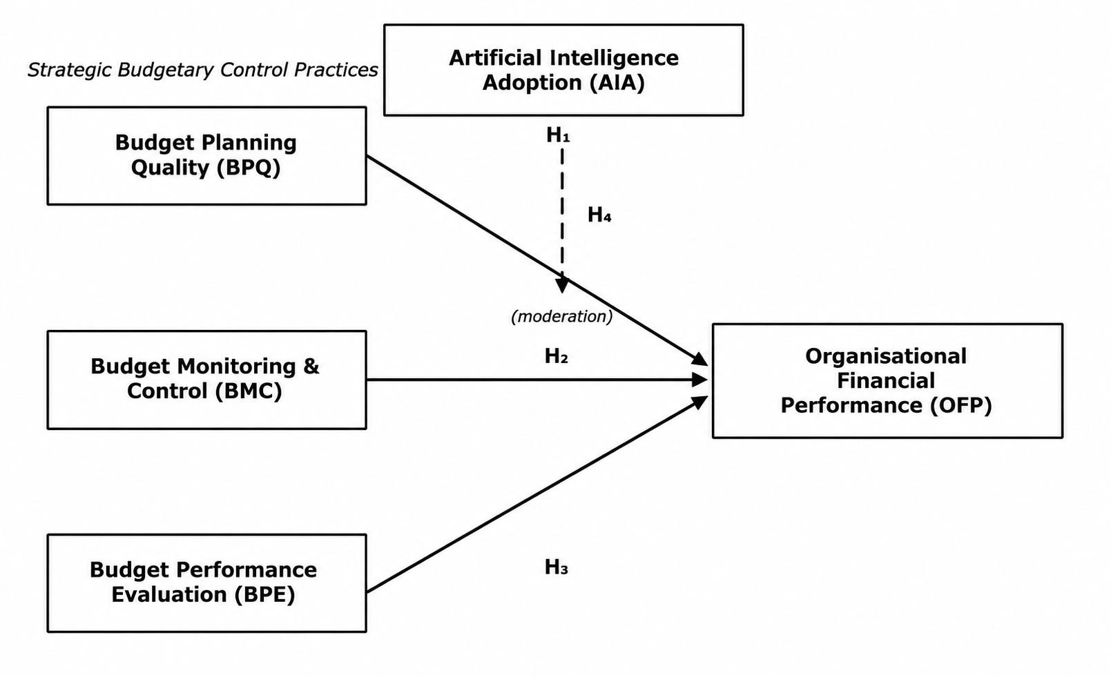
Figure 1: Conceptual Framework of the Study
Organisational Financial Performance
Financial performance is read here as an outcome rather than an activity: the degree to which a firm attains its profitability, liquidity, efficiency, and growth objectives through the deployment of scarce resources (Drury, 2021). For listed agriculture and consumer goods firms, the construct is best captured operationally through perceived profitability, cost efficiency, liquidity adequacy, and revenue or asset growth relative to expectation. The choice of perceptual measurement is deliberate. Audited ratios record what happened, but they cannot distinguish the contribution of the control system from that of market conditions, whereas finance principals who operate the budget daily are well placed to judge whether performance reflects the discipline of the process behind it. Performance so defined is sensitive to the maturity of a firm's planning and control systems and to the integrity of the budgetary process that underpins them (Otley, 2016), and it is measured in this study through respondents' assessments of those qualities.
Budget Planning Quality and Financial Performance
The first dimension concerns the realism, comprehensiveness, participation, and strategic alignment with which a firm formulates its budgets. Planning quality is the point at which strategy is either translated into financially coherent targets or left as aspiration, since only a well-constructed budget directs scarce resources towards value-creating activity (Drury, 2021). Where planning is participative and forward-looking, resources are allocated efficiently and performance strengthens; where it is perfunctory, the budget guides little. The empirical record supports this reading. Okpolosa (2022) found that a sound budgetary control system, beginning with the quality of preparation, improved the financial performance of listed manufacturing firms in Nigeria, while Okafor and Adebayo (2025) showed that effective budgetary control promotes resource optimisation and strategic adaptability among listed firms, and Ajibola et al. (2024) reached a similar conclusion for financial-management outcomes. What these studies share, and what matters for the present argument, is the implication that planning is not a clerical preliminary but the stage at which most of the budget's eventual value is either created or forfeited. These considerations yield the first null hypothesis, Ho1: Budget planning quality has no significant effect on the organisational financial performance of listed agriculture and consumer goods firms in Nigeria.
Budget Monitoring and Control and Financial Performance
The second dimension shifts from the design of the budget to its enforcement: the regularity with which actual results are compared against plan, variances investigated, and corrective action taken. Monitoring earns its value where conditions move quickly, because timely variance analysis exposes deviations while they can still be corrected rather than after they have hardened into losses (Otley, 2016). A firm that watches its budget continuously converts the plan from a static document into a live instrument of control, and in a volatile operating environment such as Nigeria's the interval between deviation and detection is itself a determinant of how much value monitoring can protect. Akinadewo et al. (2024) associated active budgetary monitoring with stronger financial discipline and performance, while Bisogno and Cuadrado-Ballesteros (2022) linked transparent, continuously reviewed budgeting to governance quality and fiscal outcomes. On this basis the second null hypothesis states, Ho2: Budget monitoring and control has no significant effect on the organisational financial performance of listed agriculture and consumer goods firms in Nigeria.
Budget Performance Evaluation and Financial Performance
The third dimension concerns the use to which budget outcomes are put once results are known: whether performance against budget informs the appraisal of departments and managers, feeds decision-making, and carries consequence through reward or sanction. Evaluation closes the control loop, since a budget that is planned and monitored but never used to hold anyone to account exerts little behavioural pull (Otley, 2016). Where evaluation is rigorous and tied to accountability, managerial effort aligns with financial objectives, and it is this behavioural channel, rather than the arithmetic of variance reports, that gives evaluation its force. Okpolosa (2022) reported that linking budget performance to responsibility strengthened the financial results of Nigerian manufacturing firms, and Omemgbeoji and Ofor (2024) found that systematic budget evaluation improved firm effectiveness. The third null hypothesis follows, Ho3: Budget performance evaluation has no significant effect on the organisational financial performance of listed agriculture and consumer goods firms in Nigeria.
Artificial Intelligence Adoption as Moderator
The three budgetary dimensions describe what a firm does; artificial intelligence adoption describes how intelligently it does it. Adoption here denotes the integration of predictive analytics, automated forecasting, and machine-learning-enabled reporting into the financial-control process (Babina et al., 2024; Cimino et al., 2025). Its moderating role follows from a simple observation: the same planning, monitoring, and evaluation practices yield a larger performance return when they are powered by tools that forecast more accurately, flag variances in real time, and surface patterns that manual review would miss. Babina et al. (2024) demonstrated that artificial intelligence adoption raises firm growth and productivity, and Cimino et al. (2025) showed that intelligent technologies function as a dynamic capability that amplifies the effect of managerial practices on performance, a result echoed for Nigerian manufacturing by Omemgbeoji and Ofor (2024). Read together, these studies imply that artificial intelligence does not merely add to performance but conditions the payoff to budgetary discipline. That implication, if confirmed, would mean the return on budgetary control is partly a technology decision, which is precisely what the fourth null hypothesis tests, Ho4: Artificial intelligence adoption has no significant moderating effect on the relationship between strategic budgetary control practices and the organisational financial performance of listed agriculture and consumer goods firms in Nigeria.
Theoretical Framework
The study takes its primary logic from the dynamic capabilities theory advanced by Teece, Pisano, and Shuen (1997) and extended by Teece (2007), which holds that advantage in changing environments rests on a firm's capacity to sense opportunities and threats, seize them, and reconfigure its resource base accordingly. Strategic budgetary control fits this account well. Budget planning represents the sensing of future conditions, monitoring and control the seizing and continual adjustment of resources, and performance evaluation the reconfiguration through which lessons are absorbed into the next cycle (Eisenhardt & Martin, 2000). The theory's central claim, that capabilities deliver advantage only when a firm can renew them against a shifting environment, supplies the warrant for treating artificial intelligence adoption as a moderator rather than a mere covariate: intelligent tooling is the enabling capability that determines whether budgetary routines are exercised statically or dynamically.
Contingency theory complements this view by insisting that no single control configuration suits every setting; effectiveness depends on the fit between a firm's control system and the conditions it faces (Donaldson, 2001; Otley, 2016). Where dynamic capabilities theory explains why budgetary control should raise performance, contingency theory explains why identical practices perform unevenly across firms and environments, and why the volatile Nigerian macroeconomic setting rewards firms whose controls are both disciplined and technologically adaptive. Together the two perspectives ground the moderated model estimated below.
Research Method
The study adopted a cross-sectional survey design grounded in the positivist paradigm, a choice suited to testing hypothesised relationships among latent constructs measured at a single point in time. The population comprised the agriculture and consumer goods firms listed on the Nigerian Exchange as of January 2026, and within those firms the respondents of interest were finance-function principals, including chief financial officers, financial controllers, finance and budget managers, management accountants, internal auditors, financial planning and analysis managers, and heads of finance. These officers were targeted because of their direct responsibility for budgeting and financial control, which positions them to assess both the quality of their firms' budgetary practices and the technological capability supporting them. The accessible population was 135 such respondents across the listed firms in the two sectors.
Purposive sampling was employed to reach respondents with direct budgetary responsibility, and the sample size of 101 was determined by applying the Taro Yamane (1967) formula to the accessible population at a 5 per cent margin of error. This sample also exceeded the minimum requirements recommended by Hair et al. (2022) for variance-based structural equation modelling, both under the ten-times rule relative to the largest number of structural paths directed at any construct and under statistical power considerations for detecting effects of moderate size. The design therefore combined the practical necessity of targeting knowledgeable informants with the statistical adequacy demanded by the chosen analytical technique.
Data were collected using a structured questionnaire anchored on a five-point Likert scale, covering budget planning quality, budget monitoring and control, budget performance evaluation, artificial intelligence adoption, and organisational financial performance. Measurement items were adapted from validated prior studies (Bisogno & Cuadrado-Ballesteros, 2022; Drury, 2021; Otley, 2016) and contextualised for Nigerian listed firms. Content and face validity were established through expert review by academics and senior finance practitioners, while a pilot study confirmed clarity and internal-consistency reliability, with Cronbach's Alpha of at least 0.70 for every construct. Of the 120 questionnaires distributed, 109 were returned and 101 were valid for analysis, representing an 84.2 per cent usable response rate. Table 1 presents the study variables, their measurement, and the sources from which the items were adapted.
Table 1: Variables and Measurement
Variable | Type | Measurement Scale | Source
Organisational Financial Performance (OFP) | Dependent Variable | Budget achievement, resource efficiency, cost reduction, service delivery, financial sustainability (5 items) | Drury (2021); Okafor & Adebayo (2025)
Budget Planning Quality (BPQ) | Independent Variable | Budget clarity, stakeholder participation, realistic estimates, strategic alignment (4 items) | Bisogno & Cuadrado-Ballesteros (2022)
Budget Monitoring and Control (BMC) | Independent Variable | Budget monitoring, variance analysis, corrective actions, budget compliance (4 items) | Otley (2016)
Budget Performance Evaluation (BPE) | Independent Variable | Performance review, target assessment, feedback utilisation, budget accountability (4 items) | Ajibola et al. (2024)
Artificial Intelligence Adoption (AIA) | Moderator | AI-enabled budgeting, financial analysis, decision support, budget control automation (4 items) | Babina et al. (2024); Cimino et al. (2025)
Source: Authors' compilation, 2026.
Analysis employed partial least squares structural equation modelling in SmartPLS, chosen because it handles reflectively measured latent constructs, tolerates modest samples and non-normal data, and lends itself naturally to interaction modelling (Hair et al., 2019; Ringle et al., 2022; Sarstedt et al., 2022). Estimation proceeded in the conventional two stages. The measurement model was first assessed for indicator reliability, internal-consistency reliability, convergent validity, and discriminant validity, the latter through the Fornell and Larcker (1981) criterion and the Heterotrait-Monotrait ratio (Henseler et al., 2015). The structural model was then evaluated for explanatory and predictive power through the coefficient of determination, the Stone-Geisser statistic, and effect sizes, with the significance of path coefficients established by bootstrapping across 5,000 subsamples. The moderating effect was captured through the product-indicator approach, and common-method concerns were addressed following the full collinearity assessment of Kock (2015).
The model specifies organisational financial performance (OFP) as the dependent variable; budget planning quality (BPQ), budget monitoring and control (BMC), and budget performance evaluation (BPE) as the independent variables; and artificial intelligence adoption (AIA) as both a direct predictor and a moderator. The structural model is expressed as:
OFP_{i} = β₀ + β₁BPQ_{i} + β₂BMC_{i} + β₃BPE_{i} + β₄AIA_{i} + β₅(SBCP_{i} × AIA_{i}) + ε_{i}
where β0 is the intercept, β1 to β5 are the path coefficients, SBCP represents the composite strategic budgetary control practices score, and ε is the error term. Positive coefficients are expected throughout, indicating favourable direct and moderating effects. The conceptual, structural, and bootstrapped path models are presented in Figures 1 to 3.
Results and Discussion
Response Rate and Demographic Profile
Of the 120 questionnaires distributed, 109 were returned and 101 were valid for analysis, an 84.2 per cent usable response rate. As Table 2 shows, male respondents accounted for 59.4 per cent, and the 30 to 39 years age group constituted the largest proportion at 41.6 per cent. Most respondents held postgraduate qualifications, with 48.5 per cent holding master's degrees and 9.9 per cent doctorates, and participants occupied key finance positions ranging from finance and budget managers to chief financial officers and heads of finance. Furthermore, 82.2 per cent had at least five years of professional experience, indicating that responses were obtained from finance professionals well placed to assess both budgetary practice and technological capability in their firms.
Table 2: Demographic Profile of Respondents (N = 101)
Characteristic | Category | Freq. | %
Gender | Male | 60 | 59.4
 | Female | 41 | 40.6
Age (years) | Below 30 | 10 | 9.9
 | 30 to 39 | 42 | 41.6
 | 40 to 49 | 34 | 33.7
 | 50 and above | 15 | 14.9
Education | HND / B.Sc. | 35 | 34.7
 | Master's degree | 49 | 48.5
 | Doctorate | 10 | 9.9
 | Professional only | 7 | 6.9
Role | CFO / Finance Director | 11 | 10.9
 | Financial Controller | 13 | 12.9
 | Finance / Budget Manager | 22 | 21.8
 | Management / Cost Accountant | 19 | 18.8
 | Internal Auditor | 16 | 15.8
 | FP&A Manager | 12 | 11.9
 | Head of Finance & Accounts | 8 | 7.9
Experience | Below 5 years | 18 | 17.8
 | 5 to 10 years | 38 | 37.6
 | 11 to 15 years | 28 | 27.7
 | Above 15 years | 17 | 16.8
Source: Field Survey, 2026.
Descriptive Statistics
Table 3 reports the construct means and dispersions. Judged against a midpoint of 3.0 on the five-point scale, all three budgetary dimensions drew broad agreement, with budget planning quality rated highest (M = 3.84, SD = 0.70), budget monitoring and control close behind (M = 3.72, SD = 0.73), and budget performance evaluation a little lower (M = 3.66, SD = 0.75). Artificial intelligence adoption recorded the lowest mean of the five constructs (M = 3.49, SD = 0.79), an early indication that respondents regard their firms' intelligent-tooling maturity as only moderate and a foreshadowing of the constraint the moderation test probes. Financial performance itself stood at M = 3.77 (SD = 0.68), a respectable but improvable level consistent with the uneven recovery described in the introduction.
Table 3: Descriptive Statistics
Construct | Mean | Std. Dev. | Remark
Budget Planning Quality (BPQ) | 3.84 | 0.70 | High agreement
Budget Monitoring and Control (BMC) | 3.72 | 0.73 | High agreement
Budget Performance Evaluation (BPE) | 3.66 | 0.75 | High agreement
Artificial Intelligence Adoption (AIA) | 3.49 | 0.79 | Moderate
Organisational Financial Performance (OFP) | 3.77 | 0.68 | High agreement
Source: SmartPLS output, Field Survey, 2026. N = 101 for all variables.
Measurement Model Assessment
The measurement model was examined for indicator reliability, internal consistency, and convergent validity, with results in Table 4 and the estimated model in Figure 2. Every outer loading fell between 0.769 and 0.859, clearing the 0.70 mark and confirming indicator reliability. Cronbach's Alpha (0.824 to 0.871), rho_A (0.831 to 0.877), and composite reliability (0.884 to 0.906) all exceeded 0.70, so internal consistency held across the five constructs. Convergent validity was equally secure: each average variance extracted value, from 0.656 to 0.690, surpassed the 0.50 benchmark, meaning that every construct accounted for more than half the variance in its indicators (Hair et al., 2022). The constructs were therefore fit for structural estimation.
Table 4: Construct Reliability and Convergent Validity
Construct | Loadings | α | ρA | CR | AVE
Budget Planning Quality (BPQ) | 0.802 - 0.859 | 0.871 | 0.877 | 0.906 | 0.690
Budget Monitoring and Control (BMC) | 0.789 - 0.841 | 0.845 | 0.852 | 0.896 | 0.684
Budget Performance Evaluation (BPE) | 0.783 - 0.836 | 0.838 | 0.846 | 0.892 | 0.674
Artificial Intelligence Adoption (AIA) | 0.769 - 0.821 | 0.824 | 0.831 | 0.884 | 0.656
Organisational Financial Performance (OFP) | 0.776 - 0.848 | 0.861 | 0.868 | 0.900 | 0.672
Source: SmartPLS output, 2026. Thresholds: loadings > 0.70; α, ρA, CR > 0.70; AVE > 0.50.
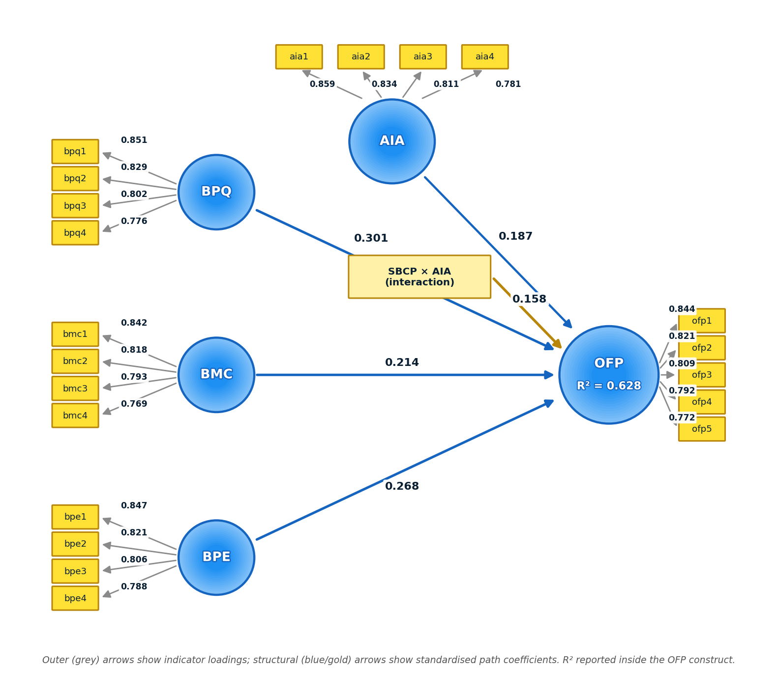
Figure 2: Measurement and Structural Model
Discriminant Validity
Discriminant validity was tested in two ways. Under the Fornell and Larcker criterion (Table 5), the square root of each construct's average variance extracted, shown on the diagonal, exceeded that construct's correlations with every other, so the constructs are distinct. The HTMT ratios (Table 6) tell the same story, each falling beneath the conservative 0.85 ceiling (Henseler et al., 2015). That the five constructs correlate positively yet remain separable is theoretically sensible: firms with strong planning, disciplined monitoring, rigorous evaluation, and mature intelligent tooling also tend to perform better financially, but none of these is a proxy for another.
Table 5: Discriminant Validity (Fornell and Larcker Criterion)
 | BPQ | BMC | BPE | AIA | OFP
BPQ | 0.831
BMC | 0.548 | 0.827
BPE | 0.512 | 0.534 | 0.821
AIA | 0.421 | 0.398 | 0.436 | 0.810
OFP | 0.642 | 0.578 | 0.609 | 0.503 | 0.820
Diagonal (bold) = square root of AVE; off diagonal = construct correlations.
Table 6: Discriminant Validity (HTMT Ratio)
 | BPQ | BMC | BPE | AIA | OFP
BPQ
BMC | 0.642
BPE | 0.598 | 0.631
AIA | 0.487 | 0.462 | 0.509
OFP | 0.741 | 0.672 | 0.708 | 0.584
All HTMT values fall below the 0.85 threshold.
Structural Model Assessment
With the measurement model secure, attention turned to structural estimation, summarised in Table 7. The model accounted for 62.8 per cent of the variance in financial performance (R² = 0.628; adjusted R² = 0.604), a substantial figure for behavioural research, and the Stone-Geisser Q² of 0.401 confirmed predictive relevance. Effect sizes ranged from small to medium, with budget planning quality contributing the largest individual f², a pattern that anticipates the path results. Path significance was established by bootstrapping 5,000 subsamples; Table 8 reports the coefficients and Figure 3 depicts the t-statistics. The remainder of this section takes each research question in turn, presenting the result and its discussion together.
Table 7: Structural Model Quality Criteria
Criterion | Value | Remark
R² (OFP) | 0.628 | Substantial
Adjusted R² (OFP) | 0.604 | Substantial
Q² (OFP) | 0.401 | Predictive relevance
f²: BPQ to OFP | 0.121 | Medium
f²: BMC to OFP | 0.072 | Small
f²: BPE to OFP | 0.108 | Small to medium
f²: AIA to OFP | 0.061 | Small
f²: SBCP × AIA to OFP | 0.052 | Small
Source: SmartPLS output, 2026.
Table 8: Path Coefficients and Hypothesis Testing (5,000 Bootstrap Subsamples)
Path | β | SE | t-value | p-value | Decision
BPQ to OFP | 0.301 | 0.079 | 3.810 | 0.000 | Ho1 Rejected
BMC to OFP | 0.214 | 0.075 | 2.853 | 0.004 | Ho2 Rejected
BPE to OFP | 0.268 | 0.077 | 3.481 | 0.001 | Ho3 Rejected
AIA to OFP (direct) | 0.187 | 0.078 | 2.397 | 0.017 | Significant
SBCP × AIA to OFP | 0.158 | 0.064 | 2.469 | 0.014 | Ho4 Rejected
Source: SmartPLS output, 2026. β = standardised path coefficient.
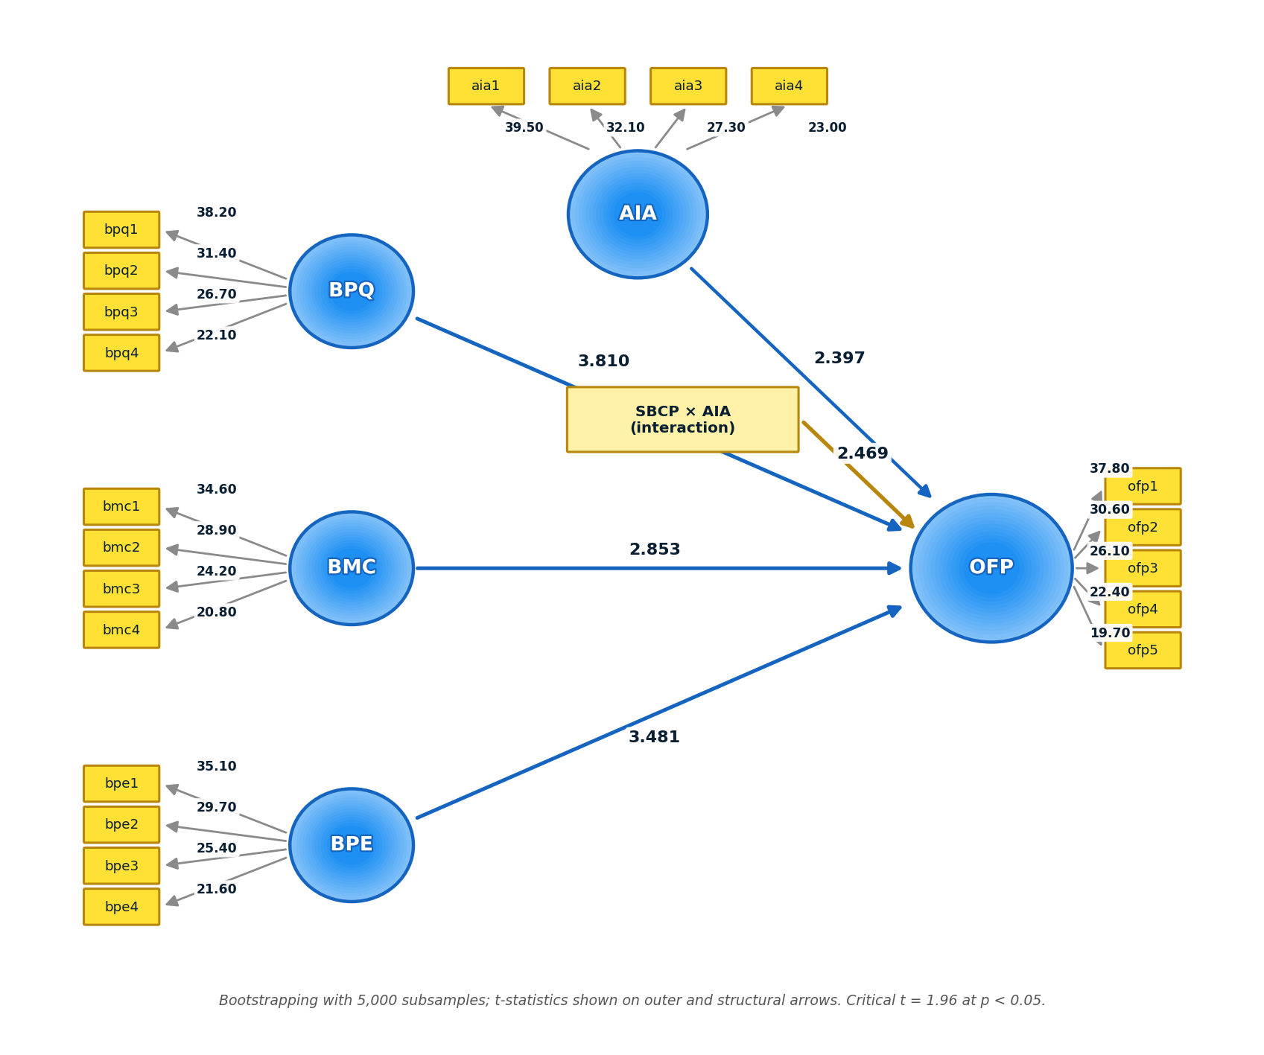
Figure 3: Structural Model, Bootstrapping (t-statistics)
Budget Planning Quality and Financial Performance (RQ1)
In answer to the first research question, budget planning quality had a significant positive effect on organisational financial performance (β = 0.301, t = 3.810, p < 0.001), the strongest of the three budgetary paths, and the first null hypothesis was accordingly rejected. The result indicates that realistic, participative, and strategically aligned budgeting raises performance by directing scarce resources towards value-creating activity before a single naira is spent. It is consistent with Okpolosa (2022), who traced the performance contribution of budgetary control in Nigerian manufacturing to the quality of preparation, with Okafor and Adebayo (2025) on resource optimisation among listed firms, and with Ajibola et al. (2024) on disciplined budget formulation. In the authors' judgement, the primacy of planning in this sample reflects the environment in which these firms budget: where exchange rates, input costs, and demand can move sharply within a single budget year, the realism of the assumptions built into the plan determines how much of the rest of the control cycle is even usable, since monitoring against a fictional baseline protects nothing. Theoretically, the finding maps onto the sensing element of dynamic capabilities theory, confirming that the capacity to read future conditions accurately is the point at which budgetary control begins to create value (Teece, 2007).
Budget Monitoring and Control and Financial Performance (RQ2)
On the second research question, budget monitoring and control significantly improved financial performance (β = 0.214, t = 2.853, p = 0.004), leading to the rejection of the second null hypothesis. The interpretation is that regular comparison of actual results against plan, prompt investigation of variances, and timely corrective action convert the budget from a static document into a live instrument of control, protecting margins that volatility would otherwise erode. The result agrees with Akinadewo et al. (2024), who associated active monitoring with stronger financial discipline, and with Bisogno and Cuadrado-Ballesteros (2022) on the outcomes of continuously reviewed budgeting. That the coefficient is the smallest of the three budgetary paths deserves comment rather than silence. In the authors' assessment, monitoring is partly downstream of planning, since the value of variance analysis is capped by the realism of the baseline it references, and in an inflationary environment a portion of observed variances originates in shocks that no corrective action can fully reverse. Monitoring, in other words, preserves value that planning has made possible rather than creating it independently. Through a contingency lens, the finding confirms that the return to monitoring depends on the fit between the control routine and the pace of the environment it polices (Otley, 2016).
Budget Performance Evaluation and Financial Performance (RQ3)
Turning to the third research question, budget performance evaluation exerted a significant positive effect on financial performance (β = 0.268, t = 3.481, p = 0.001), and the third null hypothesis was rejected. The result indicates that using budget outcomes to appraise departments and managers, to inform decisions, and to carry consequence through reward or sanction promotes the accountability that aligns managerial effort with financial objectives. It is consistent with Okpolosa (2022) on responsibility-linked budget performance and with Omemgbeoji and Ofor (2024) on systematic evaluation and firm effectiveness. That evaluation outranks monitoring in this sample is, in the authors' reading, a distinctly behavioural result: variance reports inform, but consequences motivate, and in firms where consequence management is credible the budget disciplines conduct throughout the year rather than only at review points. The finding corresponds to the reconfiguration element of dynamic capabilities theory, whereby the lessons of one budget cycle are absorbed into the next, so that evaluation is the mechanism through which budgetary control learns (Eisenhardt & Martin, 2000; Teece, 2007).
The Moderating Effect of Artificial Intelligence Adoption (RQ4)
On the fourth research question, the interaction between strategic budgetary control practices and artificial intelligence adoption was positive and significant (β = 0.158, t = 2.469, p = 0.014), while adoption also exerted a direct positive effect on performance (β = 0.187, t = 2.397, p = 0.017). The fourth null hypothesis was therefore rejected. The interpretation is that artificial intelligence matters twice over: it raises performance in its own right, and, more tellingly, it amplifies the payoff to budgetary discipline through more accurate forecasting, real-time variance detection, and decision support that manual review cannot match. The result aligns with Babina et al. (2024) on the firm-level returns to artificial intelligence and with Cimino et al. (2025), who model intelligent technologies as a capability that magnifies the effect of managerial practice, and it extends the Nigerian evidence of Omemgbeoji and Ofor (2024) from direct effects to moderation. In the authors' judgement, the most consequential feature of this result sits beside the descriptive statistics: adoption recorded the lowest mean of the five constructs, at only a moderate 3.49, which means the amplification detected here is being generated at modest levels of tooling maturity. The moderation coefficient is therefore best read as unexploited headroom, since firms that deepen adoption should expect the return on their existing budgetary discipline to rise, not merely their performance level. Theoretically, the finding vindicates the study's framework on both fronts: artificial intelligence operates as the enabling capability that determines whether budgetary routines are exercised statically or dynamically (Teece, 2007), and the uneven payoff across firms is exactly the pattern contingency theory predicts when identical practices meet unequal technological conditions (Donaldson, 2001).
Synthesis of Findings
Taken together, the four results describe a coherent hierarchy. Planning quality creates the potential for performance, evaluation converts that potential into behaviour, monitoring protects it against erosion, and artificial intelligence determines how fully the whole cycle pays off. The model's explanatory power, at 62.8 per cent of the variance in performance, indicates that this budgetary-technological account captures the greater part of what separates stronger from weaker performers among Nigeria's listed agriculture and consumer goods firms.
Conclusion
This study set out to establish whether artificial intelligence adoption governs the performance returns to strategic budgetary control among Nigerian listed agriculture and consumer goods firms, and the evidence answers in the affirmative on every count. Budget planning quality was the strongest driver of performance, confirming that budgetary control delivers its value chiefly through the realism and alignment of the plan. Budget performance evaluation and budget monitoring and control each raised performance independently, establishing accountability-linked evaluation and disciplined monitoring as measurable antecedents rather than incidental features. Artificial intelligence adoption mattered twice over, lifting performance directly and, more tellingly, amplifying the payoff to budgetary discipline. The larger lesson is that the financial dividend of budgetary control in Nigeria's listed real sector depends not only on how well firms plan, monitor, and evaluate their budgets, but on whether they have equipped that discipline with intelligent tools.
The study's limits qualify these claims in the usual ways. A cross-sectional design fixes the relationships at one moment and cannot settle causality, which longitudinal work would help resolve. Reliance on self-reported perceptions of performance invites social-desirability bias, tempered here by respondent anonymity and the full collinearity check applied to the data. The focus on listed agriculture and consumer goods firms sharpens analytical depth but narrows generalisation to unlisted operators and to other sectors. Future research could extend the model to additional sectors and markets, adopt longitudinal or mixed-methods designs, triangulate perceptual measures with audited financial ratios, and test further moderators such as firm size, environmental dynamism, or board oversight.
Recommendations
The following recommendations flow directly from the findings:
1. Boards and management of listed agriculture and consumer goods firms should prioritise the quality of budget planning through realistic, participative, and strategy-aligned formulation, since planning quality recorded the strongest effect on financial performance.
2. Firms should institutionalise rigorous budget performance evaluation, with clear responsibility accounting and consequence management, because evaluation was confirmed as the second-strongest antecedent of performance.
3. Management should strengthen budget monitoring and control through timely, frequent variance analysis and prompt corrective action, ensuring that deviations are detected and addressed before they erode results.
4. Firms should invest deliberately in artificial intelligence capability, including predictive analytics, real-time dashboards, and automated reporting integrated with their budgetary systems, because adoption both raised performance directly and amplified the returns to budgetary control.
References
Ajibola, I., Ojeme, S. S., & Akinwumi, A. (2024). Budgetary control and public sector financial management in Nigeria. International Journal of Advanced Multidisciplinary Research and Studies, 4(4), 603-608.
Akinadewo, I. S., Dagunduro, M. E., Akinadewo, J. O., Oluwagbade, I. O., & Akpan, J. U. (2024). How does artificial intelligence and accountability optimize energy management and cost reduction in Nigeria's manufacturing firms? In 2024 International Conference on Science, Engineering and Business for Driving Sustainable Development Goals (SEB4SDG). IEEE.
Babina, T., Fedyk, A., He, A., & Hodson, J. (2024). Artificial intelligence, firm growth, and product innovation. Journal of Financial Economics, 151, Article 103745. https://doi.org/10.1016/j.jfineco.2024.103745
Bisogno, M., & Cuadrado-Ballesteros, B. (2022). Budget transparency and governance quality: A cross-country analysis. Public Management Review, 24(10), 1610-1631. https://doi.org/10.1080/14719037.2021.1916064
Central Bank of Nigeria. (2025). Purchasing managers' index report. Central Bank of Nigeria.
Cimino, A., Corvello, V., Troise, C., Thomas, A., & Tani, M. (2025). Artificial intelligence adoption for sustainable growth in SMEs: An extended dynamic capability framework. Corporate Social Responsibility and Environmental Management, 32(5), 6120-6138. https://doi.org/10.1002/csr.70019
Donaldson, L. (2001). The contingency theory of organizations. Sage Publications.
Drury, C. (2021). Management and cost accounting (11th ed.). Cengage Learning.
Eisenhardt, K. M., & Martin, J. A. (2000). Dynamic capabilities: What are they? Strategic Management Journal, 21(10-11), 1105-1121. https://doi.org/10.1002/1097-0266(200010/11)21:10/11<1105::AID-SMJ133>3.0.CO;2-E
Fornell, C., & Larcker, D. F. (1981). Evaluating structural equation models with unobservable variables and measurement error. Journal of Marketing Research, 18(1), 39-50. https://doi.org/10.1177/002224378101800104
Hair, J. F., Hult, G. T. M., Ringle, C. M., & Sarstedt, M. (2022). A primer on partial least squares structural equation modeling (PLS-SEM) (3rd ed.). Sage Publications.
Hair, J. F., Risher, J. J., Sarstedt, M., & Ringle, C. M. (2019). When to use and how to report the results of PLS-SEM. European Business Review, 31(1), 2-24. https://doi.org/10.1108/EBR-11-2018-0203
Henseler, J., Ringle, C. M., & Sarstedt, M. (2015). A new criterion for assessing discriminant validity in variance-based structural equation modeling. Journal of the Academy of Marketing Science, 43(1), 115-135. https://doi.org/10.1007/s11747-014-0403-8
Kock, N. (2015). Common method bias in PLS-SEM: A full collinearity assessment approach. International Journal of e-Collaboration, 11(4), 1-10. https://doi.org/10.4018/ijec.2015100101
National Bureau of Statistics. (2026). Consumer price index and gross domestic product report, fourth quarter 2025. National Bureau of Statistics.
Nigerian Exchange. (2025). NGX market data and sector indices. Nigerian Exchange.
Okafor, C. E., & Adebayo, N. P. (2025). Evaluating the role of budgetary control in enhancing financial performance of Nigeria's commercial banks. Ayden Journal of Management and Social Sciences, 13(3), 1-12. https://doi.org/10.5281/zenodo.17062599
Okpolosa, M. O. (2022). Budgetary control system and financial performance of listed manufacturing firms in Nigeria. BW Academic Journal, 1(1), 9.
Omemgbeoji, I. S., & Ofor, N. (2024). Artificial intelligence in accounting and firm effectiveness among manufacturing companies in Nigeria. International Journal of Social Sciences and Management Research, 10(8), 1-15.
Otley, D. (2016). The contingency theory of management accounting and control: 1980-2014. Management Accounting Research, 31, 45-62. https://doi.org/10.1016/j.mar.2016.02.001
PwC. (2025). 2025 Nigeria budget and economic outlook. PricewaterhouseCoopers.
Ringle, C. M., Wende, S., & Becker, J.-M. (2022). SmartPLS 4. SmartPLS GmbH. https://www.smartpls.com
Sarstedt, M., Ringle, C. M., & Hair, J. F. (2022). Partial least squares structural equation modeling. In C. Homburg, M. Klarmann, & A. Vomberg (Eds.), Handbook of market research (pp. 587-632). Springer. https://doi.org/10.1007/978-3-319-57413-4_15
Teece, D. J. (2007). Explicating dynamic capabilities: The nature and microfoundations of (sustainable) enterprise performance. Strategic Management Journal, 28(13), 1319-1350. https://doi.org/10.1002/smj.640
Teece, D. J., Pisano, G., & Shuen, A. (1997). Dynamic capabilities and strategic management. Strategic Management Journal, 18(7), 509-533. https://doi.org/10.1002/(SICI)1097-0266(199708)18:7<509::AID-SMJ882>3.0.CO;2-Z
World Bank. (2024). Nigeria development update. World Bank.
Yamane, T. (1967). Statistics: An introductory analysis (2nd ed.). Harper & Row.
Appendix: Research Questionnaire
Section A: Respondent Background Information
Please indicate your response by ticking [✓] the appropriate box.
1. Gender: [ ] Male [ ] Female
2. Age (years): [ ] Below 30 [ ] 30 to 39 [ ] 40 to 49 [ ] 50 and above
3. Highest educational qualification: [ ] HND / B.Sc. [ ] Master's degree [ ] Doctorate [ ] Professional only
4. Current role in the organisation: [ ] CFO / Finance Director [ ] Financial Controller [ ] Finance / Budget Manager [ ] Management / Cost Accountant [ ] Internal Auditor [ ] FP&A Manager [ ] Head of Finance & Accounts [ ] Others
5. Years of working experience: [ ] Below 5 years [ ] 5 to 10 years [ ] 11 to 15 years [ ] Above 15 years
6. Sector of the firm: [ ] Agriculture [ ] Consumer Goods
Section B: Strategic Budgetary Control, Artificial Intelligence Adoption, and Financial Performance
Please indicate the extent of your agreement with each statement by ticking [✓] the box that best reflects your view, using the scale below.
Scale: SD = Strongly Disagree (1) D = Disagree (2) N = Neutral / Undecided (3) A = Agree (4) SA = Strongly Agree (5)
Budget Planning Quality (BPQ)
Statement | SD | D | N | A | SA
The budgets prepared in my organisation are realistic and based on reliable assumptions.
Budget preparation in my organisation involves the active participation of relevant departments and managers.
The budgeting process in my organisation is comprehensive and covers all key operational areas.
Budgets in my organisation are clearly aligned with the firm's strategic objectives.
Budget Monitoring and Control (BMC)
Statement | SD | D | N | A | SA
Actual performance is regularly compared against budgeted figures in my organisation.
Budget variances are promptly identified and investigated in my organisation.
Corrective actions are taken in a timely manner when significant budget deviations occur.
My organisation operates an effective system for continuous monitoring of budget implementation.
Budget Performance Evaluation (BPE)
Statement | SD | D | N | A | SA
Budget outcomes are used to evaluate the performance of departments and managers.
My organisation links budget performance to clear accountability and responsibility.
Periodic reviews of budget performance inform managerial decision-making in my organisation.
Rewards or sanctions in my organisation are influenced by the achievement of budget targets.
Artificial Intelligence Adoption (AIA)
Statement | SD | D | N | A | SA
My organisation uses artificial intelligence tools to support budgeting and forecasting.
Predictive analytics are applied in my organisation to anticipate financial outcomes.
My organisation has adopted automated systems for financial reporting and analysis.
Artificial intelligence applications are integrated into my organisation's financial control processes.
Organisational Financial Performance (OFP)
Statement | SD | D | N | A | SA
The profitability of my organisation has improved over the past three years.
My organisation manages its operating costs efficiently.
My organisation maintains adequate liquidity to meet its financial obligations.
The revenue and asset growth of my organisation has been satisfactory relative to expectations.
Overall, my organisation's financial performance compares favourably with that of industry peers.

