TITLE: DIGITIZING PRE-INDEPENDENCE GAZETTES OF THE FEDERAL REPUBLIC OF NIGERIA
AUTHOR: Jumoke Bukunmi Sohe
Status: Library Officer
Institutional Affiliation: University of Ibadan
Phone number: 08039139737
E-mail address: adejmkb@yahoo.com
Contact address: Kenneth Dike Library, University of Ibadan, Ibadan

Abstract
The Nigeria’s pre-independence gazettes published between the late 19th century and 1960 served as the official publication of the government. It was a means of communicating government actions and colonial policies to the people. They are historic document and one of the nation’s national heritages. These historic documents are under the threat of mold and insect damage, hence, the need to preserve them digitally and provide wider access to them. This study was carried out in Kenneth Dike Library, University of Ibadan. Three (3) volumes of the gazettes were digitized and made available online through https://gazettes.africa/ The paper presented the various stages involved in the digitization process as well as the software and hardware used.
Keywords
Gazettes, Digitization, Kenneth Dike Library
Introduction
Despite the immense historical and legal value of Nigeria’s pre-independence gazettes, they remain largely trapped in decaying paper formats. The physical state of these records is increasingly precarious due to poor storage conditions and the natural aging of acidic paper. Without a systematic digitization program, these primary sources are becoming inaccessible to the public and are at high risk of total loss. The world’s interest has been directed to a knowledge-driven economy, and this has led to the need to supply and access knowledge (Obasola and Usman, 2024); this therefore redirected the focus of libraries to digital preservation. According to Muhammad (2024), the application of ICT has brought about revolution in the education sector and academic libraries have adopted ICT in their operations, especially in managing their records; this has led to efficiency documentation, storage tracking, and retrieval of important records.
One of the functions of a library is to preserve knowledge and records. In order to do this, libraries have adopted various ICT tools including digitization to effectively perform this function. As the main information hub of academic institutions, libraries are required to modernize their services to align with the current digital environment (Sofia, 2023). Nneji (2018), stated that in order to survive in the era of information explosion, libraries worldwide are engaging in digitization of their resources. Otubelu and Ume (2015) explained that digitization has become a normal activity carried out by libraries as they seek to contribute to the world information resource. Nneji (2018) opined that there has been a significant deficit in the implementation of digitization initiatives within the Nigerian academic library sector. However, Ude, Okeke, and Onwurah (2025) stressed the need to integrate digitization into institutions’ plans and policies. Abdulsalami, Nwachukwu, and Salami (2015) explained that many libraries have made efforts to prevent physical destruction of their collections as a result of disasters like wars, fire, flood, and earthquake.
Pre-independence gazettes of the federal republic of Nigeria are information sources that are historic and contain vital information about the rule of the country under colonial administration. These information sources are very rear to find. The Kenneth Dide Library (KDL), University of Ibadan served as the legal deposit for the country before the creation of the National Library in 1964. Obasola and Usman (2024) noted that historically, the Kenneth Dike Library served as the primary national repository for Nigerian published works. However, starting in June 1970, this responsibility was shared with the National Library of Nigeria, which assumed the leading role and became the primary institution for compiling the national bibliography. As a result of this privilege, Kenneth Dide Library have in her collections, the gazettes of the federal republic of Nigeria as far back as 1901. These rear materials may not be found elsewhere in the world.
The Nigeria gazette acted as the newspaper record for the British administration during the colonial era. It later replaced the Northern Nigeria Gazette and the Southern Nigeria Government Gazette. Ukata and Wechie (2019) defined records as information created by an individual or organization and is maintained as evidence to pursue legal obligations. Gazettes are government records and they contain legislation and ordinances, land and property notices, public appointments, and economic data. Gazettes are government records which must be preserved because they represent the heritage of the nation. Most of these gazettes were printed on acidic paper which are now yellowing. Many of them are currently under the threat of insect damage, mold, and foxing. Chuquilin, Cajusol and Puican (2025) assert that digital transformation of government documents aids faster access to information, reduces operational cost and it in line with the Sustainable Development Goal 8.
The digitization of pre-independence gazettes of the Federal Republic of Nigeria is a study of great historical, legal, and administrative value. Preservation of Nigeria’s gazette is necessary for national integrity and academic rigor. As the physical copies of these foundational documents succumb to the effects of time and environmental degradation, this study provides a roadmap for their survival in the digital age. Digitizing these records eliminates the barriers of distance and physical fragility, and allows researchers and scholars worldwide to conduct keyword-based searches and data mining on the socio-political evolution of Nigeria. Many contemporary legal issues, especially those that involve land rights, traditional titles, and boundaries, rely on precedents set during the pre-independence era. A digital repository of gazettes will allow legal professionals to retrieve certified true copies of gazetted notices, proclamations, and laws with speed and accuracy, thereby enhancing the efficiency of the judicial process. Omigie and Odion (2024) believed that information mining from paper records can be restricted and inefficient sometimes, but with digitization of records, users can easily work with them.
As at the time of carrying out this study, the Nigeria gazettes that were available online were from 1957. This implies that the ones before 1957 have not been converted to digital format and if they have, they are not accessible electronically. As for the newly published ones, they are published electronically and made available and accessible online for use. AfricanLII and South African non-profit Laws.Africa reported a fire incident that happened at the University of Cape Town in 2021 which destroyed the government gazettes archives that were in the holdings of the university. Disaster can happen anytime without notice, but when there is backup of resources, loss will be minimal, hence digital preservation is necessary.
Though this article focuses on documenting the processes involved (technical and ethical) in digitizing the pre-independence gazettes of Nigeria, meaning of digitization will be briefly discussed in the context of this paper. Malipatil (2020) described digitization as a hot topic in librarianship. He defined it as the process of turning information materials into binary digits. Digitization serves as the core framework upon which all effective digital library operations are built Omigie & Ezegwu (2022). Digitization is the process of converting information resources that are in printed format into electronic format. Otubelu and Ume (2015) described digitization as the various steps that are required to convert historical records and other documents into accessible online formats. Libraries digitize their resources to make them accessible to a wide range of users in different places and at the same time.
The need to digitize
Physical information materials are prone to deterioration as time goes on. According to Abdulsalami, Nwachukwu, and Salami (2015), many library materials are exposed to improper storage, humidity, improper handling, excessive heat, slow decay, and insect infestation. There is therefore need to urgently preserve the heritage of our nation so that they will still be useful to generations to come. The pre-independence gazettes of the federal republic of Nigeria are endangered as some of them are being eaten by pests even with the effort of the library management to preserve them. Kudirova, Кудирова, and Kudirova, 2024 noted that institutions have been seeking to protect fragile materials and improve access to them so as to ensure their long-term preservation.
Apart from the need to preserve gazettes, there is also need to make them accessible. Many researchers may not be aware of the existence of these rich collections or they may be aware but cannot access them due to factors like distance. Malipatil (2020) explained that digitizing library resources makes information accessible to everyone, instead of a limited user. Digitizing the gazettes and making them available online will therefore make them accessible to a wider user from all over the world. Some materials may be existing in the library and users may not know their existence and usefulness. However, with digitization, they will be made visible as digitization makes the “invisible to be visible” (Malipatil, 2020).
Furthermore, because of the limited available copies, the number of users that can make use of them at the same time is limited, but with digitization, as many as possible users can use them at the same time. Dhule (2018) explained that with digitization, a document can serve a large population remotely in various locations and library users can make use of old materials without causing damages on them. In their study, Kudirova, Кудирова, and Kudirova (2024) find out that digitization reduces physical handling of historical documents.
Digitization stages
Three stages were involved in the project: Pre-digitization stage, digitization stage, and post digitization stage. The digitization project started on May 1 through August 2024.
Pre- digitization stage.
Conceiving the idea- The idea of digitizing the gazettes came to mind after considering the fragile condition of the gazettes and the need to rescue and preserve them. Also seeing the plead from Gazette.africa for libraries and organizations to rise to the challenge of preserving these rear materials, the thought came to mind to take up to the challenge.
Selecting the volumes to be digitized- Because of the project’s time frame, only 3 years (1953, 1954, and 1955) were selected. The reason for selecting these volumes was because they preceded the last year of the one available online (1957).
Getting approval- Since the gazettes are not on the open shelves, there was need to get approval to access them and digitize them. The University Librarian of Kenneth Dike Library was approached and a formal letter was written to seek approval to access the gazettes, digitize them and use the resources available in the digitization section of the KDL to carry out the project. The University Librarian, Dr Mercy Iroaganachi graciously approved the request.
Unbounding the gazettes - The gazettes were taken to the bindery section of the KDL to unbounded professionally so that the pages will easily flow in the scanner.
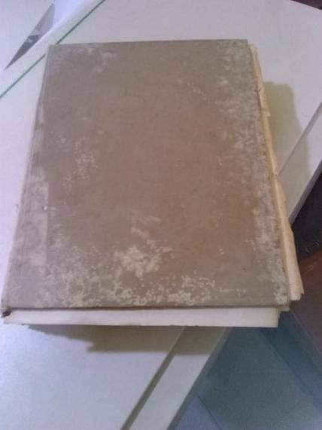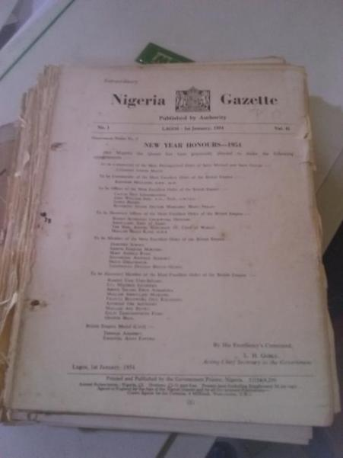
Gazette in bounded state Gazette in loose state
Digitization stage
Digitization process
The already existing digitization hardware and software in the KDL was used. Each page of the gazette was systematically scanned using Mustek flatbed scanner and HP ScanJet Enterprise scanner. Proper cropping of all the pages were done. Scanned and cropped pages were saved into TIFF format and edited with macromedia fireworks. The next stage was conversion and combining of the edited pages into PDF. During the conversion to PDF, Optical Character Recognition (OCR) was done on the texts to make them searchable. Each year of the gazettes has volume number, so they were saved according to their number and year in this format “nigeriagazette_1954_41_01”
nigeriagazette_1954_41_01
Nigeria gazette year of publication volume number

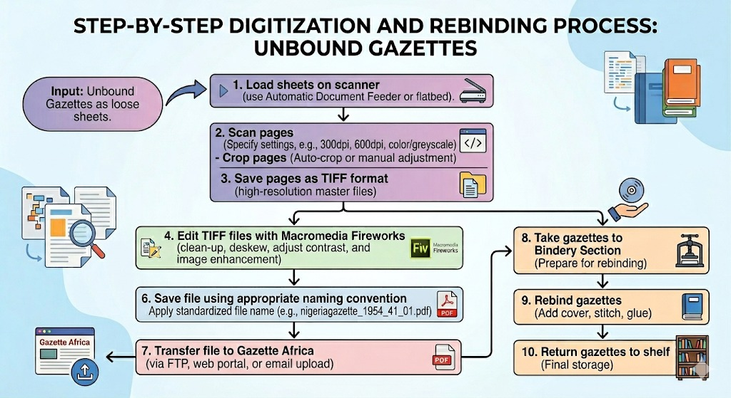
Post digitization stage
At this stage, the digitized files were sent to gazette Africa for uploading and online hosting. The hard copies were taken to the bindery section of the KDL for rebinding and they were returned to the section where they were taken from.

Hardware and software equipment used
- HP Scanjet Enterprise Flow 5000 s4 Sheet-feed Scanner.
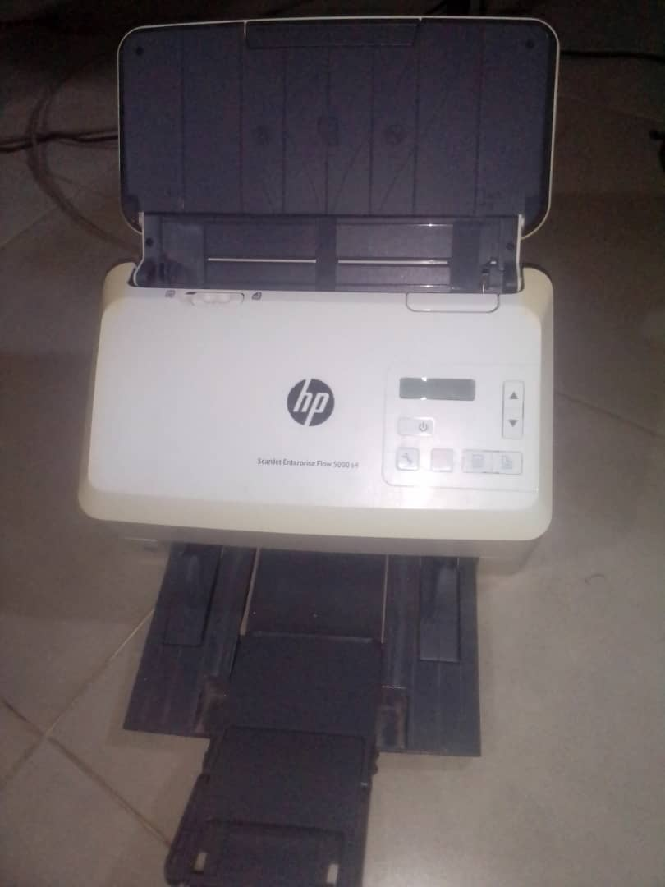
This scanner captures entire document (front only or front and back) with one-pass duplex scanning. It is small and slim, perfect for desktop. Up to 60 pages can be loaded into the automatic document feeder at ones; the scanner picks them sheet by sheet. The scanner can also scan into editable text, PDF files and other file formats using built-in OCR.

Mustek A3 Scanner
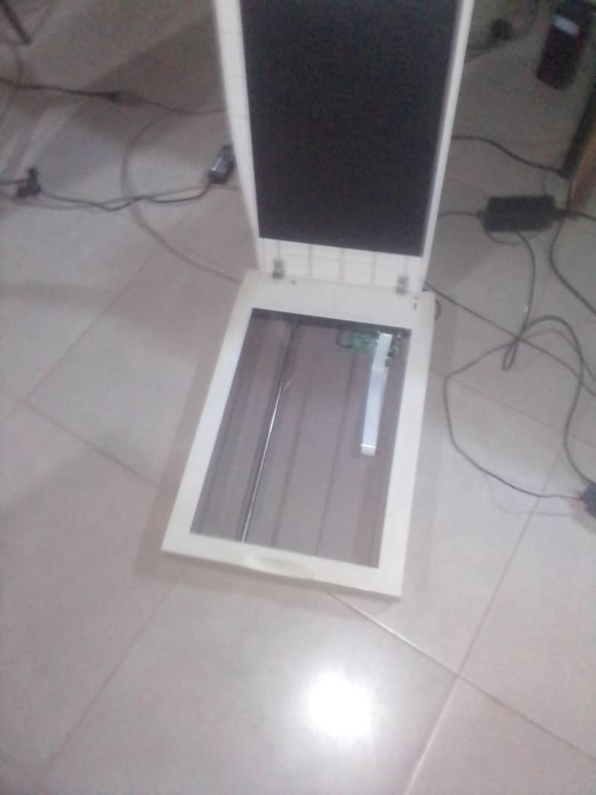
This scanner has A3 size glass size and has the capacity to scan large documents. It scans into gray scale, color or black and white.
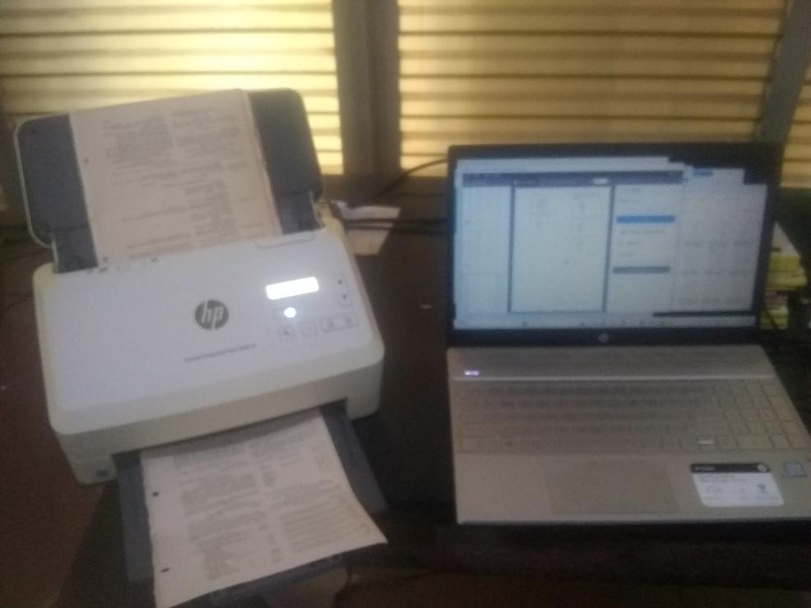
Work station - Digitization chamber at Kenneth Dike Library
Software used:
- ABBYY FineReader 12 Sprint is the software is the driver of Mustek A3 scanner. The software allows the user to select color to scan to (color, black and white, grayscale). It also allows user to choose the size of the document to be scanned (A4, A3, Quarto, legal letter, Executive, B4, B5). It has resolutions of 200dpi, 300dpi, and 600dpi. It also allows a user to adjust the brightness of the document to be scanned. After scanning, it saves document into searchable PDF, image-only PDF, Microsoft word, and other formats.
- Macromedia Fireworks: This software was used do necessary editing on the pages, not on the texts.
- Adobe acrobat PDF Professional 7: This software is used to combine pages and convert them to PDF, insert more pages, delete pages, extract pages, replace pages, crop pages and rotate pages. It also has the capacity to convert to OCR, reduce the size of a file, and check accessibility of a file among other functions.
Recommendations
- The National Library of Nigeria and the Kenneth Dike Library should prioritize the digitization of all remaining pre-independence Nigerian gazettes. Efforts must be made to ensure these digital surrogates are hosted on open-access platforms to enhance global accessibility for researchers and historians.
- Libraries should ensure that rear materials in their possession are digitally preserved.
- Libraries should give priority to metadata standardization and ensure that digitized African local content remains accessible across global search engines and institutional repositories.

Conclusion
Digitization is only one of the ways of preserving information resources like gazettes. Libraries and information centers should employ every necessary means to preserve the resources in their collection. There is more to be done in preserving the pre-colonial gazettes of the Federal Republic of Nigeria.
References
Chuquilin Condor, M. M., Cajusol Yovera, S. A., & Puican Rodríguez, V. H. (2025). Public documents digitization: Towards efficiency and reduction of municipal expenses [version 1; peer review: 2 approved with reservations]. F1000Research, 14, 918. https://doi.org/10.12688/f1000research.169678.1
Dhule, S. (2028). Digitization of libraries: Benefits and challenges. Knowledge Librarian: An International Peer Reviewed Bilingual E-Journal of Library and Information Science, (Special Issue), 312–315.
Hamooua, C., Mulauzi, F., & Njobvu, B. (2011). Archival legislation and the management of public sector records in Zambia: A critical review. South African Archives Journal, 1, 149–158.
Kudirova, S. (2024). Digitization and preservation of archival documents. International Conference on Advance Science and Technology, 1(7), 3–6.
Malipatil, B. (2020). Digitization of library: A brief introduction. International Journal of Advances in Engineering and Management, 2(10), 698–701.
Muhammad, S. M. (2024). Information and Communication Technology (ICT) and record management efficiency in an era of digitization: A case of Federal University of Birnin Kebbi, Kebbi State, Nigeria. Journal of Association of Educational Management and Policy Practitioners, 5(1), 14–22.
Nneji, K. O. (2018). Digitization of academic library resources: A case study of Donal E. U. Ekong Library. Library Philosophy and Practice (e-journal), Article 1990. http://digitalcommons.unl.edu/libphilprac/1990
Nnenna, O. B., & Ume, L. E. (2015). Digitization of library resources in academic libraries: Challenges and implication. IOSR Journal of Mobile Computing & Application, 2(2), 35–40.
Obasola, O., & Usman, R. A. (2024). Digitising old Yoruba newspapers at Kenneth Dike Library. IASSIST Quarterly, 48(2), 1–17.
Omigie, C. A., & Ezegwu, P. C. (2022). Emerging technologies and information provision in Nigerian academic libraries. In E. E. Adomi (Ed.), ICTs in libraries: A basic text (pp. 233–244). Credence Press Limited.
Omigie, C. A., & Odion, E. F. (2024). Exploring digital library and digitization components for librarians in academic libraries in Nigeria. Journal of Library Services and Technologies, 6(3), 109–120.
Sofia, S. (2023). The role of the library in a digital age [Master’s thesis, Uppsala University]. DiVA Portal. https://uu.diva-portal.org/smash/get/diva2:1800028/FULLTEXT01.pdf
Udem, O. K., Okeke, I. E., & Onwurah, B. (2015). Digitization of library resources in university libraries: A practical approach, challenges and prospects. Madonna University Journal of Research in Library and Information Science, 3(2), 36–47.
Ukata, P. F., & Wechie, N. (2019). Electronic records management and national development: A case of Nigeria. International Journal of Social Sciences and Management Research, 5(2), 35–57.

Acknowledgement
The study was made possible with the cooperation of Young African Library Leaders’ Fellowship (YALLF), Kenneth Dike Library, and Gazette Africa.

