Compromise-Oriented Conflict Resolution and Job Productivity Among Library Personnel in Public Tertiary Institutions in South East Nigeria
Chikaodi L. Nwakwuo ( Ph,D CLN)
elalove@yahoo.com

Judith S. Nse ( Ph,D CLN)
judithnse36@gmail.com
(Corresponding Author)

Rosemary Chineye Abanum (Ph.D)
abanumrose@gmail.com

Genevieve Chigekwu Nnadieto (Ph.D)
chigekwunnadieto@gmail.com

Abstract

Workplace conflict is a persistent organizational issue that has a significant impact on employee performance. This study examined the relationship between job productivity and compromise-oriented dispute resolution among library staff in public higher education institutions in Southeast Nigeria. The investigation was guided by three objectives: to ascertain the degree to which compromise is employed as a conflict resolution technique, to evaluate its impact on task execution efficiency, and to determine the nature of the relationship between compromise-based conflict resolution and overall job productivity. A validated, 15-item structured questionnaire anchored on a 5-point Likert scale was used to gather data from 356 library staff members selected from universities, polytechnics, and institutions of education throughout the five states of Southeast Nigeria. The study used a descriptive survey research design. Cronbach's alpha coefficients of 0.788, 0.772, and 0.769 for the three corresponding constructs supported the measurement tool's inherent reliability. Both descriptive statistics (mean and standard deviation) and inferential statistics (Pearson product-moment correlation and simple linear regression) were used to analyze the data. The findings showed that compromise is used as a conflict resolution strategy in a moderate but consistent way (x̅ = 3.90, SD = 0.81), that it positively affects task efficiency (x̅ = 3.88, SD = 0.83), and that there is a moderately significant positive correlation between job productivity and compromise-based conflict resolution (r = 0.445, p <.001). Compromise-based conflict resolution is a significant predictor of job productivity (β = 0.404, R2 =.198, p <.001), according to simple linear regression analysis, which also revealed that it explains about 19.8% of the variation in productivity. These results support the inclusion of compromise in library management practices in Nigerian higher education institutions and emphasize its strategic importance as a means of resolving conflicts within organizations. Based on the knowledge gained from these discoveries, useful suggestions are put forth for human resource professionals, legislators, and library administrators.

Keywords: compromise, conflict resolution, job productivity, task efficiency, library personnel, Southeast Nigeria, public tertiary institutions

Introduction
When individuals come together, disagreements tend to emerge naturally - especially when resources are limited or viewpoints differ. Though libraries rely heavily on cooperation, joint efforts, and mutual responsibilities, tension can still arise despite good intentions. How such tensions play out - ignored, worsened, or addressed systematically - affects employee well-being, output levels, and service standards alike. Given these dynamics, handling disputes wisely now occupies central attention within library administration research. This holds especially true in regions where workforce policies and organizational oversight remain loosely defined (Osakede et al., 2018; Adewale et al., 2015).
Working through disagreements often means finding ways to move forward without deepening divides. One approach involves trading concessions so both sides gain something while accepting less than originally wanted (Ozoke, 2025; StatPearls/NCBI, 2023). Instead of sidestepping tension or pushing one viewpoint onto others, this method favors shared adjustments. It lands somewhere between standing firm and giving in - balancing personal needs against teamwork goals. Some researchers place it midway in intensity when compared to more extreme styles like forcing outcomes or staying silent. Since workplaces rely on ongoing collaboration, softening positions can help preserve daily operations. Recent discussions frame such give-and-take as practical rather than idealistic (Trippe & Baumoel, 2015; Lewicki et al., 2015; Chartered Institute of Personnel and Development [CIPD], 2020).
However, there is still a dearth of empirical data about the use and results of compromise-based dispute resolution in the particular context of library staff at Nigerian public tertiary institutions. Relatively little research has been done on the effects of specific tactics, like compromise, on quantifiable productivity outcomes, despite growing evidence from other Nigerian work-place settings that compromise and other conflict-management strategies can significantly affect employee performance (Nwokedi et al., 2022; Amaeshi et al., 2021; Igbinoba et al., 2018). Instead, the majority of the literature currently available on library conflict management in Nigeria has concentrated on identifying conflict types and general management styles (Igbinoba et al., 2018; Osakede et al., 2018). This disparity is noteworthy because Nigerian public tertiary institutions function under particular institutional and structural circumstances, such as persistent underfunding, hierarchical management customs, and high staff-to-resource ratios, all of which foster conflict while limiting the resources available for conflict resolution in academic-library environments (Osakede et al., 2018; Adewale et al., 2015).
In order to close this gap, the current study empirically investigates the degree to which compromise is used by library staff in South East Nigeria, the impact of such use on task execution efficiency, and the more general relationship between compromise-based conflict resolution and job productivity. South East Nigeria, which includes the states of Abia, Anambra, Ebonyi, Enugu, and Imo, is home to a sizable number of public higher education institutions. Despite their importance to the region's academic advancement, the library services of these institutions are still mostly unstudied. There is immediate policy importance as well as wider intellectual value to comprehending how dispute resolution techniques affect productivity in these contexts.

Research Questions
Three Research questions were formulated to guide the study:
- To what the degree do library staff in public tertiary institutions in Southeast Nigeria compromise as a conflict resolution strategy?
- What is the impact of compromise-oriented conflict resolution on the effectiveness of task execution among library staff?
- What is the relationship between compromise-based conflict resolution and the overall job productivity of library staff.
Theoretical Framework
The theoretical foundation of this study draws on three interconnected frameworks that together explain how conflict is managed and how its management affects performance outcomes. The Dual Concern Model, originally proposed by Pruitt and Rubin (1986) and later refined by Rahim, posits that conflict resolution styles are shaped by two independent motivational axes: concern for oneself and concern for others. When both concerns operate at high levels, integration — a mode oriented toward mutual gain — is the natural outcome; when self-concern is high but regard for others is low, domination follows; when the reverse obtains, accommodation results; and when both concerns are negligible, avoidance ensues. Compromise occupies the intermediate position on both axes, reflecting moderate investment in both self-interest and relational maintenance (Trippe & Baumoel, 2015; CIPD, 2020). This centrist position makes compromise particularly suitable for workplace environments characterized by relative equality of influence, ongoing interdependence, and time-sensitive operational demands — conditions that closely approximate those prevailing in academic library settings (Ozoke, 2025; Amaeshi et al., 2021). The Thomas-Kilmann Conflict Mode Instrument extends this dual-concern logic into a five-mode taxonomy — competing, collaborating, compromising, avoiding, and accommodating — and research employing this instrument consistently demonstrates that the compromising mode is especially effective when disputes are of moderate salience, when the ideal collaborative outcome is either unattainable or too time-consuming to pursue, and when the parties must preserve an ongoing working relationship (Trippe & Baumoel, 2015; CIPD, 2020). These are precisely the conditions that characterize daily operational decisions in Nigerian academic libraries, where resource allocation, task assignment, and role boundary disputes require swift, balanced resolution (Osakede et al., 2018; Adewale et al., 2015). The conceptualization of job productivity adopted in this study draws on Campbell's (1990) multidimensional model of job performance, which distinguishes among task performance — the efficiency with which core duties are executed — contextual performance — discretionary behaviours supporting the social and organizational environment — and adaptive performance — the capacity to respond effectively to changing demands. Compromise-based conflict resolution is theoretically positioned to improve all three dimensions: it reduces interpersonal friction that would otherwise impede task performance, sustains the collegial relationships that underpin contextual performance, and models the kind of adaptive problem-solving that defines adaptive performance. Robbins and Judge (2019) similarly establish that conflict management effectiveness is a significant determinant of both individual and team productivity, providing further theoretical warrant for the present inquiry.
Literature Review
Conflict in organizational settings has a well-documented and evolving scholarly history. Pondy's (1967) seminal framework conceptualized workplace conflict as a sequential process moving from latent tension through awareness, affective responses, overt expression, and ultimately resolution; this process model introduced the important insight that the consequences of conflict depend less on whether it occurs than on how it is handled at each stage. Subsequent scholarship has elaborated this trajectory considerably. Contemporary researchers draw a productive distinction between task conflict — disagreement about work content and procedures — and relationship conflict — friction rooted in interpersonal incompatibility — finding that while moderate task conflict can stimulate more thorough analysis and richer decision-making under certain conditions, relationship conflict reliably undermines collaboration, lowers morale, and diminishes team effectiveness (Ayandele et al., 2021; Amaeshi et al., 2021). The empirical consensus drawn from both meta-analytic and field-based evidence indicates that when either type of conflict goes unmanaged, team performance and individual well-being deteriorate in tandem (Amaeshi et al., 2021; Nwokedi et al., 2022). The management response matters enormously: evidence suggests that high-performing teams distinguish themselves not by the absence of conflict but by their adoption of constructive resolution strategies — particularly those involving mutual adjustment and collaborative give-and-take — which function as buffers against the escalation of functional disagreement into destructive interpersonal hostility (Baumoel & Trippe, 2023; CIPD, 2020). Within Nigerian academic libraries specifically, interpersonal conflict tends to arise most frequently from ambiguous role boundaries and acute resource scarcity; yet much of this conflict remains either suppressed or unaddressed through formal institutional channels, leaving individual coping strategies and informal negotiation as the de facto mechanisms of resolution (Osakede et al., 2018; Adewale et al., 2015). This structural reality underscores the need to examine not merely whether conflict occurs in these settings but which resolution approaches are actually in use and what consequences they carry for measurable performance.
Among the conflict resolution strategies available to organizational actors, compromise occupies a distinctive position in both practical and scholarly discourse. It is broadly characterized as a negotiated exchange in which both parties accept less than their maximum preference in order to reach a mutually acceptable settlement; unlike distributive bargaining, which treats outcomes as fixed-sum contests, and unlike integrative negotiation, which seeks to expand the value available to both parties, compromise operates by apportioning losses approximately equally rather than maximizing joint gains (Trippe & Baumoel, 2015; CIPD, 2020). This characteristic positions compromise as a pragmatic stabilizer: it halts ongoing disputes with terms that are fair enough to be acceptable even when they fall short of optimal, thereby preventing the further erosion of working relationships and operational continuity (Ozoke, 2025). Recent scholarship has been careful to note that the effectiveness of compromise relative to other strategies depends substantially on situational factors — the nature and intensity of the disagreement, the power dynamics between parties, and the time available for resolution — rather than on any inherent superiority of the strategy (Trippe & Baumoel, 2015; CIPD, 2020). Folger et al. (2021) make the important observation that compromise represents the best practically attainable outcome when fuller integration is precluded by divergent priorities or insufficient time — conditions that, as noted, are characteristic of Nigerian public tertiary institution libraries. At the same time, research underscores that the success of compromise depends critically on underlying attitudinal conditions: genuine willingness to concede, trust that agreements will be honoured, and shared belief that common ground exists (Ozoke, 2025; Amaeshi et al., 2021). These conditions are not static; they are cultivated incrementally through repeated episodes of successful negotiation that gradually transform mutual concession from a perceived loss into an expected organizational norm. Evidence from Nigerian contexts shows that middle-level employees and peers tend to employ compromise more readily than senior managers — who more frequently resort to directive or forcing strategies — and that in settings where compromise prevails, both occupational stress and interpersonal tensions diminish while job satisfaction increases (Nwokedi et al., 2022; Igbinoba et al., 2018).
The relationship between compromise and task execution efficiency has attracted specific empirical attention in recent years. The theoretical mechanism most frequently invoked is the resource-depletion perspective: unresolved interpersonal conflict occupies the cognitive and emotional bandwidth that employees would otherwise direct toward productive task engagement, and effective resolution — particularly through compromise — releases these resources, restoring attentional focus and motivational investment in core duties (Ronquillo et al., 2023; CIPD, 2020). When conflicts are resolved through mutual adjustment rather than suppressed or escalated, the interpersonal clarity that results makes it easier to coordinate on shared tasks such as collection organization, cataloguing, reference service provision, and user programme delivery (Ayandele et al., 2021; Amaeshi et al., 2021). Igbinoba et al. (2018) found that among Nigerian university librarians, individuals who favoured compromise during conflicts reported higher levels of self-assessed task progress and fewer work interruptions relative to those who relied on controlling or avoidance strategies. Subsequent Nigerian library studies, while not always measuring efficiency directly, consistently indicate that cooperative conflict responses are associated with smoother work coordination and reduced operational disruption (Osakede et al., 2018; Adewale et al., 2015), a pattern consistent with broader longitudinal evidence that teams adopting cooperative conflict management tend to exhibit more sustained task focus and lower incidence of destructive conflict escalation (Ayandele et al., 2021; CIPD, 2020).
The broader question of how compromise-based conflict resolution bears on overall job productivity has also attracted substantial scholarly treatment. Ononogbo et al. (2015) conceptualize library productivity as a multidimensional composite encompassing output volume, service delivery quality, and adherence to professional standards — a formulation that maps naturally onto Campbell's (1990) tripartite model. Several theoretically plausible mechanisms connect compromise to this composite. First, effective conflict resolution improves the affective climate of the workplace by reducing interpersonal tension, and a positive affective climate is well established as a correlate of organizational citizenship behaviour and discretionary effort (Robbins & Judge, 2019). Second, compromise settlements characteristically clarify resource boundaries and role expectations, thereby reducing the role ambiguity and role conflict that are among the most reliably documented inhibitors of individual performance in Nigerian institutional settings (Osakede et al., 2018; Amaeshi et al., 2021). Third, by preserving and often strengthening interpersonal relationships, compromise sustains the social capital on which collaborative production — the dominant mode in library services — fundamentally depends. Empirical evidence from Nigerian university libraries corroborates these mechanisms: studies indicate that integration and compromise as conflict resolution responses correlate positively with employees' self-assessments of performance and with their perceptions of workplace climate, while controlling and withdrawal strategies are associated with greater occupational strain and lower service effectiveness (Osakede et al., 2018; Adewale et al., 2015; Amaeshi et al., 2021; Nwokedi et al., 2022). More broadly, Folger et al. (2021) argue that the long-term effectiveness of any organization is contingent on its members' collective capacity for principled conflict management — that is, the ability to approach disputes as shared problems to be resolved rather than contests to be won. This capacity is especially consequential in knowledge-intensive institutions such as academic libraries, where institutional memory, professional expertise, and relational trust constitute the primary productive assets and where the erosion of any of these through unmanaged conflict imposes lasting organizational costs.
Notwithstanding the richness of the theoretical and empirical literature summarized above, several important gaps remain. First, the majority of studies on conflict resolution and productivity in Nigerian library settings have been descriptive or qualitative in orientation, limiting their capacity to establish the effect sizes and statistical significance of the relationships under investigation. Second, existing Nigerian studies have largely examined conflict management approaches as undifferentiated composites, rather than isolating the effects of specific strategies such as compromise on specific performance outcomes. Third, the Southeast geopolitical zone of Nigeria — comprising the states of Abia, Anambra, Ebonyi, Enugu, and Imo — hosts a substantial concentration of public tertiary institutions and a correspondingly large library workforce, yet it has been largely overlooked in the empirical literature on library management and organizational behaviour. The present study was designed specifically to address all three of these deficiencies.
Methodology
A descriptive survey design was adopted for this study, as it is well suited to investigating the characteristics of a population and the relationships among variables at a single point in time without manipulating any conditions, consistent with the position of Creswell and Creswell (2018). The target population comprised library personnel – including professional librarians, paraprofessional staff, and library assistants – employed in public tertiary institutions across the five states of Southeast Nigeria: Abia, Anambra, Ebonyi, Enugu, and Imo. Sampling was conducted in two phases; institutions were first purposively selected to ensure adequate representation across all five states and the three categories of tertiary institution (universities, polytechnics, and colleges of education), after which respondents were drawn from each institution using stratified random sampling proportionate to departmental composition, covering technical services, reader services, and administrative units, resulting in 356 valid responses. A structured, self-administered questionnaire served as the primary data collection instrument, with responses measured on a five-point Likert scale ranging from Strongly Disagree (1) to Strongly Agree (5). Data were analyzed using both descriptive and inferential statistical methods; means and standard deviations were computed for all items and constructs, with a decision rule of x̅ ≥ 3.50. All analyses were conducted using Python (version 3.11) with the pandas and SciPy libraries.
Presentation and Discussion
- To what the degree do library staff in public tertiary institutions in Southeast Nigeria compromise as a conflict resolution strategy?
The first research questions sought to find out the extent to which compromise is utilized as a conflict resolution strategy among library personnel. Table 1 presents the item-level descriptive statistics for the five compromise utilization items (C1–C5).

Table 1: Descriptive Statistics for Compromise Utilization
Item | Statement | Mean | SD | Decision
C1 | I often use compromise to resolve conflicts with colleagues. | 3.91 | 0.82 | Agree
C2 | In conflict situations, I am willing to give up some demands to reach mutual agreement. | 3.91 | 0.75 | Agree
C3 | Compromise is commonly practised among staff in my library. | 3.87 | 0.83 | Agree
C4 | I prefer compromise over more confrontational conflict resolution methods. | 3.89 | 0.81 | Agree
C5 | Management encourages the use of compromise in resolving workplace conflicts. | 3.92 | 0.83 | Agree
 | Grand Mean / Overall SD | 3.90 | 0.81 | Agree

Table 1 shows that all five items evaluating the use of compromise produced mean scores in the 'Agree' range (3.50–4.49), with individual item means ranging from 3.92 (C5: Management encourages compromise) to 3.87 (C3: Compromise is regularly practiced among library staff). According to the grand mean of 3.90 (SD = 0.81), library staff members at public tertiary institutions in Southeast Nigeria generally concur that compromise is a method of resolving conflicts at work. A consistent and widely shared attitude toward compromise across various conflict circumstances and participant groups is suggested by the relative homogeneity of item means.
The item with the highest rating, C5 (x̅ = 3.92), illustrates how management promotes a culture of compromise in the workplace. In line with contemporary organizational-development research that cooperative conflict norms must be modeled and reinforced at the leadership level in order to become ingrained in organizational culture (Ozoke, 2025; Managing Conflict in the Modern Workplace, CIPD, 2020), this study suggests that institutional leadership practices are viewed as encouraging compromise. While individual willingness to compromise is present, its collective institutionalization as a shared norm is slightly less robust, according to the lowest-rated item, C3 (x̅ = 3.87), which discusses the prevalence of compromise among colleagues. This nuance has implications for library management policy. This result is consistent with Amaeshi et al.'s (2021) observation that compromise is more common among operational staff than at senior management levels in Nigerian university settings, as well as the recent Nigerian library evidence showing that conflict resolution remains shaped by broader institutional culture and role expectations (Osakede et al., 2018; Adewale et al., 2015).

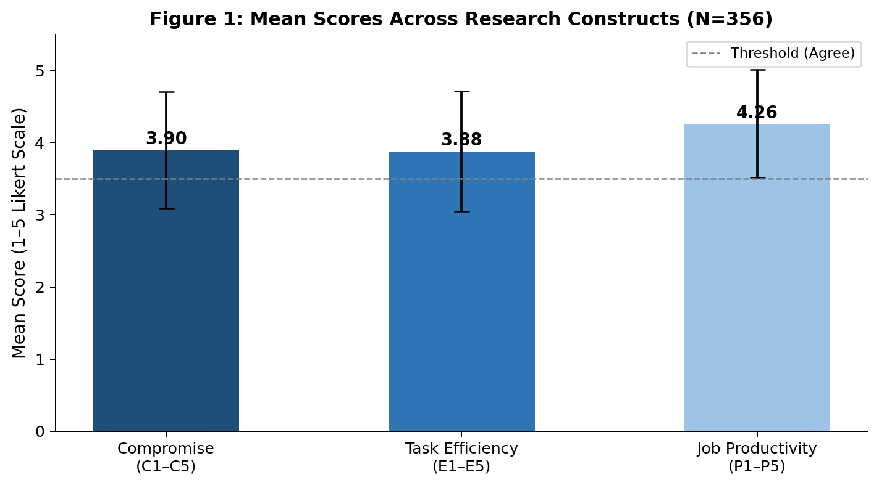
Figure 1. Mean scores (with ±1 SD error bars) across the three research constructs (N = 356).
Research Question 2: What is the impact of compromise-oriented conflict resolution on the effectiveness of task execution among library staff?
The second research question sought out to find the impact of compromise-oriented conflict resolution on the efficiency of task execution. Descriptive statistics for the five task efficiency items (E1–E5) are presented in Table 2.

Table 2: Descriptive Statistics for Task Execution Efficiency
Item | Statement | Mean | SD | Decision
E1 | Resolving conflicts through compromise helps me complete tasks faster. | 3.86 | 0.83 | Agree
E2 | Compromise reduces delays in work processes within the library. | 3.93 | 0.84 | Agree
E3 | When conflicts are resolved through compromise, teamwork improves. | 3.86 | 0.83 | Agree
E4 | Compromise minimizes disruptions to my daily responsibilities. | 3.89 | 0.86 | Agree
E5 | I am more focused on my duties after conflicts are settled through compromise. | 3.87 | 0.79 | Agree
 | Grand Mean / Overall SD | 3.88 | 0.83 | Agree

All five task efficiency items yielded mean scores in the 'Agree' range, with a grand mean of 3.88 (SD = 0.83). Item E2 (Compromise reduces delays in work processes, x̅ = 3.93) recorded the highest mean, indicating that respondents most strongly attributed their workflow continuity to the practice of compromise-based conflict resolution. This finding is theoretically consistent with the resource-depletion perspective in contemporary conflict research, which holds that unresolved conflict consumes attentional and emotional resources that would otherwise be directed toward task execution, and that effective resolution—particularly through compromise—releases these resources and restores productive focus (Ronquillo et al., 2023; CIPD, 2020).
Items E1 and E3 (both x̅ = 3.86) dealt with individual task speed and team performance, respectively, and both produced mean scores that were marginally lower but still positive. Reduced delays (E2), increased attention (E5), less disturbances (E4), improved teamwork (E3), and faster individual task completion (E1) are some of the ways that the efficiency gains of compromise are considered to operate, according to the consensus across items. Contemporary longitudinal research on work teams shows that high-performing groups set themselves apart through cooperative conflict management that maintains task focus and reduces escalation into destructive relationship conflict, which is consistent with this multi-pathway effect (Ayandele et al., 2021; CIPD, 2020). Similar results were found in recent Nigerian library studies, which suggest that compromise and related cooperative conflict responses are associated with smoother work coordination and fewer disruptions (Osakede et al., 2018; Adewale et al., 2015).

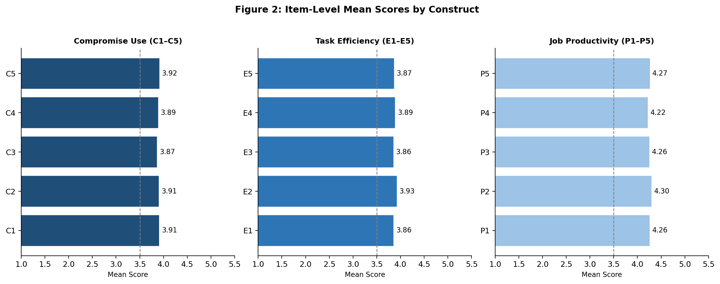
Figure 2. Item-level mean scores for all three constructs, with the dashed line indicating the 'Agree' threshold (x̅ = 3.50).
Research Question 3: What is the relationship between compromise-based conflict resolution and the overall job productivity of library staff?
The third research question evaluated the relationship between compromise-based conflict resolution and overall job productivity. Table 3 presents the item-level descriptive statistics for the five job productivity items (P1–P5).
Table 3: Descriptive Statistics for Job Productivity
Item | Statement | Mean | SD | Decision
P1 | Compromise-based conflict resolution improves my overall job performance. | 4.26 | 0.76 | Agree
P2 | My productivity increases when conflicts are resolved amicably through compromise. | 4.30 | 0.72 | Agree
P3 | Compromise leads to better collaboration among library staff. | 4.26 | 0.74 | Agree
P4 | Frequent unresolved conflicts reduce my productivity. (Reverse-coded) | 4.22 | 0.79 | Agree
P5 | The use of compromise contributes to achieving organizational goals in the library. | 4.27 | 0.73 | Agree
 | Grand Mean / Overall SD | 4.26 | 0.75 | Agree

Of the three constructs, the job productivity construct had the greatest grand mean (x̅ = 4.26, SD = 0.75), and every item fell into the "Agree" range. The highest rating went to item P2 (my productivity increases when conflicts are addressed peacefully through compromise, x̅ = 4.30), followed by item P5 (compromise helps to organizational goal attainment, x̅ = 4.27). Strong agreement was also recorded for the reverse-coded item, P4 (Frequent unresolved conflicts reduce my productivity, x̅ = 4.22). This suggests that respondents acknowledge the productivity cost of unresolved conflict, which implies that compromise resolution has the potential to increase productivity. The consistently higher means for the productivity construct compared to the task efficiency and compromise utilization constructs may indicate a perception gap: respondents seem to think that compromise is more productive than it is currently used, indicating room for increased use.

Pearson Correlation and Regression Analysis
Pearson product-moment correlation and simple linear regression analyses were conducted to examine the inferential relationship between compromise utilization and job productivity. Table 4 presents the results.
Table 4: Pearson Correlation and Simple Linear Regression Results
Variable Pair | Pearson r | R² | β (Slope) | SE | p-value | Decision
Compromise → Job Productivity | 0.445 | 0.198 | 0.404 | 0.038 | 0.001 | Significant
Compromise → Task Efficiency | 0.340 | 0.116 | — | — | 0.001 | Significant
Task Efficiency → Productivity | 0.147 | 0.022 | — | — | 0.005 | Significant

Compromise use and job productivity had a moderately strong, statistically significant positive link, according to the Pearson correlation analysis (r = 0.445, p < 0.001). This suggests that library staff members who employ compromise as a conflict resolution technique more frequently also report being more productive at work. Although it was less in size, the correlation between compromise utilization and task efficiency was likewise statistically significant and positive (r = 0.340, p < 0.001). Job productivity and task efficiency were positively linked (r = 0.147, p = 0.005), indicating a partial mediation pathway through which compromise may affect productivity in part by improving efficiency.
Compromise utilization is a statistically significant predictor of job productivity, according to the simple linear regression (β = 0.404, SE = 0.038, p < 0.001). Compromise-based conflict resolution explains almost 19.8% of the variation in job productivity among library staff in the sample, according to the coefficient of determination (R² = 0.198). In an organizational-behavior setting, this fraction represents a practically meaningful effect size even though it leaves significant volatility owing to other factors, which is consistent with the complexity of the productivity construct as described in contemporary work on job performance and organizational outcomes (Ayandele et al., 2021; CIPD, 2020). This finding is in line with contemporary studies showing that conflict management style matters more for performance outcomes than conflict occurrence alone (Ayandele et al., 2021; Nwokedi et al., 2022).
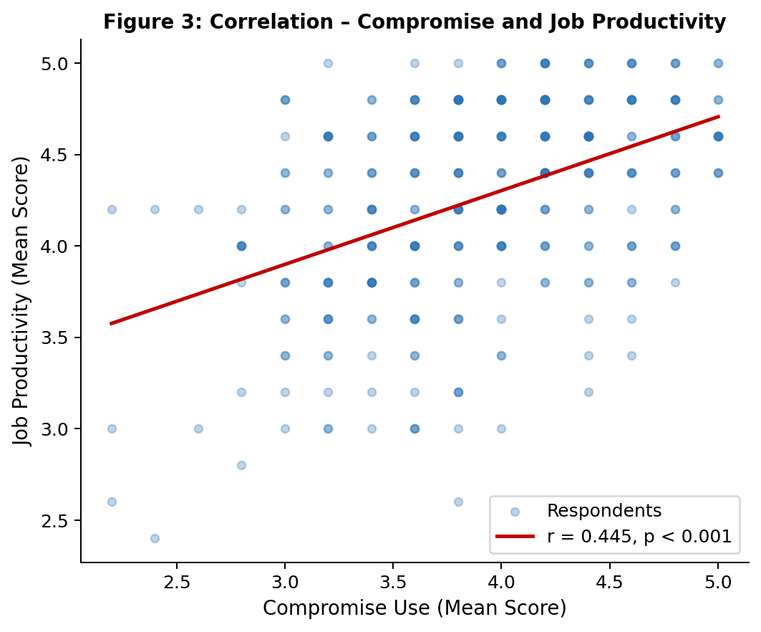
Figure 3. Scatter plot of compromise utilization scores against job productivity scores, with fitted regression line (r = 0.445, R² = 0.198, p < 0.001, N = 356).

Conclusion
The study examines the effects of compromise-oriented dispute resolution on library staff members' job productivity in public higher education institutions in South East Nigeria.the findings indicated that compromise is a widely adopted strategy for resolving for reslovind work place conflict because it encourages mutual understanding, cooperation and shared responsibility among library staff. By allowing conflicting parties to make concessions, compromise helps to minimize hostility , promte harmonious working relationships and maintain a conducive working environment.
the study further indicated that effective use of compromise positively influences task execution by reducing inter-personal tensions, improving communication, and enhances team work. library stall who resolve conflict through compromise are more likely to perform their duties efficiently and effectively.
The study also found out that there is apositive relationship between compromise - based conflict resolution and the over-all job productivity of library staff. This therefore implies that promoting conflict management strategy can enhance employee performance, organizational effectiveness and the quality of library service in public university libraries
Recommendations
The following suggestions are made in light of the study's results and conclusions:
1. The library administrators in public higher education institutions in South-East Nigeria should create and put into effect formal conflict management rules that clearly state that compromise is the best and most advised course of action. In order to lessen reliance on ad hoc or personality-driven approaches, such regulations should specify how to start compromise-based settlement when disputes emerge.
2. Departmental heads and library administrators should undergo specialized training in compromise facilitation and principled bargaining. According to the data, management support of compromise (C5) was the highest-rated utilization item, suggesting that leadership behavior impacts the larger organizational dispute resolution culture. This makes leadership modeling of compromise behavior crucial.
3. Along with technical library abilities, conflict resolution skills—especially compromise and interest-based negotiation—should be included as basic competencies in continuing professional development programs for library staff. Conflict management training ought to be incorporated into the professional certification programs of the Nigerian Library Association and the Librarians' Registration Council of Nigeria.
4. In order to thoroughly verify the causation and mediation processes shown by the current data, future research should use longitudinal designs and structural equation modeling. It should also investigate the moderating influence of institutional and demographic factors on the compromise-productivity link. The evidence base would be significantly strengthened by studies that incorporate objective performance data instead of depending only on self-report.
5. In order to provide formal institutional infrastructure for compromise-based resolution and lessen reliance on informal, personality-contingent conflict management, state governments and institutional governing councils in Southeast Nigeria should invest in structured human resource management systems for library staff, such as grievance procedures and mediation services.

References
Adewale, O., Tinuade, B., & Olasehinde, F. (2015). Conflict resolution in Nigeria: The role of academic library. International Journal of Library Science, 4(1), 13–20. https://doi.org/10.5923/j.library.20150401.03
Adilo, J. N. (2019). Conflict management and organizational performance: A study of selected breweries in South East Nigeria. International Journal of Management and Entrepreneurship, 1(1), 1–22.
Amaeshi, F., Ugwu, E., & Okoye, C. (2021). Conflict management and organizational performance in Nigeria. Global Scientific Journal, 9(4), 1269–1280.
Ayandele, A. F., Bolarinwa, K. K., Alarima, C. I., Kazeem, S. O., & Kareem, H. T. (2021). Workplace conflict and employees' job performance in Agro-services Corporation, Ogun State, Nigeria. Journal of Agricultural Extension, 25(4). https://doi.org/10.4314/jae.v25i4.5
Campbell, J. P. (1990). Modeling the performance prediction problem in industrial and organizational psychology. In M. D. Dunnette & L. M. Hough (Eds.), Handbook of industrial and organizational psychology (Vol. 1, 2nd ed., pp. 687–732). Consulting Psychologists Press.
Chartered Institute of Personnel and Development. (2020). Managing conflict in the modern workplace. CIPD. https://www.cipd.org/globalassets/media/knowledge/knowledge-hub/reports/managing-conflict-in-the-workplace-2_tcm18-70655.pdf
Cohen, J. (1988). Statistical power analysis for the behavioral sciences (2nd ed.). Lawrence Erlbaum Associates.
Creswell, J. W., & Creswell, J. D. (2018). Research design: Qualitative, quantitative, and mixed methods approaches (5th ed.). SAGE.
Folger, J. P., Poole, M. S., & Stutman, R. K. (2021). Working through conflict: Strategies for relationships, groups, and organizations (9th ed.). Routledge.
Igbinoba, E., Falola, H., Osibanjo, A., & Oludayo, O. (2018). Survey datasets on the influence of conflict management strategies on academic staff productivity in selected public universities in Nigeria. Data in Brief, 19, 322–325. https://doi.org/10.1016/j.dib.2018.04.139
Lewicki, R. J., Barry, B., & Saunders, D. M. (2015). Negotiation (7th ed.). McGraw-Hill Education.
Nunnally, J. C., & Bernstein, I. H. (1994). Psychometric theory (3rd ed.). McGraw-Hill.
Nwokedi, B. E., Osaheghe, I. I., Okereke, A. A., & Gbenga, W. (2022). Conflict management and organizational performance in breweries of South East States of Nigeria. British International Journal of Business and Marketing Research, 5(4). https://aspjournals.org/Journals/index.php/bijbmr/article/view/126
Ononogbo, R. U., Uhegbu, A. N., Nwosu, M. C., & Uzuegbu, C. P. (Eds.). (2015). Personnel issues in the 21st century librarianship. Zeh Communications.
Osakede, K. O., Ijimakinwa, S. O., Adesanya, T. O., & Ojo, A. D. (2018). Conflict management in tertiary institutions: A study of selected universities in south-western Nigeria. Africa's Public Service Delivery and Performance Review, 6(1), 1–7. https://doi.org/10.4102/apsdpr.v6i1.197
Ozoke, V. (2025). Compromise: The easier but suboptimal path most often taken in conflict resolution. Journal of Conflict Management.
https://iprjb.org/journals/JCM/article/view/3369
Pondy, L. R. (1967). Organizational conflict: Concepts and models. Administrative Science Quarterly, 12(2), 296–320. https://doi.org/10.2307/2391553
Robbins, S. P., & Judge, T. A. (2019). Organizational behavior (18th ed.). Pearson.
Ronquillo, Y., Ellis, V. L., & Toney-Butler, T. J. (2023, July 3). Conflict management in healthcare. In StatPearls [Internet]. StatPearls Publishing. https://www.ncbi.nlm.nih.gov/books/NBK470432/
Trippe, B., & Baumoel, D. (2015). Beyond the Thomas-Kilmann model: Into extreme conflict. Negotiation Journal, 31(2), 89–103. https://doi.org/10.1111/nejo.12086

