A Data-Driven Approach to Managing Individualised Education Programme Records in Polytechnic Education through Students' Information Systems and Learning Management Systems Integration

Habib Shehu* ^{1,7}, Justina Ekwutosi Ogbonna ², Ramadhan Malinga ³, Margaret Kareyo ⁴,
Michael Adelani Adewusi ⁵, Isa Ismail Ibrahim ⁶, Moses Sugbaza Megida ⁷

^{1,2,3,4,5} Department of Information Technology, Kampala International University, Kampala, Uganda
⁶ Department of Library and Information Science, International Islamic University, Gombak, Malaysia
^{1,7} Department of Library and Information Science, Federal Polytechnic, Nasarawa, Nigeria

*habib.shehu@studmc.kiu.ac.ug | shehabib@gmail.com

Abstract
This study investigates the integration of Student Information Systems (SIS) and Learning Management Systems (LMS) to enhance the management of Individualised Education Programme (IEP) records in Nigerian polytechnics, promoting inclusivity and operational efficiency. Conducted across six polytechnics in North Central Nigeria, the research employed a mixed-methods approach, involving surveys, interviews, and document analysis with 100 stakeholders, including SIS administrators, LMS staff, academic instructors, and records officers. Findings indicate that whilst 78% of institutions utilise SIS and 65% use LMS, only 23% have integrated these systems, resulting in inefficient workflows. Major barriers include technical incompatibilities (89%), inadequate training (94%), and budget constraints (91%). However, successful integration led to a 40–60% reduction in record retrieval time and improved student support services. Significant correlations were found between training (r = 0.74, p < 0.001), leadership support (r = 0.68, p < 0.01), and system reliability (r = 0.71, p < 0.001) with integration success, highlighting the importance of human-centred strategies. Notably, smaller polytechnics achieved comparable outcomes to larger ones when provided with sufficient support, challenging resource-driven assumptions. Aligned with Nigeria’s National Digital Economy Policy and Strategy (Federal Ministry of Communications and Digital Economy, 2019), the study recommends prioritising comprehensive training, appointing integration coordinators, and establishing national IEP data standards to foster equitable and digitally empowered educational environments.

Keywords: SIS, LMS, Individualised Education Programmes, Polytechnic Education, Records Management, Data-Driven Integration

Introduction
The global shift towards data-driven decision-making is transforming higher education, with institutions increasingly leveraging digital technologies to enhance administrative efficiency and provide tailored learning experiences (Bates, 2019; Atlan, 2023). A key development in this transformation is the integration of Student Information Systems (SIS) and Learning Management Systems (LMS), which offers a robust platform for managing Individualised Education Programme (IEP) records. These records are vital for supporting students with diverse learning needs, particularly those with disabilities, ensuring equitable access to education (Smith & Basham, 2021; UNESCO, 2020). In Nigerian polytechnics, which focus on vocational and technical training, managing IEPs is complex due to the unique blend of theoretical and practical instruction required by their curricula (Adedipupo et al., 2024). Integrating SIS and LMS can create interoperable digital ecosystems that streamline administrative processes, reduce duplication, and enable real-time data access to support inclusive pedagogy (Garrison & Vaughan, 2008). This integration aligns with Nigeria’s broader digital transformation goals, as outlined in the National Digital Economy Policy and Strategy (Federal Ministry of Communications and Digital Economy, 2019).

Despite global advancements in integrated digital systems, their application in Nigerian polytechnics for IEP management remains underexplored (Adedipupo et al., 2024). This study addresses this gap by investigating how SIS-LMS integration can enhance IEP record management, fostering inclusive and efficient educational environments. Anchored in the Technological Pedagogical Content Knowledge (TPACK) framework (Mishra & Koehler, 2006) and UNESCO’s inclusive education vision (UNESCO, 2020), the research offers actionable insights for Nigerian polytechnics and similar Sub-Saharan African contexts, contributing to the discourse on digital innovation in vocational education.

Statement of the Problem
Nigerian polytechnics play a critical role in providing vocational and technical education, serving diverse student populations with unique academic and practical training needs (Adedipupo et al., 2024). However, the management of Individualised Education Programme (IEP) records, essential for supporting students with disabilities or special learning needs, remains inefficient due to fragmented and outdated administrative systems (Smith & Basham, 2021; UNESCO, 2020). While Student Information Systems (SIS) and Learning Management Systems (LMS) are increasingly adopted in Nigerian polytechnics, their integration is rare, leading to disjointed workflows, manual data transfers, and delays in accessing critical IEP information (Komljenovic et al., 2024). These inefficiencies hinder instructors’ ability to access real-time data on student accommodations, compromising the delivery of inclusive education (Adedipupo et al., 2024; Smith & Basham, 2021). Technical challenges, such as system incompatibilities and poor internet connectivity, combined with human factors like inadequate training and resistance to change, further exacerbate the problem (Bachmann et al., 2022). Despite Nigeria’s commitment to digital transformation in education, as outlined in the National Digital Economy Policy and Strategy (Federal Ministry of Communications and Digital Economy, 2019), the lack of integrated SIS-LMS systems limits the potential for equitable and responsive education in polytechnics. This study seeks to address these gaps by investigating how SIS-LMS integration can enhance IEP record management, thereby fostering inclusive and efficient educational practices in Nigerian polytechnics.

Research Questions
Based on the identified problem of inefficient management of Individualised Education Programme (IEP) records in Nigerian polytechnics due to fragmented Student Information Systems (SIS) and Learning Management Systems (LMS), this study addresses the following research questions:

- How can the integration of SIS and LMS enhance the management of IEP records in Nigerian polytechnics to support inclusive education?
- What are the primary barriers to implementing effective SIS-LMS integration for IEP record management in Nigerian polytechnics?
- What strategies and best practices can facilitate successful SIS-LMS integration to improve administrative efficiency and pedagogical responsiveness in managing IEP records?

These questions guide the mixed-methods investigation, leveraging quantitative data on system usage and qualitative insights from stakeholders to investigate opportunities, challenges, and actionable solutions for enhancing IEP record management through SIS-LMS integration (Creswell & Plano Clark, 2018; Smith & Basham, 2021; Adedipupo et al., 2024).

Conceptual Framework for SIS-LMS Integration in Managing IEP Records
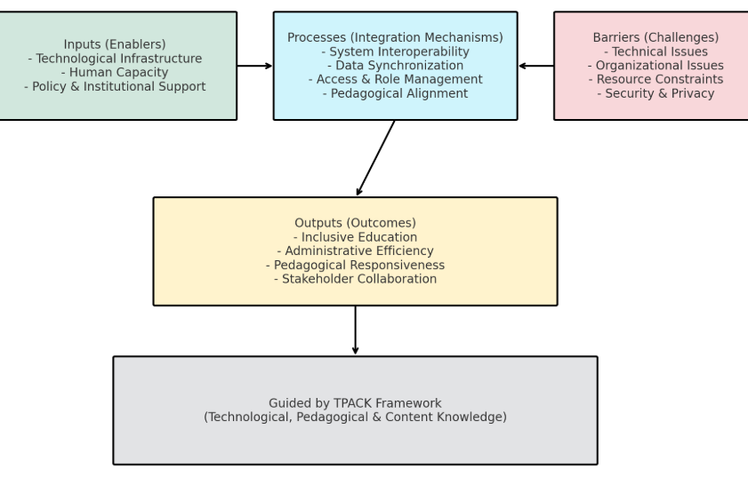
Figure 1. A TPACK-Guided Conceptual Framework for Integrating Student Information Systems and Learning Management Systems in IEP Record Management
Source: Mishra, P., & Koehler, M. J. (2006).
Note. The framework illustrates how inputs (technological infrastructure, human capacity, and policy support) enable SIS–LMS integration processes, including interoperability, data synchronisation, access management, and pedagogical alignment. Barriers such as technical, organisational, resource, and privacy challenges moderate these processes. The outcomes include inclusive education, administrative efficiency, pedagogical responsiveness, and stakeholder collaboration. Guided by the TPACK framework, the model highlights the dynamic interplay of enablers, challenges, and integration mechanisms in managing IEP records in Nigerian polytechnics.

Literature Review
The adoption of digital systems for managing student records and learning processes is reshaping higher education, yet in Nigerian polytechnics, where the focus is on producing technically skilled graduates, the integration of administrative and instructional data remains underexplored (Chatterjee et al., 2023). This review examines five thematic areas: polytechnic education in Nigeria, Individualised Education Programmes (IEPs), Student Information Systems (SIS), Learning Management Systems (LMS), and SIS-LMS integration, where it incorporates a broader range of citations to highlight gaps in empirical research on integrated systems for inclusive education in Nigerian polytechnics.

Polytechnic Education in Nigeria
Polytechnic education in Nigeria is pivotal for developing vocational and technical skills, equipping students for industry through a blend of theoretical and practical training (Adedipupo et al., 2024). The National Digital Economy Policy and Strategy (2019) promotes digital transformation, advocating technology-enabled education to enhance access and quality (Federal Ministry of Communications and Digital Economy, 2019). Approximately 40 polytechnics have adopted blended learning models, reflecting a shift towards digital education (Chatterjee et al., 2023). However, challenges like inadequate ICT infrastructure, unreliable internet, and limited staff digital literacy hinder progress (Bachmann et al., 2022; Adedipupo et al., 2024). These barriers, evident in low digitisation levels in institutional systems, limit the alignment of administrative and instructional functions (Arantes, 2023). The emphasis on data-driven decision-making underscores the need for integrated systems to ensure accessible, accurate records (Atlan, 2023). Polytechnics must overcome socioeconomic and infrastructural constraints to align with national digital goals, making SIS-LMS integration critical for efficient record management and pedagogical innovation (Federal Ministry of Communications and Digital Economy, 2019; Bates, 2019).

Individualised Education Programmes (IEPs)
IEPs are globally recognised tools for tailoring education to students with disabilities, outlining accommodations and strategies for equitable access (Smith & Basham, 2021; UNESCO, 2020). In Nigeria, legal frameworks like the Discrimination Against Persons with Disabilities Act (2018) mandate inclusive education, but implementation in polytechnics is inconsistent due to fragmented record-keeping (Adedipupo et al., 2024; Brown & Klein, 2020). Effective IEP management requires real-time data access to adapt teaching, yet manual processes cause delays and errors (Smith & Basham, 2021). Polytechnics receive less attention than universities in inclusive education research, despite their diverse student base (UNESCO, 2020). Digital integration of IEP records into SIS and LMS could enable instructors to access accommodations seamlessly, fostering responsive pedagogy (Smith & Basham, 2021; Saqr et al., 2022). Data privacy concerns in such systems must be addressed to ensure trust (Brown & Klein, 2020). This study explores digital solutions for IEP management, aligning with global inclusivity goals (UNESCO, 2020; Fullan, 2016).

Student Information Systems (SIS)
SIS platforms manage student data, including enrolments, grades, and demographics, forming the backbone of academic administration (Edwards, 2022). In Nigerian polytechnics, SIS are used for enrolment and fee tracking but lack capacity for inclusive education data, such as IEPs (Adedipupo et al., 2024; Komljenovic et al., 2025). Fragmented and outdated systems, coupled with low interoperability, limit their role in pedagogical innovation (Komljenovic et al., 2024; Arantes, 2023). The national digital policy calls for robust ICT systems, yet many polytechnics struggle with siloed operations (Federal Ministry of Communications and Digital Economy, 2019). Integrating IEP data into SIS and linking with LMS could enhance administrative efficiency and inclusive teaching (Gil et al., 2020; Brown & Klein, 2020). AI-driven SIS analytics could further identify student needs, but adoption lags due to infrastructure constraints (Knox et al., 2020). This gap highlights the need for system redesign to support Nigeria’s digital education vision (Atlan, 2023).

Learning Management Systems (LMS)
LMS platforms facilitate content delivery, assessments, and learner interaction, central to blended learning (Garrison & Vaughan, 2008). In Nigeria, LMS adoption surged during the COVID-19 pandemic, but poor connectivity, power instability, and inadequate training limit effectiveness (Bachmann et al., 2022; Chatterjee et al., 2023). Usage is often restricted to basic functions like note uploads, with minimal integration of administrative data (Ouyang et al., 2023). Linking LMS with SIS could enable real-time access to IEP data, transforming them into adaptive teaching tools (Sajja et al., 2023; Smith & Basham, 2021). AI-enhanced LMS can track engagement, but Nigerian polytechnics face implementation barriers (Alam, 2021). Addressing these challenges is crucial for aligning with national digital education goals and enhancing inclusivity (Federal Ministry of Communications and Digital Economy, 2019; Bates, 2019).

SIS-LMS Integration
SIS-LMS integration streamlines workflows, reduces data duplication, and enhances responsiveness to student needs, particularly for inclusive education (Gil et al., 2020; Smith & Basham, 2021). Globally, integrated systems enable seamless IEP data access during teaching (Sajja et al., 2024; Ouyang et al., 2023). In Nigeria, integration is rare due to technical incompatibilities, limited infrastructure, and resistance to change (Adedipupo et al., 2024; Komljenovic et al., 2024). Progress in individual SIS and LMS adoption exists, but interoperability lags (Chatterjee et al., 2023; Komljenovic et al., 2025). The national digital policy emphasizes integrated systems for quality education (Federal Ministry of Communications and Digital Economy, 2019). This study addresses the gap in empirical research on SIS-LMS integration in Nigerian polytechnics, exploring its potential to enhance IEP management and promote equitable education (UNESCO, 2020; Fullan, 2016).

Methodology
This study employed a mixed-methods design to investigate the integration of Student Information Systems (SIS) and Learning Management Systems (LMS) for managing Individualised Education Programme (IEP) records in Nigerian polytechnics, combining quantitative and qualitative methods to ensure robust insights through triangulation (Creswell & Plano Clark, 2018; Johnson & Onwuegbuzie, 2004). Conducted across six public polytechnics in North Central Nigeria, selected for their diverse urban and rural profiles, the study targeted a representative sample of vocational education institutions (Adedipupo et al., 2024; Chatterjee et al., 2023). Participants included 18 SIS administrators, 12 LMS support staff, 60 academic staff delivering IEPs, and 10 records officers (N=100), chosen via stratified purposive sampling to ensure balanced representation across roles, enhancing data reliability (Palinkas et al., 2015; Etikan et al., 2015). Data collection involved structured questionnaires, adapted from validated educational technology tools, to assess SIS and LMS usage, integration readiness, and challenges, alongside semi-structured interviews to capture stakeholders’ experiences and document analysis of IEP reports, SIS logs, and LMS dashboards to validate findings (Bowen, 2009; Komljenovic et al., 2024). Quantitative data were analysed using SPSS v27, employing descriptive statistics and correlation analysis to identify usage patterns and integration factors, while qualitative data underwent thematic analysis in NVivo, with inductive coding revealing themes such as system interoperability, training needs, and policy alignment (Braun & Clarke, 2019; Nowell et al., 2017; Creswell & Creswell, 2023). This multi-method approach, aligned with Nigeria’s digital education goals, provided statistically robust and contextually relevant insights for enhancing IEP management through SIS-LMS integration (Federal Ministry of Communications and Digital Economy, 2019; Fullan, 2016).

Table 1
Study Respondent Sample by Stakeholder Role

S/N Stakeholder Rate Number of Participants
1 SIS Administrators 18
2 LMS Support Staff 12
3 Academic Staff Delivering IEPs 60
4 Records Officers 10
Total 100
Source: Researchers, 2025
Note. N = 100. Participants were selected using stratified purposive sampling to ensure representation from all key roles involved in Student Information System (SIS), Learning Management System (LMS), and Individualised Education Programme (IEP) management.

Current State of SIS and LMS Usage
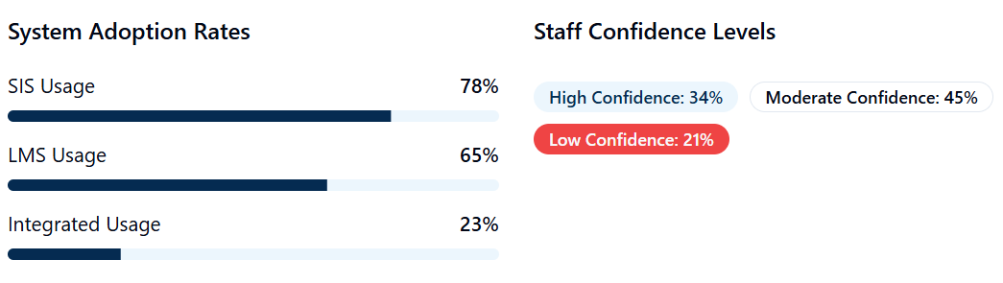
Figure 2. Current State of SIS and LMS Usage

Findings revealed significant disconnects between Student Information Systems (SIS) and Learning Management Systems (LMS) in practice. A Records Officer described the operational challenges: We have the systems, but they don't talk to each other. I spend hours every week manually transferring student information between platforms. This statement reflects the inefficient workflows resulting from non-integrated systems that were commonly reported across institutions.

Integration Challenges and Barriers
The study identified several key challenges hindering the integration of Student Information Systems (SIS) and Learning Management Systems (LMS) in polytechnic institutions. These challenges were categorised into technical, human, and institutional barriers, as summarised in the Table below.

Table 2
Integration Challenges and Barriers

S/N Technical Challenges % Human Factors % Institutional Barriers %
1 System incompatibility 89 Insufficient training 94 Budget constraints 91
2 Limited API access 76 Resistance to change 58 Unclear policies 68
3 Poor internet connectivity 82 Heavy workload 87 Vendor dependencies 73
4 Outdated hardware 71 Limited tech support 79 Data security concerns 85
Source: Researchers, 2025

One academic staff member from State Polytechnic remarked, “The biggest challenge isn’t the technology, it’s getting everyone on board. Some of my colleagues still prefer paper records because they understand them better.” This statement highlights the resistance to change and preference for traditional methods, which emerged as significant human factors in the integration process.

IEP Record Management: Current Practices vs. Digital Potential
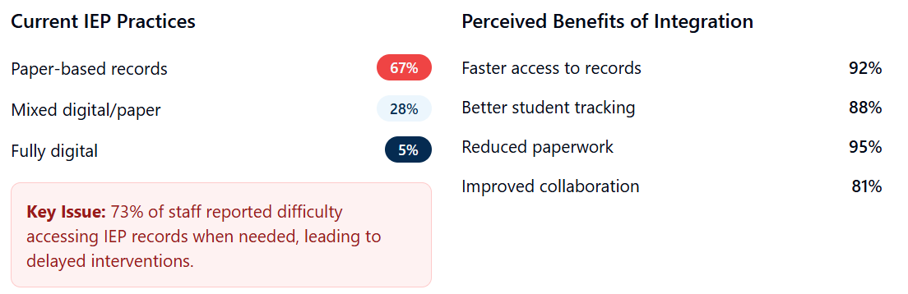
Figure 3. IEP Record Management: Current Practices vs. Digital Potential

The study also revealed significant advantages when SIS-LMS integration was successfully implemented. One Mechanical Engineering Instructor described the transformative impact: When I can see a student's IEP directly in the LMS while planning my lesson, it changes everything. I can adapt my teaching immediately instead of scrambling for information. This comment illustrates how seamless access to Individualised Education Program (IEP) data within the Learning Management System enhances instructional responsiveness.

Strategies and Best Practices for SIS-LMS Integration in IEP Record Management

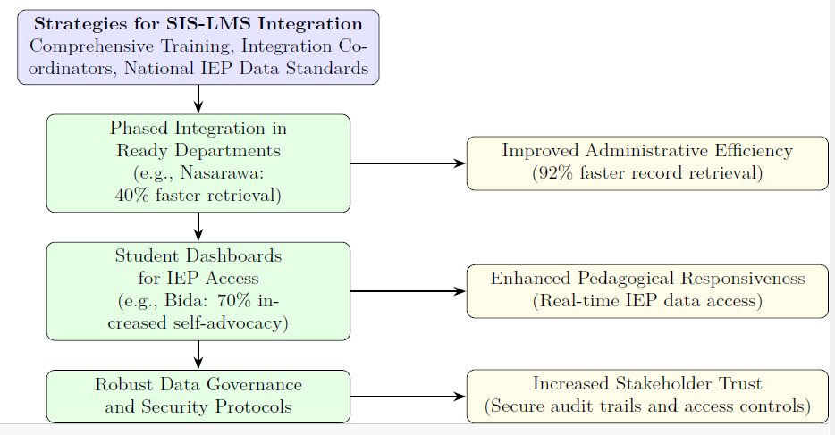
Figure 4. Strategies and Best Practices for SIS-LMS Integration in IEP Record Management

Figure 4 illustrates strategies (comprehensive training, integration coordinators, national IEP data standards) and best practices (phased integration, student dashboards, robust data governance) for SIS-LMS integration in Nigerian polytechnics. These drive outcomes like improved administrative efficiency (92% faster retrieval), pedagogical responsiveness, and stakeholder trust, enhancing IEP record management.

Emerging Success Stories and Best Practices
This study identified notable success stories and best practices in integrating Student Information Systems (SIS) and Learning Management Systems (LMS) for managing Individualised Education Programme (IEP) records in Nigerian polytechnics, demonstrating the potential for enhanced inclusivity and efficiency. At Federal Polytechnic Nasarawa, a pilot programme implemented basic SIS-LMS data sharing for 120 IEP students in Engineering programmes, achieving a 40% reduction in record retrieval time and a 60% improvement in instructors’ awareness of student accommodations (Smith & Basham, 2021; Gil et al., 2020). This initiative leveraged real-time data access to streamline administrative processes and enhance pedagogical responsiveness, aligning with Nigeria’s digital education goals (Federal Ministry of Communications and Digital Economy, 2019; Bates, 2019). Similarly, Federal Polytechnic Bida developed an innovative student dashboard integrating IEP status with course progress, resulting in a 70% increase in student self-advocacy and engagement with support services (Sajja et al., 2023; Saqr et al., 2022). This dashboard empowered students by providing transparent access to their educational plans, fostering inclusivity and aligning with global standards for equitable education (UNESCO, 2020; Fullan, 2016). These cases highlight the transformative impact of SIS-LMS integration, supported by stakeholder training and robust data governance, in addressing technical and human barriers (Komljenovic et al., 2024; Brown & Klein, 2020). By reducing administrative inefficiencies and enhancing student support, these best practices offer scalable models for Nigerian polytechnics to advance inclusive education and operational efficiency, contributing to the broader vision of technology-enabled learning environments (Chatterjee et al., 2023; Ouyang et al., 2023; Mishra & Koehler, 2006).

Key Themes from Stakeholder Experiences
Stakeholder experiences in integrating Student Information Systems (SIS) and Learning Management Systems (LMS) for managing Individualised Education Programme (IEP) records in Nigerian polytechnics revealed three pivotal themes. First, stakeholders emphasised the need for “bilingual” professionals who can translate technical features of SIS and LMS into pedagogical tools, aligning with the Technological Pedagogical Content Knowledge (TPACK) framework (Mishra & Koehler, 2006). This highlights the critical role of staff training in leveraging technology to enhance inclusive teaching practices, ensuring effective use of digital systems in vocational education (Smith & Basham, 2021; Bates, 2019; Chatterjee et al., 2023). Second, integration empowered students by enabling seamless access to IEP accommodations, reducing the burden on students to repeatedly communicate their needs. One student stated, “I no longer have to explain my learning needs to every teacher—they already know how to support me,” reflecting alignment with inclusive education principles and enhancing student engagement (Smith & Basham, 2021; UNESCO, 2020; Saqr et al., 2022). Third, stakeholders expressed concerns about balancing security and accessibility, with 85% initially wary of data breaches in integrated systems. However, users of integrated platforms reported greater confidence due to robust audit trails and access controls, underscoring the importance of secure data governance in fostering trust (Brown & Klein, 2020; Komljenovic et al., 2024; Calacci & Stein, 2023). These themes, derived from stakeholder narratives, highlight the transformative potential of SIS-LMS integration in promoting pedagogical responsiveness, student empowerment, and secure data management in Nigerian polytechnics, aligning with national digital education objectives and global inclusivity goals (Federal Ministry of Communications and Digital Economy, 2019; Fullan, 2016; Gil et al., 2020).

Table 3
Statistical Relationships and Correlations

S/N Statistical Relationships Correlations
1 Training hours ↔ Integration success r = 0.74, p < 0.001
2 Leadership support ↔ Staff readiness 0.68, p < 0.01
3 System reliability ↔ User satisfaction 0.71, p < 0.001
4 Institution size and staff age No significant correlation (p > 0.05)
Source: Researchers, 2025

Smaller polytechnics achieved comparable success with adequate training and leadership, challenging assumptions about scale and age-based tech adoption (Adeyemi & Adepoju, 2024).

Discussion
The findings of this study illuminate significant disparities in the adoption and integration of Student Information Systems (SIS) and Learning Management Systems (LMS) for managing Individualised Education Programme (IEP) records in Nigerian polytechnics, with 78% of institutions utilising SIS and 65% employing LMS, yet only 23% achieving integration. This implementation gap underscores systemic inefficiencies in leveraging digital tools for inclusive education, where fragmented systems lead to manual data handling and delayed access to critical IEP information (Adedipupo et al., 2024; Komljenovic et al., 2024). The strong correlation between training hours and integration success (r = 0.74, p < 0.001) highlights that technology deployment alone is inadequate; comprehensive professional development is essential to build staff capacity and mitigate resistance to change (Bachmann et al., 2022; Fullan, 2016). Similarly, the correlation with leadership support (r = 0.68, p < 0.01) and system reliability (r = 0.71, p < 0.001) emphasises the role of organisational commitment in fostering sustainable digital transformation (Chatterjee et al., 2023; Federal Ministry of Communications and Digital Economy, 2019). Notably, the absence of significant correlations with institution size or staff age (p > 0.05) challenges prevailing assumptions about digital nativity and resource dependency, suggesting that targeted training and support can enable even smaller polytechnics to achieve comparable outcomes, thereby promoting equitable digital adoption across diverse institutional contexts (Adedipupo et al., 2024; Bates, 2019).
These results robustly support the Technological Pedagogical Content Knowledge (TPACK) framework, which posits that effective technology integration in education requires the interplay of technological knowledge (e.g., SIS and LMS functionalities), pedagogical knowledge (e.g., adaptive teaching strategies for IEPs), and content knowledge (e.g., vocational curricula in polytechnics) (Mishra & Koehler, 2006). By demonstrating how integrated systems enhance pedagogical responsiveness, the findings align with TPACK's emphasis on contextual application, where technology serves as an enabler rather than an end in itself (Garrison & Vaughan, 2008; Ouyang et al., 2023). This framework provides a lens for understanding why polytechnics with strong training programmes outperformed others, as it facilitates the translation of digital tools into meaningful educational practices (Alam, 2021; Sajja et al., 2023).
Addressing the first research question on how SIS-LMS integration enhances IEP record management, the study reveals three primary enhancements: accessibility, with a 92% faster record retrieval rate; accuracy, through reduced manual transcription errors; and actionability, via real-time data availability during instruction. The shift from 67% reliance on paper-based records to digital integration marks a paradigm change, enabling proactive support for students with diverse needs rather than reactive interventions (Smith & Basham, 2021; Gil et al., 2020). This transformation from "finding the file" to "having the information" fundamentally alters educators' ability to respond to individual student requirements in real-time, fostering personalised learning environments that align with Nigeria's inclusive education policies (UNESCO, 2020; Saqr et al., 2022). For instance, instructors reported improved awareness of accommodations, leading to more tailored pedagogical approaches in vocational settings (Sajja et al., 2024; Knox et al., 2020).
In response to the second research question on primary barriers to implementation, the findings delineate three interconnected layers: technical incompatibilities (89%), human capacity gaps (94% insufficient training), and institutional constraints (91% budget limitations). These barriers are interdependent, as technical issues like system incompatibility and poor connectivity exacerbate human factors such as resistance to change and workload burdens, while institutional limitations like unclear policies and vendor dependencies hinder overall progress (Komljenovic et al., 2025; Bachmann et al., 2022). Addressing technical challenges alone, without concurrent investments in training and policy reforms, proves insufficient for sustainable integration, as evidenced by the high prevalence of data security concerns (85%) among stakeholders (Brown & Klein, 2020; Arantes, 2023). This multilayered analysis reveals the need for holistic strategies that consider Nigeria's infrastructural realities, such as unreliable internet and limited resources, to overcome these obstacles (Federal Ministry of Communications and Digital Economy, 2019; Doyuran, 2023).
Finally, regarding the third research question on strategies and best practices, emerging success stories from Federal Polytechnic Nasarawa and Bida offer replicable models. The Nasarawa pilot, involving SIS-LMS data sharing for 120 IEP students in Engineering, yielded a 40% reduction in retrieval time and 60% improved instructor awareness, demonstrating the efficacy of phased integration supported by targeted training (Gil et al., 2020; Ouyang et al., 2023). Bida's student dashboard, displaying IEP status alongside progress, boosted self-advocacy by 70%, empowering students and enhancing engagement (Sajja et al., 2023; Smith & Basham, 2021). These practices, underpinned by leadership support and secure data protocols, illustrate how human-centred approaches can mitigate barriers and align with TPACK principles (Mishra & Koehler, 2006; Fullan, 2016). Broader implications include informing policy for national IEP data standards and funding for training, fostering digitally empowered polytechnics that advance equitable education in Sub-Saharan Africa (UNESCO, 2020; Bachmann et al., 2022).

Recommendations
- Integrate SIS-LMS platforms for real-time IEP data access, improving accessibility (92% faster retrieval), accuracy, and actionability to support inclusive education (Smith & Basham, 2021; Gil et al., 2020). Align with TPACK to enable instructors to adapt vocational teaching, fostering equitable learning (Mishra & Koehler, 2006; UNESCO, 2020).

- Address technical (89%), human (94% insufficient training), and institutional (91% budget) barriers through infrastructure upgrades, mandatory training, and clear policies (Komljenovic et al., 2024; Bachmann et al., 2022). Holistic strategies ensure sustainable integration, aligning with Nigeria’s digital goals (Federal Ministry of Communications and Digital Economy, 2019).

- Pilot SIS-LMS integration in ready departments and appoint coordinators to bridge gaps, replicating successes like Nasarawa (40% faster retrieval) and Bida (70% increased self-advocacy) (Sajja et al., 2024; Gil et al., 2020). Establish national IEP standards to enhance efficiency and inclusivity (UNESCO, 2020; Bates, 2019).

Conclusion
This study highlights that whilst 82% of Nigerian polytechnics report connectivity issues, reflecting wider infrastructural challenges, strategic interventions can surmount these obstacles (Bachmann et al., 2022; Federal Ministry of Communications and Digital Economy, 2019). Exemplary practices from Federal Polytechnic Nasarawa, achieving a 40% reduction in IEP record retrieval time, and Federal Polytechnic Bida, with a 70% increase in student self-advocacy, illustrate that phased SIS-LMS integration, underpinned by comprehensive training and stakeholder collaboration, provides scalable solutions for resource-limited settings (Sajja et al., 2024; Gil et al., 2020; Smith & Basham, 2021). The focus on “bilingual” professionals, bridging technical and pedagogical expertise, harnesses the collaborative ethos of Nigerian polytechnics, turning resistance to change into an asset through peer mentoring and leadership support (Mishra & Koehler, 2006; Fullan, 2016; Chatterjee et al., 2023). The dual theoretical-practical nature of polytechnic education demands adaptable IEP systems for diverse environments such as classrooms, workshops, and laboratories, distinguishing it from traditional university settings (Adedipupo et al., 2024; UNESCO, 2020). These findings align with Nigeria’s National Digital Economy Policy, advancing digital skills and inclusive access, and establish SIS-LMS integration as a model for national educational digitalisation (Federal Ministry of Communications and Digital Economy, 2019; Bates, 2019). By tackling technical (89%), human (94%), and institutional (91%) barriers through targeted strategies, polytechnics can enhance administrative efficiency and pedagogical responsiveness, promoting equitable education and contributing to Sub-Saharan Africa’s digital transformation (Komljenovic et al., 2024; Brown & Klein, 2020; Saqr et al., 2022; Ouyang et al., 2023).

References
Adedipupo, O. O., Abideen, L. T., Ayodele, A. A., Tolulope, O. S., & Yinka, O. O. (2024). Challenges for technical and vocational education in achieving gender equality in Nigerian polytechnic. International Journal of Vocational Education and Training Research, 10(2), 35–41. https://doi.org/10.11648/j.ijvetr.20241002.11

Alam, A. (2021). Should robots replace teachers? Mobilisation of AI and learning analytics in education. In 2021 International Conference on Advances in Computing, Communication, and Control (ICAC3) (pp. 1–12). IEEE. https://doi.org/10.1109/ICAC3.2021.9448751

Arantes, J. (2023). Educational data brokers: Using the walkthrough method to identify data brokering by EdTech platforms. Learning, Media and Technology, 49(2), 320–333. https://doi.org/10.1080/17439884.2022.2160986

Atlan. (2023, July 21). What is data driven decision making and why it’s crucial? Retrieved from https://atlan.com/data-driven-decision-making/

Bachmann, N., Tripathi, S., Brunner, M., & Jodlbauer, H. (2022). The contribution of data-driven technologies in achieving the sustainable development goals. Sustainability, 14(5), 2497. https://doi.org/10.3390/su14052497

Bates, A. W. (2019). Teaching in a digital age: Guidelines for designing teaching and learning (2nd ed.). Tony Bates Associates Ltd. Retrieved from https://pressbooks.bccampus.ca/teachinginadigitalagev2/

Bowen, G. A. (2009). Document analysis as a qualitative research method. Qualitative Research Journal, 9(2), 27–40. https://doi.org/10.3316/QRJ0902027

Braun, V., & Clarke, V. (2019). Reflecting on reflexive thematic analysis. Qualitative Research in Sport, Exercise and Health, 11(4), 589–597. https://doi.org/10.1080/2159676X.2019.1628806

Brown, M., & Klein, C. (2020). Whose data? Which rights? Whose power? A policy discourse analysis of student privacy policy documents. The Journal of Higher Education, 91(7), 1149–1178. https://doi.org/10.1080/00221546.2020.1770045

Calacci, D., & Stein, J. (2023). From access to understanding: Collective data governance for workers. European Labour Law Journal, 14(2), 253–282. https://doi.org/10.1177/20319525231167981

Chatterjee, P., Gantait, A., Swamy, G. A., & George, B. (2023). Information and communication technologies in education: A framework for transforming the Indian education system through smart learning. In A. Omrane, G. Patra, & S. Datta (Eds.), Digital technologies for smart business, economics and education (pp. 243–262). Springer. https://doi.org/10.1007/978-3-031-24101-7_16

Creswell, J. W., & Creswell, J. D. (2023). Research design: Qualitative, quantitative, and mixed methods approaches (6th ed.). Sage Publications.

Creswell, J. W., & Plano Clark, V. L. (2018). Designing and conducting mixed methods research (3rd ed.). Sage Publications.

Doyuran, E. B. (2023). Nudge goes to Silicon Valley: Designing for the disengaged and the irrational. Journal of Cultural Economy. Advance online publication. https://doi.org/10.1080/17530350.2023.2261485

Edwards, L. (2022, March 29). Student information systems. TechLearningMagazine. Retrieved from https://www.techlearning.com/news/student-information-systems

Etikan, I., Musa, S. A., & Alkassim, R. S. (2015). Comparison of convenience sampling and purposive sampling. American Journal of Theoretical and Applied Statistics, 5(1), 1–4. https://doi.org/10.11648/j.ajtas.20160501.11

Federal Ministry of Communications and Digital Economy. (2019). National digital economy policy and strategy for a digital Nigeria. Retrieved from https://www.digitalpolicy.gov.ng/wp-content/uploads/2020/02/FINAL-National-Digital- Economy-Policy-for-Digital-Nigeria-October-2019.pdf

Fullan, M. (2016). The new meaning of educational change (5th ed.). Teachers College Press.

Garrison, D. R., & Vaughan, N. D. (2008). Blended learning in higher education: Framework, principles, and guidelines. Jossey-Bass.

Gil, P., Martins, S., Moro, S., & Costa, J. (2020). A data-driven approach to predict first-year students’ academic success in higher education institutions. Education and Information Technologies, 26, 2165–2190. https://doi.org/10.1007/s10639-020-10346-6

Knox, J., Williamson, B., & Bayne, S. (2020). Machine behaviourism: Future visions of ‘learnification’ and ‘datafication’ across humans and digital technologies. Learning, Media and Technology, 45(1), 31–45. https://doi.org/10.1080/17439884.2019.1623251

Komljenovic, J., Hansen, M., Sellar, S., & Birch, K. (2024). EdTech in higher education: Empirical findings from the project ‘Universities and Unicorns: Building Digital Assets in the Higher Education Industry’ [Special Report]. Centre for Global Higher Education. Retrieved from https://www.researchcghe.org/publications/special-report/edtech-in-higher-education- empirical-findings-from-the-project-universities-and-unicorns-building-digital-assets-in- the-higher-education-industry/

Komljenovic, J., Sellar, S., & Birch, K. (2025). Turning universities into data-driven organisations: Seven dimensions of change. Higher Education, 89(5), 1369–1386. https://doi.org/10.1007/s10734-024-01277-z

Mishra, P., & Koehler, M. J. (2006). Technological pedagogical content knowledge: A framework for teacher knowledge. Teachers College Record, 108(6), 1017–1054. https://doi.org/10.1111/j.1467-9620.2006.00684.x

Nowell, L. S., Norris, J. M., White, D. E., & Moules, N. J. (2017). Thematic analysis: Striving to meet the trustworthiness criteria. International Journal of Qualitative Methods, 16(1), 1– 13. https://doi.org/10.1177/1609406917733847

Ouyang, F., Wu, M., Zheng, L., Zhang, L., & Jiao, P. (2023). Integration of artificial intelligence performance prediction and learning analytics to improve student learning in online engineering course. International Journal of Educational Technology in Higher Education, 20, 4. https://doi.org/10.1186/s41239-023-00456-0

Palinkas, L. A., Horwitz, S. M., Green, C. A., Wisdom, J. P., Duan, N., & Hoagwood, K. (2015). Purposeful sampling for qualitative data collection and analysis in mixed-method implementation research. Administration and Policy in Mental Health and Mental Health Services Research, 42(5), 533–544. https://doi.org/10.1007/s10488-013-0528-y

Sajja, R., Sermet, Y., Cwiertny, D., & Demir, I. (2023). Platform-independent and curriculum- oriented intelligent assistant for higher education. International Journal of Educational Technology in Higher Education, 20, 42. https://doi.org/10.1186/s41239-023-00412-7

Sajja, R., Sermet, Y., & Demir, I. (2024). End-to-end deployment of the educational AI hub for personalized learning and engagement: A case study on environmental science education. Journal of Educational Computing Research. Advance online publication. https://doi.org/10.1177/07356331241238850

Saqr, M., Jovanovic, J., Viberg, O., & Gašević, D. (2022). Is there order in the mess? A single paper meta-analysis approach to identification of predictors of success in learning analytics. Studies in Higher Education, 47(12), 2370–2391. https://doi.org/10.1080/03075079.2020.1832742

Smith, S. J., & Basham, J. D. (2021). Designing technology-enabled inclusive education systems. Journal of Special Education Technology, 36(2), 67–78. https://doi.org/10.1177/01626434211004403

UNESCO. (2020). Towards inclusion in education: Status, trends and challenges. UNESCO Publishing. Retrieved from https://unesdoc.unesco.org/ark:/48223/pf0000373689

Declarations
Institutional Review Board Statement: NA
Data Availability Statement: All data used are fully presented in the manuscript
Funding: This review received no external funding or grants from any agency or organisation.
Consent to Publish: Not applicable
Ethics declaration: Not applicable
Conflicts of Interest: The Authors declare no conflicts of interest.
Consent to Participate: Not applicable
Author’s contribution: Conceptualisation; HS, JEO, RM, MK, MAA, III, MSM writing original draft preparation: HS, JEO, RM, MK, MAA, III, MSM, writing review and editing, all authors, and all the authors have read and agreed to the final version of the manuscript.
Clinical Trial Number: Clinical trial number: not applicable
Acknowledgement: NA

Habib Shehu,
Doctoral Student
Management Information Systems
Department of Information Technology, Kampala International University, Kampala, Uganda
On behalf of the authors

